**MINISTRY OF EDUCATION AND TRAINING**

**FPT UNIVERSITY**

Capstone Project Document

Build a website provide service for feed formulation

|  |  |
| --- | --- |
| **Group 7** | |
| **Group member** | Do Tan Liem – Team Leader – SE60725  Nguyen The Vinh – Team Member – SE60808  Nguyen Huu Phuc – Team Member - SE60749  Nguyen Bao Duy – Team Member - 60502 |
| **Supervisor** | Lam Huu Khanh Phuong |
| **Ext. Supervisor** | N/A |
| **Capstone Project code** | FeedFormulation |

-Ho Chi Minh City, 01/2014-

# Table of Contents

[Table of Contents 3](#_Toc385590173)

[List of Tables 5](#_Toc385590174)

[List of Figures 8](#_Toc385590175)

[Definitions, Acronyms, and Abbreviations 10](#_Toc385590176)

[A. Introduction 11](#_Toc385590177)

[1. Project Information 11](#_Toc385590178)

[2. Introduction 11](#_Toc385590179)

[3. Overview of current methods 11](#_Toc385590180)

[4. Problem Definition 11](#_Toc385590181)

[5. Proposed Solution 11](#_Toc385590182)

[5.1 Feature functions 11](#_Toc385590183)

[5.2 Advantages and Disadvantages 12](#_Toc385590184)

[6. Role and Responsibility 12](#_Toc385590185)

[B. Software Project Management Plan 12](#_Toc385590186)

[1. Problem Definition 12](#_Toc385590187)

[1.1 Name of this Capstone Project 12](#_Toc385590188)

[1.2 Problem Abstract 12](#_Toc385590189)

[1.3 Project Overview 12](#_Toc385590190)

[2. Project organization 13](#_Toc385590191)

[2.1 Software Process Model 13](#_Toc385590192)

[2.2 Roles and responsibilities 14](#_Toc385590193)

[2.3 Tools and Techniques 15](#_Toc385590194)

[3. Project Management Plan 16](#_Toc385590195)

[3.1 Task 16](#_Toc385590196)

[3.2 Task Sheets 18](#_Toc385590197)

[3.3 All Meeting Minutes 18](#_Toc385590198)

[4. Coding Convention 18](#_Toc385590199)

[C. Software Requirement Specification 19](#_Toc385590200)

[1. User Requirement Specification 19](#_Toc385590201)

[1.1 Account Management 19](#_Toc385590202)

[1.2 Manage Ingredient 19](#_Toc385590203)

[1.3 Manage Composition 19](#_Toc385590204)

[1.4 Formula Calculation 19](#_Toc385590205)

[1.5 Article 19](#_Toc385590206)

[1.6 Post Q&A 19](#_Toc385590207)

[1.7 Producer’s Store 19](#_Toc385590208)

[2. System Requirement Specification 20](#_Toc385590209)

[2.1 System Overview Use Case 20](#_Toc385590210)

[2.2 External Interface Requirement 21](#_Toc385590211)

[2.3 List of Use Case 22](#_Toc385590212)

[3. Software System Attribute 119](#_Toc385590213)

[3.1 Usability 119](#_Toc385590214)

[3.2 Reliability 119](#_Toc385590215)

[3.3 Availability 119](#_Toc385590216)

[3.4 Security 119](#_Toc385590217)

[3.5 Maintainability 119](#_Toc385590218)

[3.6 Portability 119](#_Toc385590219)

[3.7 Performance 119](#_Toc385590220)

[4. Conceptual Diagram 120](#_Toc385590221)

[Data Dictionary 121](#_Toc385590222)

[D. Software Design Description 122](#_Toc385590223)

[1. Design Overview 122](#_Toc385590224)

[2. System Architectural Design 123](#_Toc385590225)

[3. Component Diagram 124](#_Toc385590226)

[4. Detailed Description of Components 125](#_Toc385590227)

[4.1 Class Diagram 125](#_Toc385590228)

[4.2 Class Diagram Explanation 126](#_Toc385590229)

[4.3 Sequence Diagram 134](#_Toc385590230)

[5. User Interface Design 155](#_Toc385590231)

[6. Database Design 156](#_Toc385590232)

[7. Algorithms 157](#_Toc385590233)

[7.1 Linear Programming 157](#_Toc385590234)

[E. System Implementation & Test 158](#_Toc385590235)

[1. Introduction 158](#_Toc385590236)

[1.1 System Overview 158](#_Toc385590237)

[1.2 Test Approach 158](#_Toc385590238)

[2. Test Plan 159](#_Toc385590239)

[2.1 Features to be tested 159](#_Toc385590240)

[2.2 Features not to be tested 159](#_Toc385590241)

[2.3 Testing tool and Environment 159](#_Toc385590242)

[3. System Testing Test Case 160](#_Toc385590243)

[4. Module Test Case 162](#_Toc385590244)

[4.1 User Manage Ingredient 162](#_Toc385590245)

[4.2 Formula 167](#_Toc385590246)

[4.3 Article Management 171](#_Toc385590247)

[4.4 Post Management 174](#_Toc385590248)

[4.5 Administrator Ingredient management 176](#_Toc385590249)

[4.6 Administrator Nutrient Management 181](#_Toc385590250)

[4.7 Producer 184](#_Toc385590251)

[F. Software User’s Manual 190](#_Toc385590252)

[1. Installation Guide 190](#_Toc385590253)

[1.1 Setting up environment at server site 190](#_Toc385590254)

[1.2 Deployment at server side 190](#_Toc385590255)

[1.3 Setting up the environment at client side 194](#_Toc385590256)

[2. User Guide 194](#_Toc385590257)

[G. Appendix 194](#_Toc385590258)

# List of Tables

[Table 1: Roles and Responsibility 12](#_Toc385590259)

[Table 2: Hardware Requirement for Server 13](#_Toc385590260)

[Table 3: Roles and Responsibility Details 15](#_Toc385590261)

[Table 4: Add Available Ingredient 24](#_Toc385590262)

[Table 5: Edit Ingredient’s Info 26](#_Toc385590263)

[Table 6: Add Available Ingredient 27](#_Toc385590264)

[Table 7: Hide Ingredient 29](#_Toc385590265)

[Table 8: Unhide Ingredient 30](#_Toc385590266)

[Table 9: Copy Edit Ingredient’s Composition 31](#_Toc385590267)

[Table 10: Get Ingredient From System Storage 33](#_Toc385590268)

[Table 11: Get Ingredient From Producer 34](#_Toc385590269)

[Table 12: Update Price From Original Ingredient 36](#_Toc385590270)

[Table 13: Create formula 38](#_Toc385590271)

[Table 14: View formula’s detail 39](#_Toc385590272)

[Table 15: Edit formula 41](#_Toc385590273)

[Table 16: Add Ingredient Constraint 42](#_Toc385590274)

[Table 17: Edit Ingredient Constraint 43](#_Toc385590275)

[Table 18: Remove Ingredient Constraint 45](#_Toc385590276)

[Table 19: View formula’s detail 47](#_Toc385590277)

[Table 20: Edit Nutrient Constraint 49](#_Toc385590278)

[Table 21: View formula’s detail 52](#_Toc385590279)

[Table 22: Calculate Formula 53](#_Toc385590280)

[Table 23: View result 54](#_Toc385590281)

[Table 24: Export result 55](#_Toc385590282)

[Table 25: Create article 57](#_Toc385590283)

[Table 26: Edit article 59](#_Toc385590284)

[Table 27: View article content 59](#_Toc385590285)

[Table 28: Delete article 60](#_Toc385590286)

[Table 29: Delete article 61](#_Toc385590287)

[Table 30: Add new article category 62](#_Toc385590288)

[Table 31: Edit article category 63](#_Toc385590289)

[Table 32: Delete article category 64](#_Toc385590290)

[Table 33: List article by category 65](#_Toc385590291)

[Table 34: List article by tag 66](#_Toc385590292)

[Table 35: List relate article 67](#_Toc385590293)

[Table 36: View The Answer 69](#_Toc385590294)

[Table 37: Filter By Tag 70](#_Toc385590295)

[Table 38: Get Relative Post 71](#_Toc385590296)

[Table 39: Add New Question 72](#_Toc385590297)

[Table 40: Edit Question 74](#_Toc385590298)

[Table 41: Delete Question 75](#_Toc385590299)

[Table 42: Add Answer 76](#_Toc385590300)

[Table 43: Edit Answer 77](#_Toc385590301)

[Table 44: Delete Answer 78](#_Toc385590302)

[Table 45: Add Comment To Question 80](#_Toc385590303)

[Table 46: Vote For Answer 81](#_Toc385590304)

[Table 47: Add nutrient 84](#_Toc385590305)

[Table 48: Edit nutrient 85](#_Toc385590306)

[Table 49: Delete nutrient 86](#_Toc385590307)

[Table 50: Add nutrient type 87](#_Toc385590308)

[Table 51: Edit nutrient type 88](#_Toc385590309)

[Table 52: Delete nutrient type 89](#_Toc385590310)

[Table 53: Add nutrient unit 90](#_Toc385590311)

[Table 54: Edit nutrient unit 92](#_Toc385590312)

[Table 55: Delete nutrient unit 93](#_Toc385590313)

[Table 56: Add tag 94](#_Toc385590314)

[Table 57: Edit tag 95](#_Toc385590315)

[Table 58: Delete tag 96](#_Toc385590316)

[Table 59: Set Roles 97](#_Toc385590317)

[Table 60: Lock Account 98](#_Toc385590318)

[Table 61: Unlock Account 100](#_Toc385590319)

[Table 62: Add New System Ingredient 102](#_Toc385590320)

[Table 63: Edit System Ingredient’s Info 104](#_Toc385590321)

[Table 64: Edit System Ingredient’s Composition 105](#_Toc385590322)

[Table 65: Hide System Ingredient 107](#_Toc385590323)

[Table 66: Unhide System Ingredient 108](#_Toc385590324)

[Table 67: Add New Product 111](#_Toc385590325)

[Table 68: Edit Product’s Info 113](#_Toc385590326)

[Table 69: Hide Product 114](#_Toc385590327)

[Table 70: Unhide Product 116](#_Toc385590328)

[Table 71: Edit Producer Information 118](#_Toc385590329)

[Table 72: Data Dictionary 121](#_Toc385590330)

[Table 73: Animal attribute 126](#_Toc385590331)

[Table 74: Animal method 126](#_Toc385590332)

[Table 75: Ingredient attribute 126](#_Toc385590333)

[Table 76: Ingredient method 126](#_Toc385590334)

[Table 77: Nutrient attribute 127](#_Toc385590335)

[Table 78: Nutrient method 127](#_Toc385590336)

[Table 79: Composition attribute 127](#_Toc385590337)

[Table 80: Composition method 127](#_Toc385590338)

[Table 81: IngredientConstraint 128](#_Toc385590339)

[Table 82: NutrientConstraint 128](#_Toc385590340)

[Table 83: Formular attribute 129](#_Toc385590341)

[Table 84: Formular method 129](#_Toc385590342)

[Table 85: Tag 129](#_Toc385590343)

[Table 86: Article attribute 129](#_Toc385590344)

[Table 87: Article method 130](#_Toc385590345)

[Table 88: Comment 130](#_Toc385590346)

[Table 89: Role attribute 130](#_Toc385590347)

[Table 90: Role method 130](#_Toc385590348)

[Table 91: UserProfile attribute 131](#_Toc385590349)

[Table 92: UserProfile method 131](#_Toc385590350)

[Table 93: Producer Attribute 131](#_Toc385590351)

[Table 94: Producer method 131](#_Toc385590352)

[Table 95: Post attribute 132](#_Toc385590353)

[Table 96: Post method 132](#_Toc385590354)

[Table 97: Answer attribute 132](#_Toc385590355)

[Table 98: Answer method 132](#_Toc385590356)

[Table 99: Vote attribute 133](#_Toc385590357)

[Table 102: Core Workflow Test Case 162](#_Toc385590358)

[Table 103: User manage ingredient 166](#_Toc385590359)

[Table 104: Formula 171](#_Toc385590360)

[Table 105: Article management 173](#_Toc385590361)

[Table 106: Post management 176](#_Toc385590362)

[Table 107: Administrator Ingredient Management 180](#_Toc385590363)

[Table 108: Administrator Nutrient Management 183](#_Toc385590364)

[Table 109: Producer 189](#_Toc385590365)

# List of Figures

[Figure 1: Waterfall Model 13](#_Toc385590366)

[Figure 2: System Overview Use Case 20](#_Toc385590367)

[Figure 3: User’s Ingredient Management Use Case 22](#_Toc385590368)

[Figure 4: Add new Ingredient Use Case 23](#_Toc385590369)

[Figure 5: Edit ingredient’s Info 24](#_Toc385590370)

[Figure 6: Edit Ingredient’s Composition 26](#_Toc385590371)

[Figure 7: Hide Ingredient 28](#_Toc385590372)

[Figure 8: Unhide Ingredient 29](#_Toc385590373)

[Figure 9: Copy System Ingredient’s Composition 30](#_Toc385590374)

[Figure 10: Get Ingredient From System Storage 32](#_Toc385590375)

[Figure 11: Get Ingredient from Producer 33](#_Toc385590376)

[Figure 12: User’s Formulation Use Case 36](#_Toc385590377)

[Figure 13: Create Formula 37](#_Toc385590378)

[Figure 14: View formular’s detail 38](#_Toc385590379)

[Figure 15: Edit formular 39](#_Toc385590380)

[Figure 16: Add Ingredient Constraint 41](#_Toc385590381)

[Figure 17: Edit Ingredient Constraint 42](#_Toc385590382)

[Figure 18: Remove Ingredient Constraint 44](#_Toc385590383)

[Figure 19: Add Nutrient Constraint 45](#_Toc385590384)

[Figure 20: Edit Nutrient Constraint 47](#_Toc385590385)

[Figure 21: Remove Nutrient Constraint 50](#_Toc385590386)

[Figure 22: Calculate Formula 52](#_Toc385590387)

[Figure 23: View Result 53](#_Toc385590388)

[Figure 24: Export Result 54](#_Toc385590389)

[Figure 25: Manage Article Use Case 56](#_Toc385590390)

[Figure 26: Create article 57](#_Toc385590391)

[Figure 27: Edit article 58](#_Toc385590392)

[Figure 28: View article content 59](#_Toc385590393)

[Figure 29: Delete article 60](#_Toc385590394)

[Figure 30: Comment 61](#_Toc385590395)

[Figure 31: Add new article category 62](#_Toc385590396)

[Figure 32: Edit article category 63](#_Toc385590397)

[Figure 33: List article by category 64](#_Toc385590398)

[Figure 34: List article by tag 65](#_Toc385590399)

[Figure 35: List Relate Article 66](#_Toc385590400)

[Figure 36: Overview Use Case 68](#_Toc385590401)

[Figure 37: View The Answer Use Case 68](#_Toc385590402)

[Figure 38: Filter by Tag Use Case 69](#_Toc385590403)

[Figure 39: Get Relative Question Use Case 70](#_Toc385590404)

[Figure 40: Add New Question Use Case 71](#_Toc385590405)

[Figure 41: Edit Question Use Case 73](#_Toc385590406)

[Figure 42: Delete Question Use Case 74](#_Toc385590407)

[Figure 43: Add Answer Use Case 75](#_Toc385590408)

[Figure 44: Edit Answer Use Case 76](#_Toc385590409)

[Figure 45: Delete Answer Use Case 77](#_Toc385590410)

[Figure 46: Add Comment User Case 79](#_Toc385590411)

[Figure 47: Vote For Answer Use Case 80](#_Toc385590412)

[Figure 48: Management Use Case 82](#_Toc385590413)

[Figure 49: Add Nutrient 83](#_Toc385590414)

[Figure 50: Edit Nutrient 84](#_Toc385590415)

[Figure 51: Delete Nutrient 85](#_Toc385590416)

[Figure 52: Delete Nutrient 86](#_Toc385590417)

[Figure 53: Edit nutrient type 87](#_Toc385590418)

[Figure 54: Delete nutrient type 88](#_Toc385590419)

[Figure 55: Add nutrient unit 89](#_Toc385590420)

[Figure 56: Edit nutrient unit 91](#_Toc385590421)

[Figure 57: Delete nutrient unit 92](#_Toc385590422)

[Figure 58: Add tag 93](#_Toc385590423)

[Figure 59: Edit tag 94](#_Toc385590424)

[Figure 60: Delete tag 95](#_Toc385590425)

[Figure 61: Set Roles 96](#_Toc385590426)

[Figure 62: Lock Account 97](#_Toc385590427)

[Figure 63: Unlock Account 99](#_Toc385590428)

[Figure 64: Add New System Ingredient 100](#_Toc385590429)

[Figure 65: Edit System Ingredient’s Info 102](#_Toc385590430)

[Figure 66: Edit System Ingredient’s Composition 104](#_Toc385590431)

[Figure 67: Hide System Ingredient 105](#_Toc385590432)

[Figure 68: Unhide System Ingredient 107](#_Toc385590433)

[Figure 69: Producer Manage Store Use Case 109](#_Toc385590434)

[Figure 70: Add New Product 109](#_Toc385590435)

[Figure 71: Edit product info 111](#_Toc385590436)

[Figure 72: Hide product 113](#_Toc385590437)

[Figure 73: Unhide product 115](#_Toc385590438)

[Figure 74: Edit Producer Information 116](#_Toc385590439)

[Figure 75: Conceptual Diagram 120](#_Toc385590440)

[Figure 76: Model – View – Controller Architecture (MVC) 123](#_Toc385590441)

[Figure 77: Component Diagram 124](#_Toc385590442)

[Figure 78: Class Diagram 125](#_Toc385590443)

[Figure 79: Create Formula Sequence Diagram 134](#_Toc385590444)

[Figure 80: Add Ingredient Constraint 135](#_Toc385590445)

[Figure 81: Add Nutrient Constraint 135](#_Toc385590446)

[Figure 82: Calculate Formula 136](#_Toc385590447)

[Figure 83: Export Report 137](#_Toc385590448)

[Figure 84: Create Ingredient 138](#_Toc385590449)

[Figure 85: Edit Ingredient 139](#_Toc385590450)

[Figure 86: Include Ingredient 139](#_Toc385590451)

[Figure 87: User Add Ingredient from Producer’s Store 140](#_Toc385590452)

[Figure 88: Create Ingredient 141](#_Toc385590453)

[Figure 89: Create Ingredient 142](#_Toc385590454)

[Figure 90: Edit Ingredient 143](#_Toc385590455)

[Figure 91: Inactive Ingredient 144](#_Toc385590456)

[Figure 92: Create Post 145](#_Toc385590457)

[Figure 93: Edit Post 146](#_Toc385590458)

[Figure 94: Delete Post 147](#_Toc385590459)

[Figure 95: Create Anwser 148](#_Toc385590460)

[Figure 96: Add Comment to answer 149](#_Toc385590461)

[Figure 97: Like a comment 150](#_Toc385590462)

[Figure 98: Unlike a comment 150](#_Toc385590463)

[Figure 99: Create Article 151](#_Toc385590464)

[Figure 100: Edit Article 151](#_Toc385590465)

[Figure 101: View Content 152](#_Toc385590466)

[Figure 102: Delete Article 152](#_Toc385590467)

[Figure 103: Add Comment to Article 153](#_Toc385590468)

[Figure 104: Add Nutrient 153](#_Toc385590469)

[Figure 105: Edit Nutrient 154](#_Toc385590470)

[Figure 106: Add Tag 154](#_Toc385590471)

[Figure 107: Edit Tag 155](#_Toc385590472)

[Figure 141: Database Relationship Diagram 156](#_Toc385590473)

[Figure 142: Prepare deployment package 190](#_Toc385590474)

[Figure 143: Deploy database – 1 191](#_Toc385590475)

[Figure 144: Deploy database - 2 191](#_Toc385590476)

[Figure 145: Deploy database - 3 192](#_Toc385590477)

[Figure 146: Deploy web application on server – 1 192](#_Toc385590478)

[Figure 147: Deploy web application on server – 2 193](#_Toc385590479)

[Figure 148: Deploy web application on server – 3 193](#_Toc385590480)

[Figure 149: Deploy web application on server – 4 194](#_Toc385590481)

# Definitions, Acronyms, and Abbreviations

|  |  |
| --- | --- |
| Feed Formulation | **Feed formulation** is the process of quantifying the amounts of feed ingredients that need to be put together, to form a single uniform mixture (diet) for poultry that supplies all of their nutrient requirements. |
| Linear Programming | **Linear programming** (**LP**, or **linear optimization**) is a method to achieve the best outcome (such as maximum profit or lowest cost) in a mathematical model whose requirements are represented by linear relationships. Linear programming is a special case of mathematical programming (mathematical optimization).  <http://en.wikipedia.org/wiki/Linear_programming> |
|  |  |

# Introduction

## Project Information

* Project name: **Build a website provide service for feed formulation**
* Project Code: **FeedFormulation**
* Product Type: **Website Application**
* Start Date: **January 6th, 2014**
* End Date: **May** **3rd, 2013**

## Introduction

* In Viet Nam, about 74 per cent of the population lives in rural areas and 65 per cent depend on agriculture for their livelihood. Small-scale household based production accounts for about 70 per cent of the total livestock production in Vietnam. Livestock plays an important role in generating rural income in Vietnam; an estimated 8.3 million households produce poultry and seven million households produce pigs.
* The analysis or animal growth as a response to feeding has a long history in both animal science and agricultural economics. However, knowledge of these innovations is often restricted to a small area. Although many valuable items of technology have been developed by research institutions, they are often too expensive for small-scale farmers to be able to adopt them.

## Overview of current methods

* Using Person’s Square Method
* Feed formulation model using Microsoft excel

## Problem Definition

The advantages and disadvantages of current method

* Person’s Square Method:
  + Advantages: Simple, easy to formulate.
  + Disadvantages: Only support two ingredients. Users have to calculation at every steps.
* Microsoft excel:
  + Advantages: Support multiple ingredients and nutrients. Do not require user to calculations.
  + Disadvantages: Users have to input ingredient and nutrient manually.

## Proposed Solution

The system targeted user is farmers and feed production companies. The system main purpose is support use create a feed formulation plan by select ingredients, input their prices and set threshold for nutrients and ingredients. In detail, the system will enable following function:

### **Feature functions**

* Users register their account in website and have to login in order to use the service.
* Users can manage their ingredients, feed formulation, and ingredients list.
* Users can create a feed formulation plan by select ingredients, input their prices and set threshold for nutrients and ingredients. The system will solve the linear equation system and output the optimize way to use ingredient to produce feed with lowest price.
* Result of solving can be viewed as an interactive 3D chart.
* Result can be export in PDF and Excel format.
* An article system publish news to user.
* A Q&A system built and run by user.

### Advantages and Disadvantages

The advantage and disadvantage of the proposed solution:

* Advantage: Support multiple ingredients and nutrient for feed formulation. Automatic calculations. Users can use ingredient with full nutrient detail from producer.
* Disadvantage: Require access to internet.

## Role and Responsibility

|  |  |  |  |  |
| --- | --- | --- | --- | --- |
| **No** | **Full Name** | **Role** | **Position** | **Contact** |
| 1 | Lâm Hữu Khánh Phương | Project Manager | Instructor | phuonglhk@fpt.edu.vn |
| 2 | Đỗ Tấn Liêm | Developer | Team Leader | liemdtse60725@fpt.edu.vn |
| 3 | Nguyễn Thế Vinh | Developer | Team Member | vinhntse60808@fpt.edu.vn |
| 4 | Nguyễn Hữu Phúc | Developer | Team Member | phucnhse60749@fpt.edu.vn |
| 5 | Nguyễn Bảo Duy | Developer | Team Member | duynb60502@fpt.edu.vn |

Table 1: Roles and Responsibility

# Software Project Management Plan

## Problem Definition

### Name of this Capstone Project

Build a website provide service for feed formulation (FeedFormulation)

### Problem Abstract

The idea of the project is to develop a web-based application that provide service to create a feed formulation. User can manage their own ingredient and nutrient value. It also provide a range of ingredients from the system. Furthermore, a news article system and Q&A site to support farmers, feed companies and producers get in touch with the livestock industry information.

### Project Overview

#### The Current System

* Using Person’s Square Method
* Feed formulation model using Microsoft excel

#### The Proposed System

* + - The system main purpose is support use create a feed formulation plan by select ingredients, input their prices and set threshold for nutrients and ingredients. The system will solve the linear equation system and output the optimize way to use ingredient to produce feed with lowest price.
    - User can view feed formula detail with ingredient & nutrient value.
* An article system publish news to user.
* A Q&A system built and run by user.

#### Boundaries of the System

* The system targeted user is farmers and feed production companies.

#### Development Environment

##### Hardware requirements

**For Server**

|  |  |
| --- | --- |
| Windows | Recommended |
| Internet Connection | Cable, Wi-Fi (8 Mbps) |
| Operating System | Windows Server 2008 |
| Computer Processor | Intel® Core(TM) i5 CPU , M 460 @ 2.53GHz |
| Computer Memory | 4GB or more |

Table 2: Hardware Requirement for Server

##### Software requirements

* Microsoft Windows 7 Service Pack 1: operating system and platform for development.
* SQL Server 2012: used to create and manage the database for system.

## Project organization

### Software Process Model

The software will be developed by using waterfall model. The waterfall model developing process includes five main phases:

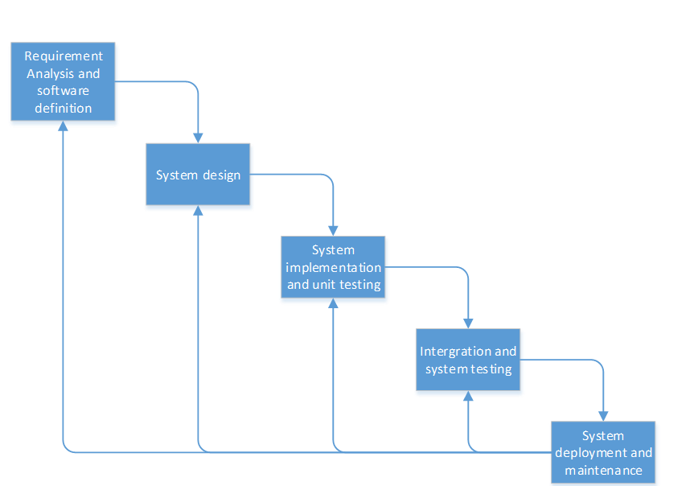

Figure 1: Waterfall Model

* + - Requirement analysis and software definition: The first phase is also the most important phase of the process which may cause great effect to other phases. This phase includes gathering requirements from customer, or from other source like the Internet, and producing the most detail and accurate software definition.
    - System design: This phase is fundamental for implementation phase. Based on customer’s requirements to create logical modules, and definite their inter relations. Using algorithm and diagram to describe implementation of those modules.
    - System implementation and Unit testing: Developing software modules follow detail designs, and doing unit testing for each module.
    - Integration and System testing: Testing output, performance in modules integrating process, and retests all functions of whole system.
    - System deployment and maintenance: After testing completely, the software is handle over client, developing team will respond for maintenance of the system.

### Roles and responsibilities

|  |  |  |  |
| --- | --- | --- | --- |
| **No** | **Full name** | **Role in Group** | **Responsibilities** |
| **1** | Lâm Hữu Khánh Phương | Project manager | * Specify user requirement * Control the development process * Give out technique and business analysis support |
| **2** | Đỗ Tấn Liêm | Team Leader, BA, DEV, Tester | * Managing process * Designing database * Clarifying requirements * Prepare documents * GUI Design * Create test plan * Coding * Testing |
| **3** | Nguyễn Thế Vinh | Team Member, BA, DEV, Tester | * Designing database * Clarifying requirements * Prepare documents * GUI Design * Create test plan * Coding * Testing |
| **4** | Nguyễn Hữu Phúc | Team Member, BA, DEV, Tester | * Designing database * Clarifying requirements * Prepare documents * GUI Design * Create test plan * Coding * Testing |
| **5** | Nguyễn Bảo Duy | Team Member, BA, DEV, Tester | * Designing database * Clarifying requirements * Prepare documents * GUI Design * Create test plan * Coding * Testing |

Table 3: Roles and Responsibility Details

### Tools and Techniques

* Tools:
  + Microsoft Visual Studio 2012 Ultimate
  + MS SQL Server 2012 Express
  + StarUML 5.0.2.1570
* Techniques:

- Front-end technologies: HTML5, CSS3, JavaScript, jQuery, AJAX.

- Back-end: ASP.NET MVC4, Entity Framework 5.

- Web Server: Microsoft IIS.

- Database Management System: MS SQL Server 2012 Express

## Project Management Plan

### Task

#### Initiating

• Description: discuss with supervisor on important aspects of the system being built. Evaluate the feasibility to implement it on time.

• Resources Needed: 4 people for 2 day.

• Risk: Project may not be feasible for developing because of strange requirements or lack of technologies.

#### Planning

• Description: Create Project Introduction.

• Deliverables: Project Introduction document.

• Resources Needed: 4 people for 1 day.

• Dependencies and Constraints: Depend on researching results and project features.

• Risk: Members lack of experience in getting requirement.

#### Specifying Requirements

• Description: Define project organization: software process, role and responsibility as well as technology being used. Create Project Management Plan with task list.

• Deliverables: Project Management Plan document.

• Resources Needed: 4 people for 2 days.

• Dependencies and Constraints: Depend on project introduction, scheduled tasks must be within 15 weeks.

• Risk: Planned task may not balance. Team may not be able to keep works in schedule due to lack of understanding about project requirement or technology. The schedule may need to change due to changes in later phases.

#### Create Software Requirements Specification (SRS)

• Description: Create software requirements specification.

• Deliverables: software requirements specification document.

• Resources Needed: 4 people for 6 days.

• Dependencies and Constraints: Depend on customer requirement.

• Risk: Difficulty to understand requirement, misunderstanding requirement may lead to failure in later phase.

#### Design Database

• Description: Create logical and physical database design.

• Deliverables: Database Design model.

• Resources Needed: 1 people for 3 days.

• Dependencies and Constraints: Depends on SRS document and SDD document.

• Risk: The database design can be inappropriate or changed based on customers’ requirements.

#### Create Software Design Description (SDD)

• Description: Design system architecture and system components.

• Deliverables: SDD document.

• Resources Needed: 4 people for 11 days.

• Dependencies and Constraints: Depends on the completion of SRS document.

• Risk: Risks may include choosing inappropriate architecture and design patterns, causing the system hard to maintain, or wasting coding efforts.

#### System Implement and Test

• Description: Implement the system based on requirements and perform test.

• Deliverables: Deployment package, source code.

• Resources Needed: 4 people for 24 days.

• Dependencies and Constraints: Depends on the completion of SRS, SDD, database design and coding framework.

• Risk: Some design documents contain errors; implementation is not always consistent with the system and detailed designs

#### Performing Testing

• Description: Implement the system based on requirements and perform test.

• Deliverables: Test reports.

• Resources Needed: 4 people for 12 days.

• Dependencies and Constraints: Depends on the completion of SRS, SDD, database design, layout design and coding framework.

• Risk: Test may not be performed thoroughly, causing spending many efforts in system test phase.

#### Create User’s Manual

• Description: Create User’s manual.

• Deliverables: User’s manual document.

• Resources Needed: 4 people for 5 days.

• Dependencies and Constraints: Depend on SRS, SDD documents and coding is finished.

• Risk: The project may do not cover all of SRS and SDD documents.

#### Deployment

• Description: Deploy the system on server.

• Deliverables: Running website with domain and hosting.

• Resources Needed: 4 people for 2 day.

• Dependencies and Constraints: Coding and system test are finished, initial data is inputted.

• Risk: The owner host lacks of support in some components such as database engine.

#### Finalizing and Closing

• Description: Finalize all related documents and prepare for presentation

• Deliverables: The complete website and related documents, presentation

• Resources Needed: 4 people for 4 day.

• Dependencies and Constraints: Coding and system test are finished, initial data is inputted.

### Task Sheets

* Reference to CD:
  + <root>/Documents/Tasksheet.xlsx
  + <root>/Documents/Project Plan.mpp

### All Meeting Minutes

Refer to Meeting Minutes folder.

## Coding Convention

C#: Use to develop website.

Summary:

* Naming Convention.
* Layout Convention.
* Commenting Convention.
* Language Guidelines

Using C# Code Convention From:

<http://msdn.microsoft.com/en-us/library/vstudio/ff926074.aspx>

# Software Requirement Specification

## User Requirement Specification

### Account Management

* Guest can register new account.

### Manage Ingredient

* User can create/edit/hide Ingredient.
* User can copy ingredient from system storage.
* User can use ingredient publish by producer.
* User can copy composition value when create ingredient.
* User can update ingredient’s price from its origin ingredient (From system storage or producers).
* Administrator can create/edit/hide storage’s ingredient.

### Manage Composition

* User can edit composition value of each ingredient.

### Formula Calculation

* User can create/edit formula.
* User set the formula’s ingredient and nutrient constraint.
* System calculate formula’s result base on ingredient and nutrient constraint and output the optimize way to use ingredient to produce feed with lowest price.
* When the formula’s constraint is changed, a warning message should be displayed to user.
* When an ingredient’s price is changed, a warning message should be displayed to user.
* User can choose to publish the formula
* Display the formula detail with ingredient and nutrient value.
* Result of solving can be viewed as an interactive 3D chart.

### Article

* Guest can view an article detail.
* User can comment on an article.
* User can view related articles.
* Admin can create/edit article.

### Post Q&A

* Guest can view list post order by date/view.
* User can create/edit post.
* User can answer a post.
* User can comment each answer.
* User can vote an answer useful or not useful.
* Admin can delete inappropriate posts.

### Producer’s Store

* User can contact to become producer.
* User must be approved by Admin to become Producer.
* Producer can edit producer’s info.
* Producer can create/edit own product and its composition.

## System Requirement Specification

### System Overview Use Case

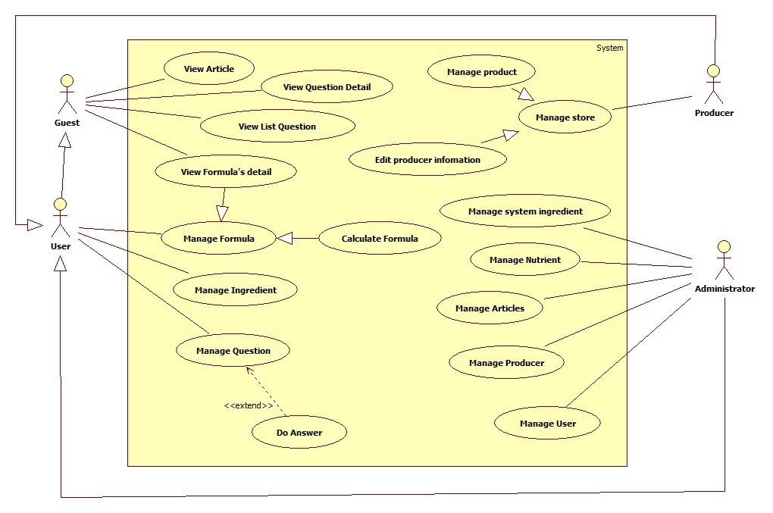

Figure 2: System Overview Use Case

### External Interface Requirement

#### User Interface

* + - The interface of website is clear, do not annoy customer.
    - The error, warning messages must be make clear, easy to understand. Error warning does not disturb customer.

#### Hardware Interface

* The system will use the standard hardware and data communications resources of a standard computer.

#### Software Interface

* Firefox Browser, Chromes with Resolution (1024\*768) or bigger and support JavaScript and HTML5

#### Communication Protocol

* Website using HTTP protocol for communication between the web browser and the web server.

### List of Use Case

#### User’s Ingredient Management Use Case

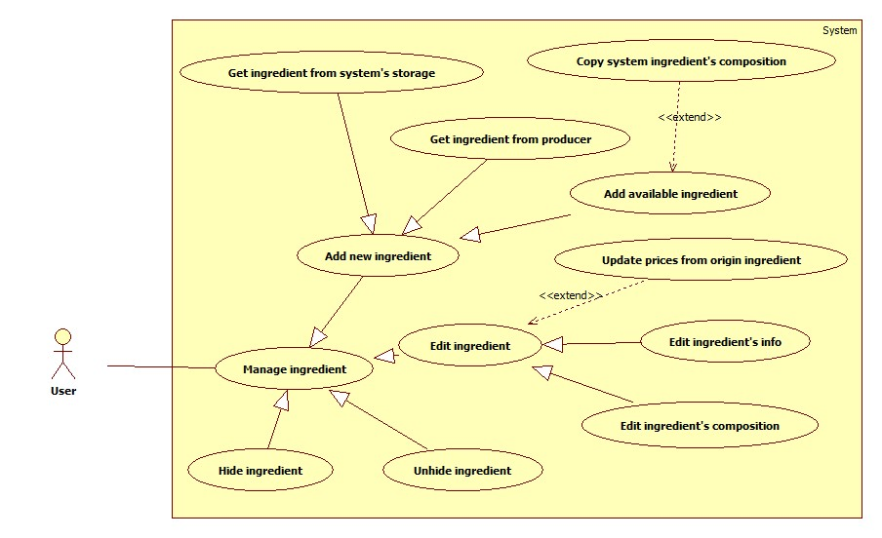

Figure 3: User’s Ingredient Management Use Case

##### Add new Ingredient



Figure 4: Add new Ingredient Use Case

|  |  |  |  |
| --- | --- | --- | --- |
| **USE CASE SPECIFICATION** | | | |
| **Use Case No.** | UI001 | **Use Case Version** | 2.0 |
| **Use Case Name** | Add Available Ingredient | | |
| **Author** | Nguyễn Thế Vinh | | |
| **Date** | 26/02/2014 | **Priority** | Normal |
| **Actor:**   * User   **Summary:**   * User can add their available ingredient.   **Goal:**   * Helps user add their available ingredient into database system.   **Triggers:**   * User wants to add their available ingredient. * User goes to “Nguyên liệu của bạn” page. In “Nguyên liệu” tab, user click button “Thêm” and fill ingredient’s information, after that click button “Tạo mới”   **Preconditions:**   * User must logged in the system.   **Post Conditions:**   * **Success**: New ingredient be added. * **Fail:** System will transfer to error page or still in current page.   **Main Success Scenario:**   |  |  |  | | --- | --- | --- | | Step | Actor Action | System Response | | 1 | User goes to “Nguyên liệu của bạn” page. In “Nguyên liệu” tab, user click button “Thêm” | System will show “Tạo nguyên liệu” page includes:   * Tên nguyên liệu [Name: Text box, Require] * Giá(VNĐ/kg) [Price: Text box, Require] * Phân loại [CategoryId: Dropdown List] * Sao chép thành phần dinh dưỡng từ nguyên liệu trong kho hệ thông [Link] * Tạo mới [Submit button] * Nhập lại [Reset button] | | 2 | - User enters the following information (Tên nguyên liệu, Giá, Phân loại).  - User can also copy nutrient composition of available ingredient in system (More info in Copy System Ingredient’s Composition Use Case).  - Click “Tạo mới” button to send request. | * System will insert user’s new ingredient and nutrient composition copy (if user choose copy system ingredient’s composition) to database. * System redirect to “Thành phần dinh dưỡng” page and show notify “Nguyên liệu \*Name\* đã được thêm mới thành công. Vui lòng nhập thành phần dinh dưỡng” |   **Alternative Scenario:** N/A  **Exceptions:**   |  |  |  | | --- | --- | --- | | Step | Actor Action | System Response | | 1 | Set blank on “Tên nguyên liệu” | System will show the validate message “Vui lòng nhập tên nguyên liệu” and focus on Name textbox | | 2 | Set blank on “Giá(VNĐ/kg)” | System will show the validate message “Vui lòng nhập giá nguyên liệu” and focus on Price textbox | | 3 | Enter non-numeric on “Giá(VNĐ/kg)” | System will show “Giá nguyên liệu phải là số” and focus on Price textbox |   **Relationships:**   * Copy System Ingredient’s Composition   **Business Rules:**   * Price must be numeric | | | |

Table 4: Add Available Ingredient

##### Edit ingredient’s Info



Figure 5: Edit ingredient’s Info

|  |  |  |  |
| --- | --- | --- | --- |
| **USE CASE SPECIFICATION** | | | |
| **Use Case No.** | UI002 | **Use Case Version** | 2.0 |
| **Use Case Name** | Edit Ingredient’s Info | | |
| **Author** | Nguyễn Thế Vinh | | |
| **Date** | 26/02/2014 | **Priority** | Normal |
| **Actor:**   * User   **Summary:**   * User can edit all information of their ingredient.   **Goal:**   * Helps user modify name, price and category of their ingredient.   **Triggers:**   * User wants to edit their ingredient. * User goes to “Nguyên liệu của bạn” page. In “Nguyên liệu” tab, user search ingredient that they want to edit, clicks on pencil icon button in the right of each ingredient in list and change ingredient’s information, after that click button “Xác nhận”   **Preconditions:**   * User must logged in the system.   **Post Conditions:**   * **Success**: Ingredient’s info be changed. * **Fail:** System will transfer to error page or still in current page.   **Main Success Scenario:**   |  |  |  | | --- | --- | --- | | Step | Actor Action | System Response | | 1 | User goes to “Nguyên liệu của bạn” page. In “Nguyên liệu” tab, user search ingredient that they want to edit, clicks on pencil icon button in the right of each ingredient in list. | System will show “Sửa nguyên liệu” page includes:   * Tên nguyên liệu [Name: Text box, Require] * Giá(VNĐ/kg) [Price: Text box, Require] * Phân loại [CategoryId: Dropdown List] * Xác nhận [Submit button] * Nhập lại [Reset button] | | 2 | - User changes the following information (Tên nguyên liệu, Giá, Phân loại).  - Click “Xác nhận” button to send request. | System will change the ingredient’s information, update change price in database.  System redirect to “Nguyên liệu của bạn” and show notify “Nguyên liệu \*Name\* đã cập nhật thành công.” |   **Alternative Scenario:** N/A  **Exceptions:**   |  |  |  | | --- | --- | --- | | Step | Actor Action | System Response | | 1 | Set blank on “Tên nguyên liệu” | System will show the validate message “Vui lòng nhập tên nguyên liệu” and focus on Name textbox | | 2 | Set blank on “Giá(VNĐ/kg)” | System will show the validate message “Vui lòng nhập giá nguyên liệu” and focus on Price textbox | | 3 | Enter non-numeric on “Giá(VNĐ/kg)” | System will show “Giá nguyên liệu phải là số” and focus on Price textbox |   **Relationships:** N/A  **Business Rules:**   * Price must be numeric | | | |

Table 5: Edit Ingredient’s Info

##### Edit Ingredient’s Composition



Figure 6: Edit Ingredient’s Composition

|  |  |  |  |
| --- | --- | --- | --- |
| **USE CASE SPECIFICATION** | | | |
| **Use Case No.** | UI003 | **Use Case Version** | 2.0 |
| **Use Case Name** | Edit Ingredient’s Composition | | |
| **Author** | Nguyễn Thế Vinh | | |
| **Date** | 26/02/2014 | **Priority** | Normal |
| **Actor:**   * User   **Summary:**   * User can edit their ingredient’s composition.   **Goal:**   * Help user modify the nutrient composition value of ingredient for each type animal   **Triggers:**   * User wants to edit their ingredient’s composition. * User goes to “Nguyên liệu của bạn” page. In “Nguyên liệu” tab, user search ingredient that they want to edit, clicks on pencil icon button in the right of each ingredient in list and clicks on dropdown button “Chỉnh sửa” in “Sửa nguyên liệu” page and chooses “Thành phần dinh dưỡng”. After that user choose animal in tab panel, clicks on value of composition that user want to modify, modify value of composition and clicks on ok icon button.   **Preconditions:**   * User must logged in the system.   **Post Conditions:**   * **Success**: Ingredient’s composition be changed. * **Fail:** System will transfer to error page or still in current page.   **Main Success Scenario:**   |  |  |  | | --- | --- | --- | | Step | Actor Action | System Response | | 1 | User clicks on dropdown button “Chỉnh sửa” in “Sửa nguyên liệu” page and choose “Thành phần dinh dưỡng”. | System will show “Chỉnh sữa thành phần dinh dưỡng” page. | | 2 | User choose animal in tab panel, clicks on value of composition that user want to modify. | Textbox will appear to the user to edit the composition value. | | 3 | User modify value and clicks on ok icon button. | System modify the value of this composition in database and notify “Cập nhật thành phần dinh dưỡng thành công” |   **Alternative Scenario:** N/A  **Exceptions:**   |  |  |  | | --- | --- | --- | | Step | Actor Action | System Response | | 1 | Input non-numeric value in composition value textbox | System will notify “Giá trị nhập vào không hợp lệ” and reset the value of this composition. |   **Relationships:** N/A  **Business Rules:**   * Composition value must be numeric | | | |

Table 6: Add Available Ingredient

##### Hide Ingredient



Figure 7: Hide Ingredient

|  |  |  |  |
| --- | --- | --- | --- |
| **USE CASE SPECIFICATION** | | | |
| **Use Case No.** | UI004 | **Use Case Version** | 2.0 |
| **Use Case Name** | Hide Ingredient | | |
| **Author** | Nguyễn Thế Vinh | | |
| **Date** | 26/02/2014 | **Priority** | Normal |
| **Actor:**   * User   **Summary:**   * User can hide their ingredient.   **Goal:**   * Help user hide their ingredient. The hidden ingredient will not show when user create of new formula.   **Triggers:**   * User wants to hide their ingredient. * User goes to “Nguyên liệu của bạn” page. In “Nguyên liệu” tab. User search ingredient that they want to hide, clicks on trash icon button in the right of each ingredient in list. After that clicks ok in confirm pop up.   **Preconditions:**   * User must logged in the system.   **Post Conditions:**   * **Success**: Ingredient’s IsAcive attribute value equals “false” in database. * **Fail:** System will transfer to error page or still in current page.   **Main Success Scenario:**   |  |  |  | | --- | --- | --- | | Step | Actor Action | System Response | | 1 | User goes to “Nguyên liệu của bạn” page. In “Nguyên liệu” tab. User search ingredient that they want to hide, clicks on trash icon button in the right of each ingredient in list. | System will show a confirm pop up “Bạn muốn ẩn nguyên liệu này?”   * Yes [Button] * No [Button] | | 2 | User selects “Yes”  [Alternative 1] | System will set IsActive attribute of this ingredient value equals “false” in database.  System reload “Nguyên liệu của bạn” page and notify “Nguyên liệu \*Name\* đã được ẩn”. |   **Alternative Scenario:**   |  |  |  | | --- | --- | --- | | Step | Actor Action | System Response | | 1 | User selects No. | User stay at current page. |   **Exceptions:** N/A  **Relationships:** N/A  **Business Rules:** N/A | | | |

Table 7: Hide Ingredient

##### Unhide Ingredient



Figure 8: Unhide Ingredient

|  |  |  |  |
| --- | --- | --- | --- |
| **USE CASE SPECIFICATION** | | | |
| **Use Case No.** | UI005 | **Use Case Version** | 2.0 |
| **Use Case Name** | Unhide Ingredient | | |
| **Author** | Nguyễn Thế Vinh | | |
| **Date** | 26/02/2014 | **Priority** | Normal |
| **Actor:**   * User   **Summary:**   * User can unhide their hidden ingredient.   **Goal:**   * Help user unhide their hidden ingredient.   **Triggers:**   * User wants to unhide their hidden ingredient. * User goes to “Nguyên liệu của bạn” page. In “Đã ẩn” tab, User search ingredient that they want to unhide, clicks on ok icon button in the right of each ingredient in list. After that, user clicks ok in confirm pop up.   **Preconditions:**   * User must logged in the system.   **Post Conditions:**   * **Success**: Ingredient’s IsAcive attribute value equals “true” in database. * **Fail:** System will transfer to error page or still in current page.   **Main Success Scenario:**   |  |  |  | | --- | --- | --- | | Step | Actor Action | System Response | | 1 | User goes to “Nguyên liệu của bạn” page. In “Đã ẩn” tab. User search ingredient that they want to unhide, clicks on ok icon button in the right of each ingredient in list. | System will show a confirm pop up “Bạn muốn khôi phục nguyên liệu này?”   * Yes [Button] * No [Button] | | 2 | User selects “Yes”  [Alternative 1] | System will set IsActive attribute of this ingredient value equals “true” in database.  System reload “Nguyên liệu của bạn” page and notify “Nguyên liệu \*Name\* đã được khôi phục”. |   **Alternative Scenario:**   |  |  |  | | --- | --- | --- | | Step | Actor Action | System Response | | 1 | User selects No. | User stay at current page. |   **Exceptions:** N/A  **Relationships:** N/A  **Business Rules:** N/A | | | |

Table 8: Unhide Ingredient

##### Copy System Ingredient’s Composition



Figure 9: Copy System Ingredient’s Composition

|  |  |  |  |
| --- | --- | --- | --- |
| **USE CASE SPECIFICATION** | | | |
| **Use Case No.** | UI006 | **Use Case Version** | 2.0 |
| **Use Case Name** | Copy System Ingredient’s Composition | | |
| **Author** | Nguyễn Thế Vinh | | |
| **Date** | 26/02/2014 | **Priority** | Normal |
| **Actor:**   * User   **Summary:**   * User can copy system ingredient’s composition when user create new ingredient.   **Goal:**   * Helps user copy composition of the same ingredient that available in system.   **Triggers:**   * User want to copy system ingredient’s composition. * In “Tạo nguyên liệu” page, user clicks on “Sao chép thành phần dinh dưỡng từ nguyên liệu trong kho hệ thống”. After that, user chooses the ingredient that user want to copy composition, click “Lưu” button and click ok in confirm pop up.   **Preconditions:**   * User must logged in the system.   **Post Conditions:**   * **Success**: Hidden textbox ingCopyId value will be update. * **Fail:** System will transfer to error page or still in current page.   **Main Success Scenario:**   |  |  |  | | --- | --- | --- | | Step | Actor Action | System Response | | 1 | In the “Tạo nguyên liệu” page, user clicks on “Sao chép thành phần dinh dưỡng từ nguyên liệu trong kho hệ thống” | System will show a modal form includes:   * Tên nguyên liệu [Name: Dropdown list, Require] * Lưu [Button] * Hủy [Button] | | 2 | User chooses the ingredient that user want to copy composition, clicks “Lưu” [Alternative 1]. | System will show a confirm pop up “Bạn muốn sao chép thành phần dinh dưỡng từ nguyên liệu này?”   * Yes [Button] * No [Button] | | 3 | User selects “Yes”  [Alternative 2] | System will set value of hidden textbox ingCopyId equals id of the ingredient that user want to copy composition(When user create, system will use this id to copy all composition of this ingredient to new ingredient) |   **Alternative Scenario:**   |  |  |  | | --- | --- | --- | | Step | Actor Action | System Response | | 1 | User clicks on “Hủy” button. | Modal will be dismissed and nothing change. | | 2 | User selects “No”. | Nothing change. |   **Exceptions:** N/A  **Relationships:**   * Add new ingredient   **Business Rules:** N/A | | | |

Table 9: Copy Edit Ingredient’s Composition

##### Get Ingredient From System Storage



Figure 10: Get Ingredient From System Storage

|  |  |  |  |
| --- | --- | --- | --- |
| **USE CASE SPECIFICATION** | | | |
| **Use Case No.** | UI007 | **Use Case Version** | 2.0 |
| **Use Case Name** | Get Ingredient From System Storage | | |
| **Author** | Nguyễn Thế Vinh | | |
| **Date** | 26/02/2014 | **Priority** | Normal |
| **Actor:**   * User   **Summary:**   * User can get ingredient from system storage.   **Goal:**   * Helps user get ingredients that available in system.   **Triggers:**   * User want to get ingredients that available in system. * User goes to “Lấy nguyên liệu” page. In “Lấy nguyên liệu” page, user search ingredients that user want to get, selects the checkbox and clicks on “Xác nhận” button.   **Preconditions:**   * User must logged in the system.   **Post Conditions:**   * **Success**: System will copy all ingredient that user want to get and make it become user’s ingredient in database. * **Fail:** System will transfer to error page or still in current page.   **Main Success Scenario:**   |  |  |  | | --- | --- | --- | | Step | Actor Action | System Response | | 1 | In navigation bar, user clicks on “Nguyên Liệu”, after that clicks on “Trong kho hệ thống” link. | System will show “Lấy nguyên liệu” page includes:   * Tên nguyên liệu [Textbox] * System Ingredient List [jsTree with checkbox] * Xác nhận [Submit button] | | 2 | User search ingredients that user want to get, selects the checkbox and clicks on “Xác nhận” button. | * System copy all ingredient that user want to get and make it become user’s ingredient in database. * System reload “Lấy nguyên liệu” page and show the message “Bạn vừa lấy thành công \*Number\* nguyên liệu.” |   **Alternative Scenario:** N/A  **Exceptions:** N/A  **Relationships:** N/A  **Business Rules:** N/A | | | |

Table 10: Get Ingredient From System Storage

##### Get Ingredient from Producer



Figure 11: Get Ingredient from Producer

|  |  |  |  |
| --- | --- | --- | --- |
| **USE CASE SPECIFICATION** | | | |
| **Use Case No.** | UI008 | **Use Case Version** | 2.0 |
| **Use Case Name** | Get Ingredient From Producer | | |
| **Author** | Nguyễn Thế Vinh | | |
| **Date** | 26/02/2014 | **Priority** | Normal |
| **Actor:**   * User   **Summary:**   * User can get ingredient from producer.   **Goal:**   * Helps user get ingredients from prestige producer. Help user better access to producer and help producer promote their products.   **Triggers:**   * User want to get ingredient from producer. * User goes to “Nhà sản xuất” page. Choose a producer that user want to get ingredient and click on “Xem chi tiết” button. Search ingredient that user want to get. After that click on plus icon on top of ingredient and click ok on confirm pop up.   **Preconditions:**   * User must logged in the system.   **Post Conditions:**   * **Success**: System will copy ingredient that user want to get from producer and make it become user’s ingredient in database. * **Fail:** System will transfer to error page or still in current page.   **Main Success Scenario:**   |  |  |  | | --- | --- | --- | | Step | Actor Action | System Response | | 1 | In navigation bar, user clicks on “Nhà sản xuất”, after that clicks on “Danh sách” link. | System will show “Nhà sản xuất” page includes list all producer that registered in system. | | 2 | User search producer that user want to get ingredient. And click on “Xem chi tiết” button. | System will show “Chi tiết nhà sản xuất” page includes information of this producer, contact and list all product of this producer. | | 3 | User search ingredient (producer’s product) that user want to get by category or name. After that click on plus icon on top of ingredient. | System will show a confirm pop up “Bạn muốn lấy nguyên liệu này?”   * Yes [Button] * No [Button] | | 4 | User selects “Yes”  [Alternative 1] | * System copy ingredient that user want to get and make it become user’s ingredient in database. * After that, system show an alert “Lấy nguyên liệu thành công”. |   **Alternative Scenario:**   |  |  |  | | --- | --- | --- | | Step | Actor Action | System Response | | 1 | User selects No. | User stay at current page. |   **Exceptions:**   * N/A   **Relationships:**   * N/A   **Business Rules:**   * N/A | | | |

Table 11: Get Ingredient From Producer

##### Update Price from Original Ingredient

|  |  |  |  |
| --- | --- | --- | --- |
| **USE CASE SPECIFICATION** | | | |
| **Use Case No.** | UI009 | **Use Case Version** | 2.0 |
| **Use Case Name** | Update Price From Original Ingredient | | |
| **Author** | Nguyễn Thế Vinh | | |
| **Date** | 26/02/2014 | **Priority** | Normal |
| **Actor:**   * User   **Summary:**   * User can get update price from origin ingredient that they get from system or producer.   **Goal:**   * Help user get update price from origin ingredient that they get from system or producer easily.   **Triggers:**   * User wants to get update price from origin ingredient. * User goes to “Nguyên liệu của bạn” page. In “Nguyên liệu” tab. User click on button “Cập nhật giá”. After that clicks ok in confirm pop up.   **Preconditions:**   * User must logged in the system.   **Post Conditions:**   * **Success**: All ingredient that user copied from system or producer will get the update price * **Fail:** System will transfer to error page or still in current page.   **Main Success Scenario:**   |  |  |  | | --- | --- | --- | | Step | Actor Action | System Response | | 1 | User goes to “Nguyên liệu của bạn” page. In “Nguyên liệu” tab. User click on button “Cập nhật giá”. | System will show a confirm pop up “Bạn muốn cập nhật giá cho tất cả nguyên liệu được lấy từ kho và nhà sản xuất?”   * Yes [Button] * No [Button] | | 2 | User selects “Yes”  [Alternative 1] | * System will update price of all ingredient that user get from system and producer base on price of origin ingredient. * System will reload page and notify “Bạn vừa cập nhật giá thành công cho \*Number\* nguyên liệu.” If all copied ingredient are had update price system will notify “Không nguyên liệu nào được cập nhật.” |   **Alternative Scenario:**   |  |  |  | | --- | --- | --- | | Step | Actor Action | System Response | | 1 | User selects No. | User stay at current page. |   **Exceptions:**   * N/A   **Relationships:**   * N/A   **Business Rules:**   * N/A | | | |

Table 12: Update Price From Original Ingredient

#### User’s Formulation Use Case

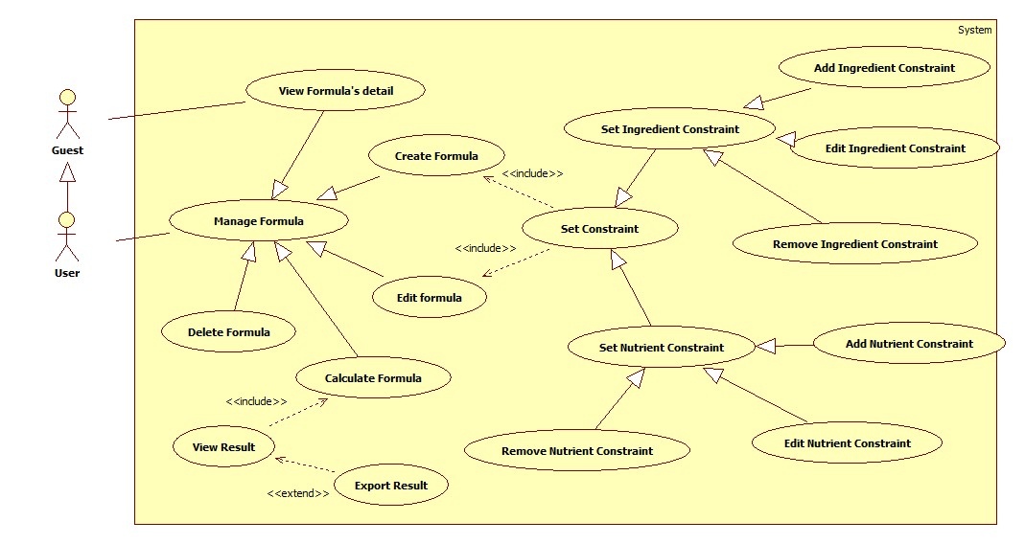

Figure 12: User’s Formulation Use Case

##### Create Formula

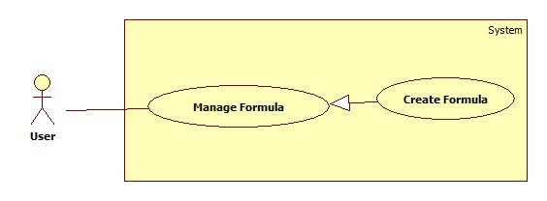

Figure 13: Create Formula

|  |  |  |  |
| --- | --- | --- | --- |
| **USE CASE – UF001** | | | |
| **Use Case No.** | **UF001** | **Use Case Version** | 2.0 |
| **Use Case Name** | Create formula | | |
| **Author** | Do Tan Liem | | |
| **Date** | 12/02/2014 | **Priority** | Normal |
| **Actor:** User  **Summary:**  This use case allow user create new formula.  **Goal:**  User create new formula  **Triggers:**   * User create new formula. * To create new fomular user must: * On Home page, click on button “Bắt đầu” in middle of the page and the welcome page will be shown. * Click the “Công thức” link on the left menu. * Select “Tạo mới” to begin create new formula. * Input “Tên công thức”, “Mô tả”, “Loại vật nuôi”, “Khối lượng pha trộn” * Press “Xác nhận” to create formula.   **Preconditions:**   * User must logged in the system. * There must be at least one ingredient in the user’s ingredient list.   **Post Conditions:**   * **Success:** Display the formula’s detail page * **Fail:** Display Error Page   **Main Success Scenario:**   |  |  |  | | --- | --- | --- | | No | Actor Action | System Response | | 1 | User go to “Công thức” page | Redirect to Formula list page, contains:   * List of formula display in thumbnails with: Image of animal and formula name. | | 2 | Click on “Tạo mới” button  [Alternative 1] | Redirect to Create formula page with:   * “Tên công thức”: textbox (min length: 1, max length: 50, required). * “Loại vật nuôi”: dropdownlist (value: all animal in database) * “Mô tả”: textarea(min length: 1, max length: 255) * “Khối lượng pha trộn”: up-down numeric (default: 100) * “Công khai công thức”: checkbox (default: non-checked) | | 3 | Input formula’s information, click “Xác nhận” button | Create formula, redirect to the created formula’s detail page. |   **Alternative Scenario:**   |  |  |  | | --- | --- | --- | | No | Actor Action | System Response | | 1 | [Alternative 1]  Click “Trở về” button | Redirect to formula list page. |   **Exceptions:**   |  |  |  | | --- | --- | --- | | No | Actor Action | System Response |   **Relationships:** Login,Manage Formula, View Formula’s Detail  **Business Rules: N/A** | | | |

Table 13: Create formula

##### View formular’s detail

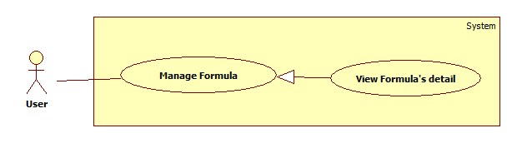

Figure 14: View formular’s detail

|  |  |  |  |
| --- | --- | --- | --- |
| **USE CASE – UF002** | | | |
| **Use Case No.** | **UF002** | **Use Case Version** | 2.0 |
| **Use Case Name** | View formula’s detail | | |
| **Author** | Do Tan Liem | | |
| **Date** | 12/02/2014 | **Priority** | Normal |
| **Actor:** User  **Summary:**  This use case allow user view formula’s detaiil.  **Goal:**  User view formula’s detail  **Triggers:**   * User view formula’s detail. * To view formula’s detail user must: * On Formula Management page, select formula from the list   **Preconditions:**   * User must logged in the system. * There must be at least one formula in the user’s formula list.   **Post Conditions:**   * **Success:** Display the formula’s detail page * **Fail:** Display Error Page   **Main Success Scenario:**   |  |  |  | | --- | --- | --- | | No | Actor Action | System Response | | 1 | User go to “Công thức” page | Redirect to Formula list page, contains:   * List of formula display in thumbnails with: Image of animal and formula name. | | 2 | Select a formula from the list | Redirect to formula detail page |   **Alternative Scenario: N/A**  **Exceptions: N/A**  **Relationships:** Login,Manage Formula, View Formula’s Detail  **Business Rules: N/A** | | | |

Table 14: View formula’s detail

##### Edit formular

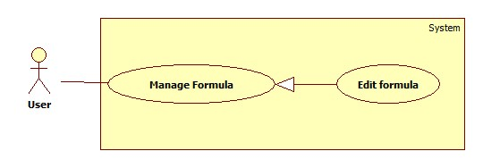

Figure 15: Edit formular

|  |  |  |  |
| --- | --- | --- | --- |
| **USE CASE – UF003** | | | |
| **Use Case No.** | **UF003** | **Use Case Version** | 2.0 |
| **Use Case Name** | Edit formula | | |
| **Author** | Do Tan Liem | | |
| **Date** | 12/02/2014 | **Priority** | Normal |
| **Actor:** User  **Summary:**  This use case allow user create new formula.  **Goal:**  User edit formula’s information  **Triggers:**   * User create new formula. * To create new fomular user must: * On Home page, click on button “Bắt đầu” in middle of the page and the welcome page will be shown. * Click the “Công thức” link on the left menu. * Select formula from the list * Press “Sửa” button. * Edit the formula’s information. * Press “Xác nhận” button.   **Preconditions:**   * User must logged in the system. * There must be at least one formula in the user’s formula list.   **Post Conditions:**   * **Success:** Display the formula’s detail page * **Fail:** Display Error Page   **Main Success Scenario:**   |  |  |  | | --- | --- | --- | | No | Actor Action | System Response | | 1 | User go to “Công thức” page | Redirect to Formula list page, contains:   * List of formula display in thumbnails with: Image of animal and formula name. | | 2 | Select a formula from the list  Press “Sửa” button | Redirect to edit formula page with:   * “Tên công thức”: textbox (min length: 1, max length: 50, required). * “Loại vật nuôi”: dropdownlist (value: all animal in database) * “Mô tả”: textarea(min length: 1, max length: 255) * “Khối lượng pha trộn”: up-down numeric (default: 100) * “Công khai công thức”: checkbox (default: non-checked) | | 3 | Input formula’s information, click “Xác nhận” button | Edit formula’s information, redirect to the created formula’s detail page. |   **Alternative Scenario:**   |  |  |  | | --- | --- | --- | | No | Actor Action | System Response | | 1 | [Alternative 1]  Click “Trở về” button | Redirect to formula detail page. |   **Exceptions:**   |  |  |  | | --- | --- | --- | | No | Actor Action | System Response |   **Relationships:** Login,Manage Formula, View Formula’s Detail  **Business Rules: N/A** | | | |

Table 15: Edit formula

##### Add Ingredient Constraint

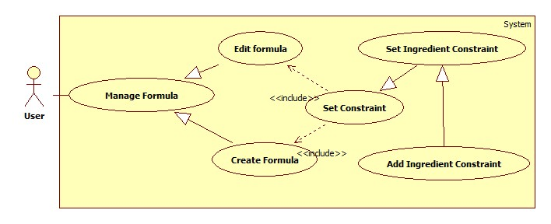

Figure 16: Add Ingredient Constraint

|  |  |  |  |
| --- | --- | --- | --- |
| **USE CASE – UF004** | | | |
| **Use Case No.** | **UF004** | **Use Case Version** | 2.0 |
| **Use Case Name** | Add Ingredient Constraint | | |
| **Author** | Do Tan Liem | | |
| **Date** | 12/02/2014 | **Priority** | Normal |
| **Actor:** User  **Summary:**  This use case allow user add ingredient constraint to formula.  **Goal:**  User add ingredient constraint to formula  **Triggers:**   * User add ingredient constraint to formula * To add ingredient constraint user must: * On formula detail page, select “Thiết lập” tab * On “Thiết lập” tab select “Nguyên liệu” tab * Select ingredient from the dropdownlist “Nguyên liệu”. * Edit min/max value * Click “Thêm” button   **Preconditions:**   * User must logged in the system. * There must be at least one formula in the user’s formula list.   **Post Conditions:**   * **Success:** Display the formula’s detail page * **Fail:** Display Error Page   **Main Success Scenario:**   |  |  |  | | --- | --- | --- | | No | Actor Action | System Response | | 1 | User select “Thiết lập” tab  User select “Nguyên liệu” tab | Redirect to formula detail page with | | 2 | Select Ingredient, input min/max value  Click “Thêm” button | Add ingredient constraint to formula  Display the ingredient constraint  The page should not reload |   **Alternative Scenario:**  **N/A**  **Exceptions:**   |  |  |  | | --- | --- | --- | |  | Actor Action | System Response | | 1 | Min value greater than Max value | “Giá trị tối đa không thể nhỏ hơn tối thiểu” |   **Relationships:** Login,Manage Formula, View Formula’s Detail  **Business Rules: N/A** | | | |

Table 16: Add Ingredient Constraint

##### Edit Ingredient Constraint

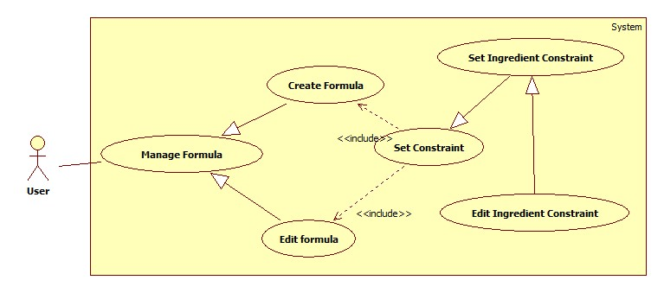

Figure 17: Edit Ingredient Constraint

|  |  |  |  |
| --- | --- | --- | --- |
| **USE CASE – UF005** | | | |
| **Use Case No.** | **UF005** | **Use Case Version** | 2.0 |
| **Use Case Name** | Edit Ingredient Constraint | | |
| **Author** | Do Tan Liem | | |
| **Date** | 12/02/2014 | **Priority** | Normal |
| **Actor:** User  **Summary:**  This use case allow user edit ingredient constraint of a formula.  **Goal:**  User edit ingredient constraint to formula  **Triggers:**   * User edit ingredient constraint of a formula * To edit ingredient constraint user must: * On formula detail page, select “Thiết lập” tab * On “Thiết lập” tab select “Nguyên liệu” tab * Click on value of constraint in the table to edit * Click  button to accept edit.   **Preconditions:**   * User must logged in the system. * There must be at least one formula in the user’s formula list.   **Post Conditions:**   * **Success:** Display the formula’s detail page * **Fail:** Display Error Page   **Main Success Scenario:**   |  |  |  | | --- | --- | --- | | No | Actor Action | System Response | | 1 | User select “Thiết lập” tab  User select “Nguyên liệu” tab | Redirect to formula detail page with | | 2 | Click on min/max value on ingredient constraint table | Change to value to textbox with button  and | | 3 | Edit value and click | Save the edited value to database, display new value, the page should not reload |   **Alternative Scenario:**   |  |  |  | | --- | --- | --- | | No | Actor Action | System Response | | 1 | [Alternative 1]  Click button | Revert to the old value |   **Exceptions:**   |  |  |  | | --- | --- | --- | | No | Actor Action | System Response |   **Relationships:** Login,Manage Formula, View Formula’s Detail  **Business Rules: N/A** | | | |

Table 17: Edit Ingredient Constraint

##### Remove Ingredient Constraint

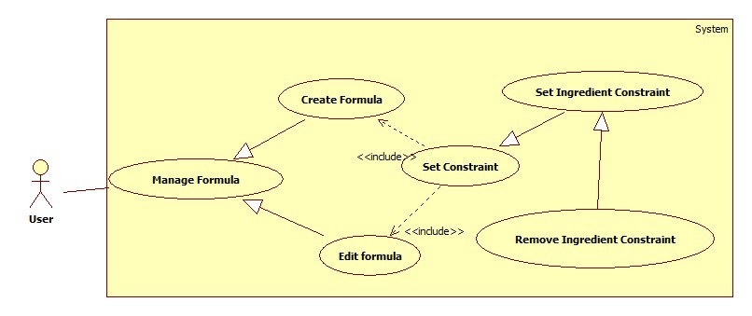

Figure 18: Remove Ingredient Constraint

|  |  |  |  |
| --- | --- | --- | --- |
| **USE CASE – UF006** | | | |
| **Use Case No.** | **UF006** | **Use Case Version** | 2.0 |
| **Use Case Name** | Remove Ingredient Constraiint | | |
| **Author** | Do Tan Liem | | |
| **Date** | 12/02/2014 | **Priority** | Normal |
| **Actor:** User  **Summary:**  This use case allow user remove ingredient constraint of formula.  **Goal:**  User remove ingredient constraint from formula  **Triggers:**   * User remove ingredient constraint from formula * To remove ingredient constraint user must: * On formula detail page, select “Thiết lập” tab * On “Thiết lập” tab select “Nguyên liệu” tab * Click  on the left of an ingredient   **Preconditions:**   * User must logged in the system. * There must be at least one formula in the user’s formula list.   **Post Conditions:**   * **Success:** Display the formula’s detail page * **Fail:** Display Error Page   **Main Success Scenario:**   |  |  |  | | --- | --- | --- | | No | Actor Action | System Response | | 1 | User select “Thiết lập” tab  User select “Nguyên liệu” tab | Redirect to formula detail page with | | 2 | Click  button | Remove the ingredient constraint which user clicked |   **Alternative Scenario:**   |  |  |  | | --- | --- | --- | | No | Actor Action | System Response |   **Exceptions:**   |  |  |  | | --- | --- | --- | | No | Actor Action | System Response |   **Relationships:** Login,Manage Formula, View Formula’s Detail  **Business Rules: N/A** | | | |

Table 18: Remove Ingredient Constraint

##### Add Nutrient Constraint

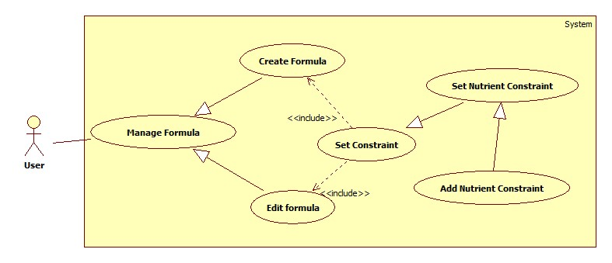

Figure 19: Add Nutrient Constraint

|  |  |  |  |
| --- | --- | --- | --- |
| **USE CASE – UF007** | | | |
| **Use Case No.** | **UF007** | **Use Case Version** | 2.0 |
| **Use Case Name** | Add Nutrient Constraint | | |
| **Author** | Do Tan Liem | | |
| **Date** | 12/02/2014 | **Priority** | Normal |
| **Actor:** User  **Summary:**  This use case allow user add nutrient constraint to formula.  **Goal:**  User add nutrient constraint to formula  **Triggers:**   * User add nutrient constraint to formula * To add nutrient constraint user must: * On formula detail page, select “Thiết lập” tab * On “Thiết lập” tab select “Dinh dưỡng” tab * Select ingredient from the dropdownlist “Dinh dưỡng”. * Edit min/max value * Click “Thêm” button   **Preconditions:**   * User must logged in the system. * There must be at least one formula in the user’s formula list.   **Post Conditions:**   * **Success:** Display the formula’s detail page * **Fail:** Display Error Page   **Main Success Scenario:**   |  |  |  | | --- | --- | --- | | No | Actor Action | System Response | | 1 | User select “Thiết lập” tab  User select “Dinh dưỡng” tab | Redirect to formula detail page with | | 2 | Select Ingredient, input min/max value  Click “Thêm” button | Add nutrient constraint to formula  Display the nutrient constraint  The page should not reload |   **Alternative Scenario:**  **N/A**  **Exceptions:**   |  |  |  | | --- | --- | --- | |  | Actor Action | System Response | | 1 | Min value greater than Max value | “Giá trị tối đa không thể nhỏ hơn tối thiểu” |   **Relationships:** Login,Manage Formula, View Formula’s Detail  **Business Rules: N/A** | | | |
| **USE CASE – UF007** | | | |
| **Use Case No.** | **UF007** | **Use Case Version** | 2.0 |
| **Use Case Name** | View formula’s detail | | |
| **Author** | Do Tan Liem | | |
| **Date** | 12/02/2014 | **Priority** | Normal |
| **Actor:** User  **Summary:**  This use case allow user create new formula.  **Goal:**  User create new formula  **Triggers:**   * User create new formula. * To create new fomular user must: * On Home page, click on button “Bắt đầu” in middle of the page and the welcome page will be shown. * Click the “Công thức” link on the left menu. * Select formula from the list   **Preconditions:**   * User must logged in the system. * There must be at least one formula in the user’s formula list.   **Post Conditions:**   * **Success:** Display the formula’s detail page * **Fail:** Display Error Page   **Main Success Scenario:**   |  |  |  | | --- | --- | --- | | No | Actor Action | System Response | | 1 | User go to “Công thức” page | Redirect to Formula list page, contains:   * List of formula display in thumbnails with: Image of animal and formula name. | | 2 | Select a formula from the list | Redirect to formula detail page with | | 3 | Input formula’s information, click “Xác nhận” button | Edit formula’s information, redirect to the created formula’s detail page. |   **Alternative Scenario:**   |  |  |  | | --- | --- | --- | | No | Actor Action | System Response | | 1 | [Alternative 1]  Click “Trở về” button | Redirect to formula detail page. |   **Exceptions:**   |  |  |  | | --- | --- | --- | | No | Actor Action | System Response |   **Relationships:** Login,Manage Formula, View Formula’s Detail  **Business Rules: N/A** | | | |

Table 19: View formula’s detail

##### Edit Nutrient Constraint

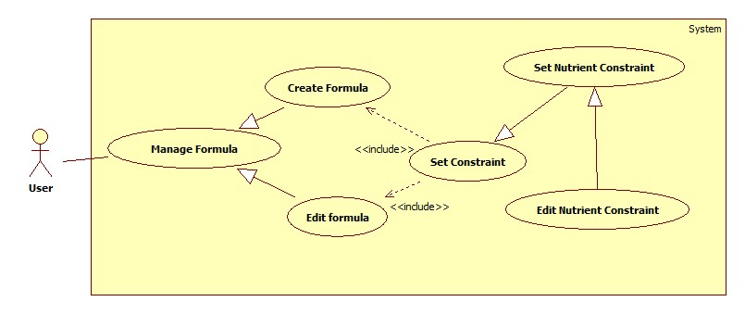

Figure 20: Edit Nutrient Constraint

|  |  |  |  |
| --- | --- | --- | --- |
| **USE CASE – UF008** | | | |
| **Use Case No.** | **UF008** | **Use Case Version** | 2.0 |
| **Use Case Name** | Edit Nutrient Constraint | | |
| **Author** | Do Tan Liem | | |
| **Date** | 12/02/2014 | **Priority** | Normal |
| **Actor:** User  **Summary:**  This use case allow user edit nutrient constraint of a formula.  **Goal:**  User edit nutrient constraint of a formula  **Triggers:**   * User edit nutrient constraint of formula * To edit nutrient constraint user must: * On formula detail page, select “Thiết lập” tab * On “Thiết lập” tab select “Dinh dưỡng” tab * Click on value of constraint in the table to edit * Click  button to accept edit.   **Preconditions:**   * User must logged in the system. * There must be at least one formula in the user’s formula list.   **Post Conditions:**   * **Success:** Display the formula’s detail page * **Fail:** Display Error Page   **Main Success Scenario:**   |  |  |  | | --- | --- | --- | | No | Actor Action | System Response | | 1 | User select “Thiết lập” tab  User select “Dinh dưỡng” tab | Redirect to formula detail page with | | 2 | Click on min/max value on nutrient constraint table | Change to value to textbox with button  and | | 3 | Edit value and click | Save the edited value to database, display new value, the page should not reload |   **Alternative Scenario:**   |  |  |  | | --- | --- | --- | | No | Actor Action | System Response | | 1 | [Alternative 1]  Click button | Revert to the old value |   **Exceptions:**   |  |  |  | | --- | --- | --- | | No | Actor Action | System Response |   **Relationships:** Login,Manage Formula, View Formula’s Detail  **Business Rules: N/A** | | | |
| **USE CASE – UF008** | | | |
| **Use Case No.** | **UF008** | **Use Case Version** | 2.0 |
| **Use Case Name** | View formula’s detail | | |
| **Author** | Do Tan Liem | | |
| **Date** | 12/02/2014 | **Priority** | Normal |
| **Actor:** User  **Summary:**  This use case allow user create new formula.  **Goal:**  User create new formula  **Triggers:**   * User create new formula. * To create new fomular user must: * On Home page, click on button “Bắt đầu” in middle of the page and the welcome page will be shown. * Click the “Công thức” link on the left menu. * Select formula from the list   **Preconditions:**   * User must logged in the system. * There must be at least one formula in the user’s formula list.   **Post Conditions:**   * **Success:** Display the formula’s detail page * **Fail:** Display Error Page   **Main Success Scenario:**   |  |  |  | | --- | --- | --- | | No | Actor Action | System Response | | 1 | User go to “Công thức” page | Redirect to Formula list page, contains:   * List of formula display in thumbnails with: Image of animal and formula name. | | 2 | Select a formula from the list | Redirect to formula detail page with | | 3 | Input formula’s information, click “Xác nhận” button | Edit formula’s information, redirect to the created formula’s detail page. |   **Alternative Scenario:**   |  |  |  | | --- | --- | --- | | No | Actor Action | System Response | | 1 | [Alternative 1]  Click “Trở về” button | Redirect to formula detail page. |   **Exceptions:**   |  |  |  | | --- | --- | --- | | No | Actor Action | System Response |   **Relationships:** Login,Manage Formula, View Formula’s Detail  **Business Rules: N/A** | | | |

Table 20: Edit Nutrient Constraint

##### Remove Nutrient Constraint

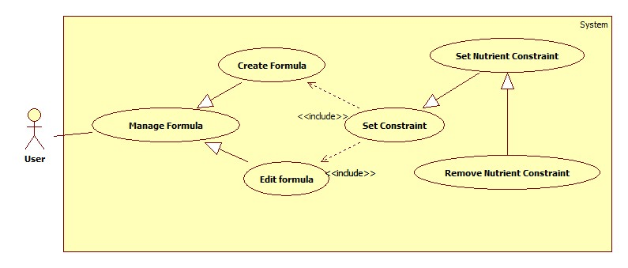

Figure 21: Remove Nutrient Constraint

|  |  |  |  |
| --- | --- | --- | --- |
| **USE CASE – UF009** | | | |
| **Use Case No.** | **UF009** | **Use Case Version** | 2.0 |
| **Use Case Name** | Remove Nutrient Constraiint | | |
| **Author** | Do Tan Liem | | |
| **Date** | 12/02/2014 | **Priority** | Normal |
| **Actor:** User  **Summary:**  This use case allow user remove nutrient constraint of formula.  **Goal:**  User remove nutrient constraint from formula  **Triggers:**   * User remove nutrient constraint from formula * To remove nutrient constraint user must: * On formula detail page, select “Thiết lập” tab * On “Thiết lập” tab select “Dinh dưỡng” tab * Click  on the left of an nutrient constraint   **Preconditions:**   * User must logged in the system. * There must be at least one formula in the user’s formula list.   **Post Conditions:**   * **Success:** Display the formula’s detail page * **Fail:** Display Error Page   **Main Success Scenario:**   |  |  |  | | --- | --- | --- | | No | Actor Action | System Response | | 1 | User select “Thiết lập” tab  User select “Nguyên liệu” tab | Redirect to formula detail page with | | 2 | Click  button | Remove the nutrient constraint which user clicked |   **Alternative Scenario:**   |  |  |  | | --- | --- | --- | | No | Actor Action | System Response |   **Exceptions:**   |  |  |  | | --- | --- | --- | | No | Actor Action | System Response |   **Relationships:** Login,Manage Formula, View Formula’s Detail  **Business Rules: N/A** | | | |
| **USE CASE – UF009** | | | |
| **Use Case No.** | **UF009** | **Use Case Version** | 2.0 |
| **Use Case Name** | View formula’s detail | | |
| **Author** | Do Tan Liem | | |
| **Date** | 12/02/2014 | **Priority** | Normal |
| **Actor:** User  **Summary:**  This use case allow user create new formula.  **Goal:**  User create new formula  **Triggers:**   * User create new formula. * To create new fomular user must: * On Home page, click on button “Bắt đầu” in middle of the page and the welcome page will be shown. * Click the “Công thức” link on the left menu. * Select formula from the list   **Preconditions:**   * User must logged in the system. * There must be at least one formula in the user’s formula list.   **Post Conditions:**   * **Success:** Display the formula’s detail page * **Fail:** Display Error Page   **Main Success Scenario:**   |  |  |  | | --- | --- | --- | | No | Actor Action | System Response | | 1 | User go to “Công thức” page | Redirect to Formula list page, contains:   * List of formula display in thumbnails with: Image of animal and formula name. | | 2 | Select a formula from the list | Redirect to formula detail page with | | 3 | Input formula’s information, click “Xác nhận” button | Edit formula’s information, redirect to the created formula’s detail page. |   **Alternative Scenario:**   |  |  |  | | --- | --- | --- | | No | Actor Action | System Response | | 1 | [Alternative 1]  Click “Trở về” button | Redirect to formula detail page. |   **Exceptions:**   |  |  |  | | --- | --- | --- | | No | Actor Action | System Response |   **Relationships:** Login,Manage Formula, View Formula’s Detail  **Business Rules: N/A** | | | |

Table 21: View formula’s detail

##### Calculate Formula

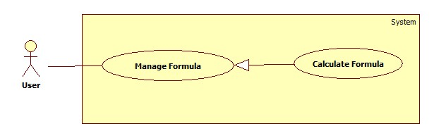

Figure 22: Calculate Formula

|  |  |  |  |
| --- | --- | --- | --- |
| **USE CASE – UF010** | | | |
| **Use Case No.** | **UF010** | **Use Case Version** | 2.0 |
| **Use Case Name** | Calculate Formula | | |
| **Author** | Do Tan Liem | | |
| **Date** | 12/02/2014 | **Priority** | Normal |
| **Actor:** User  **Summary:**  This use case allow user create new formula.  **Goal:**  User create new formula  **Triggers:**   * User calculate a formula. * To calculate fomular user must: * On List formula page, select a formula from the list * Click “Tính” button   **Preconditions:**   * User must logged in the system. * There must be at least one formula in the user’s formula list. * User must add at least one ingredient constraint to the formula.   **Post Conditions:**   * **Success:** Display the formula’s detail page * **Fail:** Display Error Page   **Main Success Scenario:**   |  |  |  | | --- | --- | --- | | No | Actor Action | System Response | | 1 | User go to list formula page | Redirect to Formula list page, contains:   * List of formula display in thumbnails with: Image of animal and formula name. | | 2 | Select a formula from the list | Redirect to formula detail page with | | 3 | Input Ingredient/Nutrient constraint.  Click “Tính” button  [Alternative 1] | System calculate formula and display result to user with chart view illustrate. |   **Alternative Scenario:**   |  |  |  | | --- | --- | --- | | No | Actor Action | System Response | | 1 | [Alternative 1]  Cannot solve the formula | Display error message. |   **Exceptions:**  N/A  **Relationships:** Login,Manage Formula, View Formula’s Detail  **Business Rules: N/A** | | | |

Table 22: Calculate Formula

##### View Result

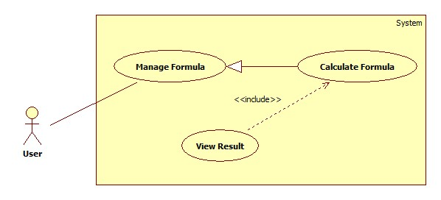

Figure 23: View Result

|  |  |  |  |
| --- | --- | --- | --- |
| **USE CASE – UF011** | | | |
| **Use Case No.** | **UF011** | **Use Case Version** | 2.0 |
| **Use Case Name** | View result | | |
| **Author** | Do Tan Liem | | |
| **Date** | 12/02/2014 | **Priority** | Normal |
| **Actor:** User  **Summary:**  This use case allow user view formula’s result.  **Goal:**  User view formula’s result  **Triggers:**   * User view formula’s result. * To view formula’s result user must: * On Formula Management page, select formula from the list   **Preconditions:**   * User must logged in the system. * There must be at least one calculated formula in the user’s formula list.   **Post Conditions:**   * **Success:** Display the formula’s detail page * **Fail:** Display Error Page   **Main Success Scenario:**   |  |  |  | | --- | --- | --- | | No | Actor Action | System Response | | 1 | User go to “Công thức” page | Redirect to Formula list page, contains:   * List of formula display in thumbnails with: Image of animal and formula name. | | 2 | Select a formula from the list | Redirect to formula detail page | | 3 | Click on “Kết quả” tab | Display result to user |   **Alternative Scenario:**   |  |  |  | | --- | --- | --- | | No | Actor Action | System Response | | 1 | [Alternative 1] |  |   **Exceptions: N/A**  **Relationships:** Login,Manage Formula, View Formula’s Detail  **Business Rules: N/A** | | | |

Table 23: View result

##### Export Result

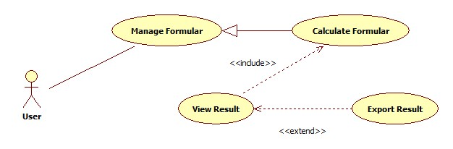

Figure 24: Export Result

|  |  |  |  |
| --- | --- | --- | --- |
| **USE CASE – UF011** | | | |
| **Use Case No.** | **UF011** | **Use Case Version** | 2.0 |
| **Use Case Name** | Export result | | |
| **Author** | Do Tan Liem | | |
| **Date** | 12/02/2014 | **Priority** | Normal |
| **Actor:** User  **Summary:**  This use case allow user export formula’s result.  **Goal:**  User export formula’s result  **Triggers:**   * User export formula’s result. * To export formula’s result user must: * On Formula Management page, select formula from the list   **Preconditions:**   * User must logged in the system. * There must be at least one calculated formula in the user’s formula list.   **Post Conditions:**   * **Success:** export the formula’s result * **Fail:** Display Error Page   **Main Success Scenario:**   |  |  |  | | --- | --- | --- | | No | Actor Action | System Response | | 1 | User go to “Công thức” page | Redirect to Formula list page, contains:   * List of formula display in thumbnails with: Image of animal and formula name. | | 2 | Select a formula from the list | Redirect to formula detail page | | 3 | Click on “Print” button  Select Excel or PDF | Export result to user |   **Alternative Scenario:**   |  |  |  | | --- | --- | --- | | No | Actor Action | System Response | | 1 | [Alternative 1] |  |   **Exceptions: N/A**  **Relationships:** Login,Manage Formula, View Formula’s Detail  **Business Rules: N/A** | | | |

Table 24: Export result

#### Manage Article Use Case



Figure 25: Manage Article Use Case

##### Create article



Figure 26: Create article

|  |  |  |  |
| --- | --- | --- | --- |
| **USE CASE – AR001** | | | |
| **Use Case No.** | AR001 | **Use Case Version** | 2.0 |
| **Use Case Name** | Create article | | |
| **Author** | Nguyen Bao Duy | | |
| **Date** | 27/02/2014 | **Priority** | Normal |
| **Actor:** Admin.  **Summary:**  This Use Case is used to create new article  **Goal:**  Create new article  **Triggers:**   * User want to create article * User go to Administrator page, click in button “Tạo bài viết mới”.   **Preconditions:** Log in as administrator role.  **Post Conditions:**   * **Success:** Redirect to article content. * **Fail:** System will transfer to error page or still in current page.   **Main Success Scenario:**   |  |  |  | | --- | --- | --- | | Step | Actor Action | System Response | | 1 | User go to “Tạo bài viết mới” page. | System show “Tạo bài viết mới” page includes:   * “Tiêu đề”: [Title: textbox, require] * “Chuyên đề”: [CategoryId: dropdownlist, require] * “Nội dung bài viết”: [Content: Editor, require] * Tag(s): [TagId: dropdownlist, optional] | | 2 | Click “Đăng bài” | Redirect to show content page this article |   **Alternative Scenario:** N/A  **Exceptions:** N/A  **Relationships:** N/A  **Business Rules:** | | | |

Table 25: Create article

##### Edit article



Figure 27: Edit article

|  |  |  |  |
| --- | --- | --- | --- |
| **USE CASE – AR002** | | | |
| **Use Case No.** | AR002 | **Use Case Version** | 2.0 |
| **Use Case Name** | Edit article | | |
| **Author** | Nguyen Bao Duy | | |
| **Date** | 27/02/2014 | **Priority** | Normal |
| **Actor:** Admin.  **Summary:**  This Use Case is used to edit an article  **Goal:**  User modify title, category, tag or content of an article.  **Triggers:**   * dfd   **Preconditions:** Log in as administrator role.  **Post Conditions:**   * **Success:** Redirect to article content. * **Fail:** System will transfer to error page or still in current page.   **Main Success Scenario:**   |  |  |  | | --- | --- | --- | | Step | Actor Action | System Response | | 1 | User views content of an article.  If user login as “Administrator” role, show Edit button.  Click “Edit” button, go to “Chỉnh sửa bài viết” page. | System show “Chỉnh sửa bài viết” page includes:   * “Tiêu đề”: [Title: textbox, require] * “Chuyên đề”: [CategoryId: dropdownlist, require] * “Nội dung bài viết”: [Content: Editor, require] * Tag(s): [TagId: dropdownlist, optional] | | 2 | Click “Hoàn thành” | Redirect to show content page this article |   **Alternative Scenario:** N/A  **Exceptions:** N/A  **Relationships:** View article content  **Business Rules: N/A** | | | |

Table 26: Edit article

##### View article content



Figure 28: View article content

|  |  |  |  |
| --- | --- | --- | --- |
| **USE CASE – AR003** | | | |
| **Use Case No.** | AR003 | **Use Case Version** | 2.0 |
| **Use Case Name** | View article content | | |
| **Author** | Nguyen Bao Duy | | |
| **Date** | 27/02/2014 | **Priority** | Normal |
| **Actor:**User.  **Summary:**  This Use Case is used to show article content  **Goal:**  Show total content in an article.  **Triggers:**   * User wants to read total content of an article.   **Preconditions:** N/A.  **Post Conditions:**   * **Success:** Go to content page. * **Fail:** System will transfer to error page or still in current page.   **Main Success Scenario:**   |  |  |  | | --- | --- | --- | | Step | Actor Action | System Response | | 1 | Click in title of any article in home page or list of article | Show content page of this article. |   **Alternative Scenario:** N/A  **Exceptions:** N/A  **Relationships:** N/A  **Business Rules:** N/A | | | |

Table 27: View article content

##### Delete article



Figure 29: Delete article

|  |  |  |  |
| --- | --- | --- | --- |
| **USE CASE – AR004** | | | |
| **Use Case No.** | AR004 | **Use Case Version** | 2.0 |
| **Use Case Name** | Delete article | | |
| **Author** | Nguyen Bao Duy | | |
| **Date** | 27/02/2014 | **Priority** | Normal |
| **Actor:** Admin  **Summary:**  This Use Case is used to delete article  **Goal:**  Administrator don’t want to show this article  **Triggers:**   * View content of an article. * If user logged in as Admin role, show delete button. Admin click in delete button   **Preconditions:** Log in as administrator role.  **Post Conditions:**   * **Success:** Redirect to list of all article. * **Fail:** System will transfer to error page or still in current page.   **Main Success Scenario:**   |  |  |  | | --- | --- | --- | | Step | Actor Action | System Response | | 1 | Go to content page | Show content of this article. Include 2 button “Sửa” or “Xóa” | | 2. | Click “Xóa” button | Go to list of articles page. |   **Alternative Scenario:** N/A  **Exceptions:** N/A  **Relationships:** View article content  **Business Rules:** | | | |

Table 28: Delete article

##### Comment



Figure 30: Comment

|  |  |  |  |
| --- | --- | --- | --- |
| **USE CASE – AR005** | | | |
| **Use Case No.** | AR005 | **Use Case Version** | 2.0 |
| **Use Case Name** | Comment in article | | |
| **Author** | Nguyen Bao Duy | | |
| **Date** | 27/02/2014 | **Priority** | Normal |
| **Actor:** User.  **Summary:**  This Use Case is used to comment in article  **Goal:**  Comment in article  **Triggers:**   * User views article and want to comment * User goes to article content, input content in editor in “Bình luận” tab. Click “Bình luận” to submit/   **Preconditions:** User had logged in.  **Post Conditions:**   * **Success:** Redirect to article content. * **Fail:** System will transfer to error page or still in current page.   **Main Success Scenario:**   |  |  |  | | --- | --- | --- | | Step | Actor Action | System Response | | 1 | Go to article content page | Show article content include article comment:   * “Đăng bình luận mới”:[Content: editor, require] * Button “Hoàn thành” | | 2 | Click “Hoàn thành” button | Add new comment in “Bình luận” tab |   **Alternative Scenario:** N/A  **Exceptions:** N/A  **Relationships:** View article content  **Business Rules:** N/A | | | |

Table 29: Delete article

##### Add new article category



Figure 31: Add new article category

|  |  |  |  |
| --- | --- | --- | --- |
| **USE CASE – AR006** | | | |
| **Use Case No.** | AR006 | **Use Case Version** | 2.0 |
| **Use Case Name** | Add new article category | | |
| **Author** | Nguyen Bao Duy | | |
| **Date** | 27/02/2014 | **Priority** | Normal |
| **Actor:** Admin.  **Summary:**  This Use Case is used to manage category of article  **Goal:**  Admin use to add new category of article.  **Triggers:**   * Admin click in a “Chuyên đề” * Add new: add new category * Edit: edit category   **Preconditions:** Log in as administrator role.  **Post Conditions:**   * **Success:** Show message “Chuyên đề <Name> đã được thêm”. * **Fail:** System will transfer to error page or still in current page.   **Main Success Scenario:**   |  |  |  | | --- | --- | --- | | Step | Actor Action | System Response | | 1 | Admin clink in “Chuyên đề” | Show list of category of article include “Thêm” button, “Chỉnh sửa” button | | 2 | Click “Thêm” button | Show modal include:   * “Chuyên đề”:[Name: textbox, require] * Button “Thêm” |   **Alternative Scenario:** N/A  **Exceptions:** N/A  **Relationships: N/A**  **Business Rules: N/A** | | | |

Table 30: Add new article category

##### Edit article category



Figure 32: Edit article category

|  |  |  |  |
| --- | --- | --- | --- |
| **USE CASE – AR007** | | | |
| **Use Case No.** | AR007 | **Use Case Version** | 2.0 |
| **Use Case Name** | Edit category | | |
| **Author** | Nguyen Bao Duy | | |
| **Date** | 27/02/2014 | **Priority** | Normal |
| **Actor:** Admin.  **Summary:**  This Use Case is used to edit category of article  **Goal:**  Admin use to edit category of article.  **Triggers:**   * Admin click in a “Chuyên đề” * Add new: add new category * Edit: edit category   **Preconditions:** Log in as administrator role.  **Post Conditions:**   * **Success:** Show message “Chuyên đề <Name> đã sửa thành công”. * **Fail:** System will transfer to error page or still in current page.   **Main Success Scenario:**   |  |  |  | | --- | --- | --- | | Step | Actor Action | System Response | | 1 | Admin clink in “Chuyên đề” | Show list of category of article include “Thêm” button, “Chỉnh sửa” button in each line of category. | | 2 | Click “Chỉnh sửa” button in one line | Show modal include:   * “Chuyên đề”:[Name: textbox, require] * Button “Sửa” |   **Alternative Scenario:** N/A  **Exceptions:** N/A  **Relationships: N/A**  **Business Rules:N/A** | | | |

Table 31: Edit article category

##### Delete article category

|  |  |  |  |
| --- | --- | --- | --- |
| **USE CASE – AR008** | | | |
| **Use Case No.** | AR008 | **Use Case Version** | 2.0 |
| **Use Case Name** | Delete article category | | |
| **Author** | Nguyen Bao Duy | | |
| **Date** | 27/02/2014 | **Priority** | Normal |
| **Actor:** Admin.  **Summary:**  This Use Case is used to delete category of article  **Goal:**  Admin use to delete category of article.  **Triggers:**   * Admin click in a “Chuyên đề” * Add new: add new category * Edit: edit category * Delete: delete category   **Preconditions:** Log in as administrator role.  **Post Conditions:**   * **Success:** Show message “Chuyên đề <Name> đã xóa thành công”. * **Fail:** System will transfer to error page or still in current page.   **Main Success Scenario:**   |  |  |  | | --- | --- | --- | | Step | Actor Action | System Response | | 1 | Admin clink in “Chuyên đề” | Show list of category of article include “Thêm” button, “Chỉnh sửa” button, “Xóa” button in each line of category. | | 2 | Click “Xóa” button | Show popup to confirm | | 3 | Click Ok button | Delete this nutrient type. |   **Alternative Scenario:** N/A  **Exceptions:** N/A  **Relationships: N/A**  **Business Rules: N/A** | | | |

Table 32: Delete article category

##### List article by category



Figure 33: List article by category

|  |  |  |  |
| --- | --- | --- | --- |
| **USE CASE – AR009** | | | |
| **Use Case No.** | AR009 | **Use Case Version** | 2.0 |
| **Use Case Name** | List article by category | | |
| **Author** | Nguyen Bao Duy | | |
| **Date** | 27/02/2014 | **Priority** | Normal |
| **Actor:** User  **Summary:**  This Use Case is used to view article by category  **Goal:**  User wants to view list article by category  **Triggers:**   * User wants to view article by category. * In list of article or article content show box “Chuyên đề” content all category. * User clicks on category in box “Chuyên đề”. Show all article by this category.   **Preconditions:** N/A.  **Post Conditions:**   * **Success:** Show list article by an category * **Fail:** System will transfer to error page or still in current page**.**   **Main Success Scenario:**   |  |  |  | | --- | --- | --- | | Step | Actor Action | System Response | | 1 | Go to Article list or article content | Show content include box “Chuyên đề”. | | 2 | Click on an category | Show all article of this category |   **Alternative Scenario:** N/A  **Exceptions:** N/A  **Relationships:**  **Business Rules:** | | | |

Table 33: List article by category

##### List article by tag



Figure 34: List article by tag

|  |  |  |  |
| --- | --- | --- | --- |
| **USE CASE – AR010** | | | |
| **Use Case No.** | AR010 | **Use Case Version** | 2.0 |
| **Use Case Name** | List article by tag | | |
| **Author** | Nguyen Bao Duy | | |
| **Date** | 27/02/2014 | **Priority** | Normal |
| **Actor:** User.  **Summary:**  This Use Case is used to view article by tag  **Goal:**  User wants to view article by tag.  **Triggers:**   * User wants to view article has this tag. * In each articles have tags. * User clicks on tag have in an article. Show all article have this tag.   **Preconditions:** N/A.  **Post Conditions:**   * **Success:** Show all article has this tag * **Fail:** System will transfer to error page or still in current page**.**   **Main Success Scenario:**   |  |  |  | | --- | --- | --- | | Step | Actor Action | System Response | | 1 | Go to Article list or article content (use case AR003) | Show content included tag(s). | | 2 | Click on one tag | Show all article has this tag |   **Alternative Scenario:** N/A  **Exceptions:** N/A  **Relationships:**  **Business Rules:** | | | |

Table 34: List article by tag

##### List Relate Article



Figure 35: List Relate Article

|  |  |  |  |
| --- | --- | --- | --- |
| **USE CASE – AR011** | | | |
| **Use Case No.** | AR011 | **Use Case Version** | 2.0 |
| **Use Case Name** | List Relate Article | | |
| **Author** | Nguyen Bao Duy | | |
| **Date** | 27/02/2014 | **Priority** | Normal |
| **Actor:** User.  **Summary:**  This Use Case is used to view relate article of an article  **Goal:**  User want to view relate article of an article.  **Triggers:**   * In each articles content has box “Bài viết liên quan” has list of article related with this article. * User clicks on article in box “Bài viết liên quan”. Show this article content.   **Preconditions:** N/A.  **Post Conditions:**   * **Success:** Show list article related with this article * **Fail:** System will transfer to error page or still in current page**.**   **Main Success Scenario:**   |  |  |  | | --- | --- | --- | | Step | Actor Action | System Response | | 1 | Go to view an article content | Show content included box “Bài viết liên quan” | | 2 | User clicks on article in box “Bài viết liên quan”. | Show this article content of this article. |   **Alternative Scenario:** N/A  **Exceptions:** N/A  **Relationships:**  **Business Rules:** | | | |

Table 35: List relate article

#### Question and Answer Use Case

##### Overview Use Case



Figure 36: Overview Use Case

##### View The Answer Use Case



Figure 37: View The Answer Use Case

|  |  |  |  |
| --- | --- | --- | --- |
| **USE CASE – QA001** | | | |
| **Use Case No.** | QA001 | **Use Case Version** | 1.0 |
| **Use Case Name** | View The Answer | | |
| **Author** | Nguyễn Hữu Phúc | | |
| **Date** | 26/02/2014 | **Priority** | Normal |
| **Actor:**   * User   **Summary:**   * User can view answer of question.   **Goal:**   * Helps user can view answer of question.   **Triggers:**   * User wants to see the answer of question * User goes to “Cộng Đồng” page. User clicks on Title of question to view answer of question   **Preconditions:**  **Post Conditions:**   * **Success**: Detail page of question was shown. * **Fail:** System will transfer to error page or still in current page.   **Main Success Scenario:**   |  |  |  | | --- | --- | --- | | Step | Actor Action | System Response | | 1 | User goes to “Cộng Đồng” page and click on Title of question that user want to see more | System will show the detail page of that question and show some answer of that question. |   **Alternative Scenario:** N/A  **Exceptions:**   * System will transfer to error page or still in current page.   **Relationships:**   * N/A   **Business Rules:** | | | |

Table 36: View The Answer

##### Filter by Tag Use Case



Figure 38: Filter by Tag Use Case

|  |  |  |  |
| --- | --- | --- | --- |
| **USE CASE – QA003** | | | |
| **Use Case No.** | QA003 | **Use Case Version** | 1.0 |
| **Use Case Name** | Filter By Tag | | |
| **Author** | Nguyễn Hữu Phúc | | |
| **Date** | 26/02/2014 | **Priority** | Normal |
| **Actor:**   * User   **Summary:**   * User can view list question fitter by tag.   **Goal:**   * Helps user can view detail of question.   **Triggers:**   * User wants to see the question clearly * User goes to “Cộng Đồng” page. User clicks on Title of question to view detail of question   **Preconditions:**  **Post Conditions:**   * **Success**: Detail page of question was shown. * **Fail:** System will transfer to error page or still in current page.   **Main Success Scenario:**   |  |  |  | | --- | --- | --- | | Step | Actor Action | System Response | | 1 | User goes to “Cộng Đồng” page and click on Title of question that user want to see more | System will show the detail page of that question |   **Alternative Scenario:** N/A  **Exceptions:**   * System will transfer to error page or still in current page.   **Relationships:**   * N/A   **Business Rules:** | | | |

Table 37: Filter By Tag

##### Get Relative Question Use Case



Figure 39: Get Relative Question Use Case

|  |  |  |  |
| --- | --- | --- | --- |
| **USE CASE - QA004** | | | |
| **Use Case No.** | QA004 | **Use Case Version** | 1.0 |
| **Use Case Name** | Get Relative Post | | |
| **Author** | Nguyễn Hữu Phúc | | |
| **Date** | 26/02/2014 | **Priority** | Normal |
| **Actor:**   * User   **Summary:**   * User can see some relative question with user’s question   **Goal:**   * Helps user can sort some relative questions.   **Triggers:**   * User wants to see some relative question. * User goes to “Cộng Đồng” page. User clicks on title of question, system will show the details of that questions, the user can see “Các Bài Liên Quan” topic and click on some link on this to see some relative questions.   **Preconditions**  **Post Conditions:**   * **Success**: The detail of relative question will show. * **Fail:** System will transfer to error page or still in current page.   **Main Success Scenario:**   |  |  |  | | --- | --- | --- | | Step | Actor Action | System Response | | 1 | User goes to “Cộng Đồng” page and click on title of question | System will detail page of that question. | | 2 | Use clicks on some action link above “Các Bài Liên Quan” topic | System will show new page detail with relative question. |   **Alternative Scenario:** N/A  **Exceptions:**   * System will transfer to error page or still in current page.   **Relationships:**   * N/A   **Business Rules:** | | | |

Table 38: Get Relative Post

##### Add New Question Use Case



Figure 40: Add New Question Use Case

|  |  |  |  |
| --- | --- | --- | --- |
| **USE CASE - QA005** | | | |
| **Use Case No.** | QA005 | **Use Case Version** | 1.0 |
| **Use Case Name** | Add New Question | | |
| **Author** | Nguyễn Hữu Phúc | | |
| **Date** | 26/02/2014 | **Priority** | Normal |
| **Actor:**   * User   **Summary:**   * User can add new question.   **Goal:**   * Helps user can add new question to resolve user’s problem.   **Triggers:**   * User wants to add new question. * User goes to “Cộng Đồng” page. User clicks on “Câu Hỏi Mới ” link then user fill information in “Tiêu đề”,”Nội dung bài viết”, “Tag” and click on “Đăng Bài” button to post question.   **Preconditions:**   * User must logged in the system.   **Post Conditions:**   * **Success**: New question were added and show in “Cộng Đồng” page . * **Fail:** System will transfer to error page or still in current page.   **Main Success Scenario:**   |  |  |  | | --- | --- | --- | | Step | Actor Action | System Response | | 1 | User goes to “Cộng Đồng” page and click on “Câu Hỏi Mới” link. | System will show new page for user to add new question with “Tiêu Đề”, “Nội Dung Bài Viết”,”Tag”. | | 2 | After user fill full the information into the blank, user clicks “Đăng Bài” | System will return to “Cộng Đồng ” page and show the new question |   **Alternative Scenario:** N/A  **Exceptions:**   * System will transfer to error page or still in current page.   **Relationships:**   * N/A   **Business Rules:** | | | |

Table 39: Add New Question

##### Edit Question Use Case



Figure 41: Edit Question Use Case

|  |  |  |  |
| --- | --- | --- | --- |
| **USE CASE - QA006** | | | |
| **Use Case No.** | QA006 | **Use Case Version** | 1.0 |
| **Use Case Name** | Edit Question | | |
| **Author** | Nguyễn Hữu Phúc | | |
| **Date** | 26/02/2014 | **Priority** | Normal |
| **Actor:**   * User   **Summary:**   * User can edit question.   **Goal:**   * Helps user can edit information of question that user posted.   **Triggers:**   * User wants to edit question that user posted. * User goes to “Cộng Đồng” page. User clicks on Title of question to view detail of question and user click on “Sửa” button to go edit page to modify question.   **Preconditions:**   * User must logged in the system.   **Post Conditions:**   * **Success**: The detail page show with new information from user * **Fail:** System will transfer to error page or still in current page.   **Main Success Scenario:**   |  |  |  | | --- | --- | --- | | Step | Actor Action | System Response | | 1 | User goes to “Cộng Đồng” page and click on Title of question that user want to see more | System will show the detail page of that question | | 2 | User click on “Sửa” button | System will show edit page | | 3 | User modify question with “Tiêu Đề”, “Nội Dung”, “Tag” and click “Lưu” button | System will return to detail page with new question that user modified |   **Alternative Scenario:** N/A  **Exceptions:**   * System will transfer to error page or still in current page.   **Relationships:**   * N/A   **Business Rules:** | | | |

Table 40: Edit Question

##### Delete Question Use Case



Figure 42: Delete Question Use Case

|  |  |  |  |
| --- | --- | --- | --- |
| **USE CASE - QA007** | | | |
| **Use Case No.** | QA007 | **Use Case Version** | 1.0 |
| **Use Case Name** | Delete Question | | |
| **Author** | Nguyễn Hữu Phúc | | |
| **Date** | 26/02/2014 | **Priority** | Normal |
| **Actor:**   * User   **Summary:**   * User can delete question.   **Goal:**   * Helps user can delete information of question that user posted.   **Triggers:**   * User wants to delete question that user posted. * User goes to “Cộng Đồng” page. User clicks on Title of question to view detail of question and user click on “Xóa” button to delete question.   **Preconditions:**   * User must logged in the system.   **Post Conditions:**   * **Success**: The “Cộng Đồng ” page show and the question was deleted. * **Fail:** System will transfer to error page or still in current page.   **Main Success Scenario:**   |  |  |  | | --- | --- | --- | | Step | Actor Action | System Response | | 1 | User goes to “Cộng Đồng” page and click on Title of question that user want to see more | System will show the detail page of that question | |  | User click on “Xóa” button | System will retrun “Cộng Đồng” page and question was deleted. |   **Alternative Scenario:** N/A  **Exceptions:**   * System will transfer to error page or still in current page.5   **Relationships:**   * N/A   **Business Rules:** | | | |

Table 41: Delete Question

##### Add Answer Use Case



Figure 43: Add Answer Use Case

|  |  |  |  |
| --- | --- | --- | --- |
| **USE CASE -** QA008 | | | |
| **Use Case No.** | QA008 | **Use Case Version** | 1.0 |
| **Use Case Name** | Add Answer | | |
| **Author** | Nguyễn Hữu Phúc | | |
| **Date** | 26/02/2014 | **Priority** | Normal |
| **Actor:**   * User   **Summary:**   * User can add answer to question.   **Goal:**   * Helps user displays their ideas for some questions.   **Triggers:**   * User wants to answer to question. * User goes to “Cộng Đồng” page. User clicks on Title of question to view detail of question and fill answer in “Trả Lời Bài Viết” form and click on “Đăng Bài” button to post answer.   **Preconditions:**   * User must logged in the system.   **Post Conditions:**   * **Success**: The “Cộng Đồng” page show and the question was added. * **Fail:** System will transfer to error page or still in current page.   **Main Success Scenario:**   |  |  |  | | --- | --- | --- | | Step | Actor Action | Sstem Response | | 1 | User goes to “Cộng Đồng” page and click on Title of question that user want to answer | System will show the detail page of that question | | 2 | User fills answer in to “Trả Lời Bài Viết” form and click “Đăng Bài” button to post answer. | System will display the answer to question. |   **Alternative Scenario:** N/A  **Exceptions:**   * System will transfer to error page or still in current page.   **Relationships:**   * N/A   **Business Rules:** | | | |

Table 42: Add Answer

##### Edit Answer Use Case



Figure 44: Edit Answer Use Case

|  |  |  |  |
| --- | --- | --- | --- |
| **USE CASE -** QA009 | | | |
| **Use Case No.** | QA009 | **Use Case Version** | 1.0 |
| **Use Case Name** | Edit Answer | | |
| **Author** | Nguyễn Hữu Phúc | | |
| **Date** | 26/02/2014 | **Priority** | Normal |
| **Actor:**   * User   **Summary:**   * User can edit answer to question.   **Goal:**   * Helps user can modify answer.   **Triggers:**   * User wants to edit answer. * User goes to “Cộng Đồng” page. User clicks on Title of question to view detail of question and fill answer in “Trả Lời Bài Viết” form and click on “Sữa” button to edit answer, the system will show edit page for user to edit their question.   **Preconditions:**   * User must logged in the system.   **Post Conditions:**   * **Success**: The detail page show new answer was edit. * **Fail:** System will transfer to error page or still in current page.   **Main Success Scenario:**   |  |  |  | | --- | --- | --- | | Step | Actor Action | System Response | | 1 | User goes to “Cộng Đồng” page and click on Title of question that user want to answer | System will show the detail page of that question | | 2 | User click “Sữa” button to edit answer. | System will show edit page with “Nội Dung” editor for user can edit their question. | | 3 | User edits their answer by fill new information into “Nội Dung” editor | System will reurn detail page show new answer was edit |   **Alternative Scenario:** N/A  **Exceptions:**   * System will transfer to error page or still in current page.   **Relationships:**   * N/A   **Business Rules:** | | | |

Table 43: Edit Answer

##### Delete Answer Use Case



Figure 45: Delete Answer Use Case

|  |  |  |  |
| --- | --- | --- | --- |
| **USE CASE - QA010** | | | |
| **Use Case No.** | QA010 | **Use Case Version** | 1.0 |
| **Use Case Name** | Delete Answer | | |
| **Author** | Nguyễn Hữu Phúc | | |
| **Date** | 26/02/2014 | **Priority** | Normal |
| **Actor:**   * User   **Summary:**   * User can delete answer to question.   **Goal:**   * Helps user can delete answer.   **Triggers:**   * User wants to edit answer. * User goes to “Cộng Đồng” page. User clicks on Title of question to view detail of question and fill answer in “Trả Lời Bài Viết” form and click on “Xóa” button to delete answer.   **Preconditions:**   * User must logged in the system.   **Post Conditions:**   * **Success**: The detail page show new answer was deleted. * **Fail:** System will transfer to error page or still in current page.   **Main Success Scenario:**   |  |  |  | | --- | --- | --- | | Step | Actor Action | System Response | | 1 | User goes to “Cộng Đồng” page and click on Title of question | System will show the detail page of that question | | 2 | User click “Xóa” button to delete answer. | System will return detail page and that answer was deleted. |   **Alternative Scenario:** N/A  **Exceptions:**   * System will transfer to error page or still in current page.   **Relationships:**   * N/A   **Business Rules:** | | | |

Table 44: Delete Answer

##### Add Comment User Case



Figure 46: Add Comment User Case

|  |  |  |  |
| --- | --- | --- | --- |
| **USE CASE – QA011** | | | |
| **Use Case No.** | QA011 | **Use Case Version** | 1.0 |
| **Use Case Name** | Add Comment To Question | | |
| **Author** | Nguyễn Hữu Phúc | | |
| **Date** | 26/02/2014 | **Priority** | Normal |
| **Actor:**   * User   **Summary:**   * User can add comment to answer.   **Goal:**   * Helps user displays their ideas for some answer.   **Triggers:**   * User wants to comment to answer. * User goes to “Cộng Đồng” page. User clicks on Title of question to view detail of question and fill comment in “Bình Luận” form and click on “Bình Luận” button to post comment.   **Preconditions:**   * User must logged in the system.   **Post Conditions:**   * **Success**: The detail page show with new comment of user * **Fail:** System will transfer to error page or still in current page.   **Main Success Scenario:**   |  |  |  | | --- | --- | --- | | Step | Actor Action | System Response | | 1 | User goes to “Cộng Đồng” page and click on Title of question that user want to answer | System will show the detail page of that question | | 2 | User click on “Binh Luận” form and fill user’s comment after that user clicks on “Bình Luận” button to post comment | System will display the comment to question. |   **Alternative Scenario:** N/A  **Exceptions:**   * System will transfer to error page or still in current page.   **Relationships:**   * N/A   **Business Rules:** | | | |

Table 45: Add Comment To Question

##### Vote For Answer Use Case



Figure 47: Vote For Answer Use Case

|  |  |  |  |
| --- | --- | --- | --- |
| **USE CASE - QA012** | | | |
| **Use Case No.** | QA012 | **Use Case Version** | 1.0 |
| **Use Case Name** | Vote For Answer | | |
| **Author** | Nguyễn Hữu Phúc | | |
| **Date** | 26/02/2014 | **Priority** | Normal |
| **Actor:**   * User   **Summary:**   * User can evaluate the answer of question that user saw.   **Goal:**   * Helps user can display user view about some answers about the question that user saw.   **Triggers:**   * User wants to see answers follow day * User goes to “Cộng Đồng” page. User clicks on title of question, system will show the details of that questions. If user click on “Phù Hợp” button the vote will add one mark, on the order hand if user clicks on “Không Phù Hợp” button the vote will subtract one mark.   **Preconditions:**   * User must logged in the system.   **Post Conditions:**   * **Success**: The “Cộng Đồng” will show detail page with mark of vote that user chose. * **Fail:** System will transfer to error page or still in current page.   **Main Success Scenario:**   |  |  |  | | --- | --- | --- | | Step | Actor Actio | System Response | | 1 | User goes to “Cộng Đồng” page and click on title of question | System will detail page of that question. | | 2 | If user clicks on “Phù Hợp” button | System will show new page detail with vote of that question will add one mark. | | 3 | If user clicks on “Không Phù Hợp” button | System will show new page detail with vote of that question will subtract one mark. |   **Alternative Scenario:** N/A  **Exceptions:**   * System will transfer to error page or still in current page.   **Relationships:**   * N/A   **Business Rules:** | | | |

Table 46: Vote For Answer

#### <Administrator> Management Use Case



Figure 48: Management Use Case

##### Add Nutrient



Figure 49: Add Nutrient

|  |  |  |  |
| --- | --- | --- | --- |
| **USE CASE – AD001** | | | |
| **Use Case No.** | AD001 | **Use Case Version** | 2.0 |
| **Use Case Name** | Add nutrient | | |
| **Author** | Nguyen Bao Duy | | |
| **Date** | 28/02/2014 | **Priority** | Normal |
| **Actor:** Admin.  **Summary:**  This Use Case is used to add nutrient  **Goal:**  Admin use to add new nutrient.  **Triggers:**   * Admin click in a “Quản lý” in “Chất dinh dưỡng” in left sidebar. * Click “Thêm” button in table, input information and click “Lưu lại” button.   **Preconditions:** User logged in as Administrator role.  **Post Conditions:**   * **Success:** Show message “Thành phần <Name> đã thêm thành công.”. * **Fail:** System will transfer to error page or still in current page   **Main Success Scenario:**   |  |  |  | | --- | --- | --- | | Step | Actor Action | System Response | | 1 | Admin click in a “Quản lý” in “Chất dinh dưỡng” in left sidebar or “Quản lý chất dinh dưỡng” from administrator daskboard. | Show list of nutrient include “Thêm” button, “Chỉnh sửa” button | | 2 | Click “Thêm” button | Show modal include:   * “Tên”:[Name: textbox, require] * “Đơn vị”:[UnitId: dropdownlist, require] * “Loại nguyên liệu”:[TypeId: dropdownlist, require] * “Thứ tự ưu tiên”:[ Order: textbox, require] | | 3 | - User enters the following information.  - Click “Lưu lại” button | - System will insert new nutrient to database.  - System close modal and show notify “Thành phần <Name> đã thêm thành công.” |   **Alternative Scenario:** N/A  **Exceptions:** N/A  **Relationships:**  **Business Rules:** | | | |

Table 47: Add nutrient

##### Edit Nutrient



Figure 50: Edit Nutrient

|  |  |  |  |
| --- | --- | --- | --- |
| **USE CASE – AD002** | | | |
| **Use Case No.** | AD002 | **Use Case Version** | 2.0 |
| **Use Case Name** | Edit nutrient | | |
| **Author** | Nguyen Bao Duy | | |
| **Date** | 28/02/2014 | **Priority** | Normal |
| **Actor:** Admin.  **Summary:**  This Use Case is used to edit nutrient  **Goal:**  Admin use to edit nutrient.  **Triggers:**   * Admin click in a “Quản lý” in “Chất dinh dưỡng” in left sidebar. * Click “Chỉnh sửa” in line of nutrient want to edit, input information and click “Lưu lại” button   **Preconditions:** User logged in as Administrator role.  **Post Conditions:**   * **Success:** Show messages “Thành phần <name> đã sửa thành công”. * **Fail:** System will transfer to error page or still in current page   **Main Success Scenario:**   |  |  |  | | --- | --- | --- | | Step | Actor Action | System Response | | 1 | Admin click in a “Quản lý” in “Chất dinh dưỡng” in left sidebar or “Quản lý chất dinh dưỡng” from administrator daskboard. | Show list of nutrient include “Thêm” button, “Chỉnh sửa” button | | 2 | Click “Chỉnh sửa” button | Show modal include:   * “Tên”:[Name: textbox, require] * “Đơn vị”:[UnitId: dropdownlist, require] * “Loại nguyên liệu”:[TypeId: dropdownlist, require] * “Thứ tự ưu tiên”:[ Order: textbox, require] | | 3 | - User enters the following information.  - Click “Lưu lại” button | - System will update this nutrient to database.  - System close modal and show notify “Thành phần <Name> đã sửa thành công.” |   **Alternative Scenario:** N/A  **Exceptions:** N/A  **Relationships:**  **Business Rules:** | | | |

Table 48: Edit nutrient

##### Delete Nutrient



Figure 51: Delete Nutrient

|  |  |  |  |
| --- | --- | --- | --- |
| **USE CASE – AD003** | | | |
| **Use Case No.** | AD003 | **Use Case Version** | 2.0 |
| **Use Case Name** | Add nutrient | | |
| **Author** | Nguyen Bao Duy | | |
| **Date** | 28/02/2014 | **Priority** | Normal |
| **Actor:** Admin.  **Summary:**  This Use Case is used to delete nutrient  **Goal:**  Admin use to delete nutrient.  **Triggers:**   * Admin click in a “Quản lý” in “Chất dinh dưỡng” in left sidebar. * Click “Xóa” in line of nutrient want to delete, click “Ok” in popup.   **Preconditions:** User logged in as Administrator role.  **Post Conditions:**   * **Success:** Show message “Thành phần <name> đã xóa thành công.” * **Fail:** System will transfer to error page or still in current page   **Main Success Scenario:**   |  |  |  | | --- | --- | --- | | Step | Actor Action | System Response | | 1 | Admin click in a “Quản lý” in “Chất dinh dưỡng” in left sidebar | Show list of nutrient type include “Thêm” button, “Chỉnh sửa” button, “Xóa” button | | 2 | Click “Xóa” button | Show popup to confirm | | 3 | Click Ok button | Delete this nutrient. |   **Alternative Scenario:** N/A  **Exceptions:** N/A  **Relationships:**  **Business Rules:** | | | |

Table 49: Delete nutrient

##### Add nutrient type



Figure 52: Delete Nutrient

|  |  |  |  |
| --- | --- | --- | --- |
| **USE CASE – AD004** | | | |
| **Use Case No.** | AD004 | **Use Case Version** | 2.0 |
| **Use Case Name** | Add nutrient type | | |
| **Author** | Nguyen Bao Duy | | |
| **Date** | 28/02/2014 | **Priority** | Normal |
| **Actor:** Admin.  **Summary:**  This Use Case is used to add nutrient type  **Goal:**  Admin use to add new nutrient type.  **Triggers:**   * Admin click in a “Phân loại” in “Chất dinh dưỡng” in left sidebar. * Click “Thêm” button in table   **Preconditions:** User logged in as Administrator role.  **Post Conditions:**   * **Success:** Show message “Loại thành phần dinh dưỡng <name> đã thêm thành công.”. * **Fail:** System will transfer to error page or still in current page   **Main Success Scenario:**   |  |  |  | | --- | --- | --- | | Step | Actor Action | System Response | | 1 | Admin click in a “Phân loại” in “Chất dinh dưỡng” in left sidebar | Show list of nutrient type include “Thêm” button, “Chỉnh sửa” button | | 2 | Cick “Thêm” button | Show modal include:   * “Tên loại”:[Name: textbox, require] | | 3 | - User enters the following information.  - Click “Lưu lại” button | - System will insert new nutrient type to database.  - System close modal and show notify “Loại thành phần dinh dưỡng <name> đã thêm thành công.” |   **Alternative Scenario:** N/A  **Exceptions:** N/A  **Relationships:**  **Business Rules:** | | | |

Table 50: Add nutrient type

##### Edit nutrient type



Figure 53: Edit nutrient type

|  |  |  |  |
| --- | --- | --- | --- |
| **USE CASE – AD005** | | | |
| **Use Case No.** | AD005 | **Use Case Version** | 2.0 |
| **Use Case Name** | Edit nutrient type | | |
| **Author** | Nguyen Bao Duy | | |
| **Date** | 28/02/2014 | **Priority** | Normal |
| **Actor:** Admin.  **Summary:**  This Use Case is used to manage category of article  **Goal:**  Admin use to add new category of article.  **Triggers:**   * Admin click in a “Phân loại” in “Chất dinh dưỡng” in left sidebar. * Click “Chỉnh sửa” in line of nutrient want to edit.   **Preconditions:** User logged in as Administrator role.  **Post Conditions:**   * **Success:** Show messages “Loại thành phần dinh dưỡng <Name> đã sửa thành công”. * **Fail:** System will transfer to error page or still in current page.   **Main Success Scenario:**   |  |  |  | | --- | --- | --- | | Step | Actor Action | System Response | | 1 | Admin click in a “Phân loại” in “Chất dinh dưỡng” in left sidebar | Show list of category of article include “Thêm” button, “Chỉnh sửa” button | | 2 | Click “Chỉnh sửa” button | Show modal include:   * “Tên loại”:[Name: textbox, require] | | 3 | - User enters the following information.  - Click “Lưu lại” button | - System will update this nutrient type to database.  - System close modal and show notify “Loại thành phần dinh dưỡng <Name> đã sửa thnh công” |   **Alternative Scenario:** N/A  **Exceptions:** N/A  **Relationships:**  **Business Rules:** | | | |

Table 51: Edit nutrient type

##### Delete nutrient type



Figure 54: Delete nutrient type

|  |  |  |  |
| --- | --- | --- | --- |
| **USE CASE – AD006** | | | |
| **Use Case No.** | AD006 | **Use Case Version** | 2.0 |
| **Use Case Name** | Delete nutrient type | | |
| **Author** | Nguyen Bao Duy | | |
| **Date** | 28/02/2014 | **Priority** | Normal |
| **Actor:** Admin.  **Summary:**  This Use Case is used to delete nutrient type  **Goal:**  Admin use to delete nutrient type.  **Triggers:**   * Admin click in a “Phân loại” in “Chất dinh dưỡng” in left sidebar. * Click “Xóa” in line of nutrient type want to delete, click “Ok” in popup.   **Preconditions:** User logged in as Administrator role.  **Post Conditions:**   * **Success:** Show message “Loại thành phần dinh dưỡng <name> đã xóa thành công.” * **Fail:** System will transfer to error page or still in current page   **Main Success Scenario:**   |  |  |  | | --- | --- | --- | | Step | Actor Action | System Response | | 1 | Admin click in a “Phân loại” in “Chất dinh dưỡng” in left sidebar | Show list of nutrient type include “Thêm” button, “Chỉnh sửa” button, “Xóa” button | | 2 | Click “Xóa” btton | Show popup to confirm | | 3 | Click Ok button | Delete this nutrient type. |   **Alternative Scenario:** N/A  **Exceptions:** N/A  **Relationships:**  **Business Rules:** | | | |

Table 52: Delete nutrient type

##### Add nutrient unit



Figure 55: Add nutrient unit

|  |  |  |  |
| --- | --- | --- | --- |
| **USE CASE – AD007** | | | |
| **Use Case No.** | AD007 | **Use Case Version** | 2.0 |
| **Use Case Name** | Add nutrient unit | | |
| **Author** | Nguyen Bao Duy | | |
| **Date** | 28/02/2014 | **Priority** | Normal |
| **Actor:** Admin.  **Summary:**  This Use Case is used to add nutrient unit  **Goal:**  Admin use to add new nutrient unit.  **Triggers:**   * Admin click in a “Đơn vị” in “Chất dinh dưỡng” in left sidebar. * Click “Thêm” button in table   **Preconditions:** User logged in as Administrator role.  **Post Conditions:**   * **Success:** Show message “Đơn vị thành phần dinh dưỡng <Name> đã thêm thành công.”. * **Fail:** System will transfer to error page or still in current page.   **Main Success Scenario:**   |  |  |  | | --- | --- | --- | | Step | Actor Action | System Response | | 1 | Admin click in a “Đơn vị” in “Chất dinh dưỡng” in left sidebar. | Show list of nutrient unit include “Thêm” button, “Chỉnh sửa” button | | 2 | Click “Thêm” button | Show modal include:   * “Tên đơn vị”:[Name: textbox, require] | | 3 | - User enters the following information.  - Click “Lưu lại” button | - System will insert new nutrient unit to database.  - System close modal and show notify “Đơn vị thành phần dinh dưỡng <Name> đã thêm thành công.” |   **Alternative Scenario:** N/A  **Exceptions:** N/A  **Relationships:**  **Business Rules:** | | | |

Table 53: Add nutrient unit

##### Edit nutrient unit



Figure 56: Edit nutrient unit

|  |  |  |  |
| --- | --- | --- | --- |
| **USE CASE – AD008** | | | |
| **Use Case No.** | AD008 | **Use Case Version** | 2.0 |
| **Use Case Name** | Edit nutrient unit | | |
| **Author** | Nguyen Bao Duy | | |
| **Date** | 28/02/2014 | **Priority** | Normal |
| **Actor:** Admin.  **Summary:**  This Use Case is used to edit nutrient unit  **Goal:**  Admin use to edit nutrient unit.  **Triggers:**   * Admin click in a “Đơn vị” in “Chất dinh dưỡng” in left sidebar. * Click “Chỉnh sửa” in line of nutrient want to edit.   **Preconditions:** User logged in as Administrator role.  **Post Conditions:**   * **Success:** Show messages “Đơn vị thành phần dinh dưỡng <Name> đã sửa thành công”. * **Fail:** System will transfer to error page or still in current page**.**   **Main Success Scenario:**   |  |  |  | | --- | --- | --- | | Step | Actor Action | System Response | | 1 | Admin click in a “Quản lý” in “Chất dinh dưỡng” in left sidebar or “Quản lý chất dinh dưỡng” from administrator daskboard. | Show list of nutrient unit include “Thêm” button, “Chỉnh sửa” button | | 2 | Click “Chỉnh sửa” button | Show modal include:   * “Tên đơn vị”:[Name: textbox, require] | | 3 | - User enters the following information.  - Click “Lưu lại” button | - System will update this nutrient unit information to database.  - System close modal and show notify “Đơn vị thành phần dinh dưỡng <Name> đã sửa thành công.” |   **Alternative Scenario:** N/A  **Exceptions:** N/A  **Relationships:**  **Business Rules:** | | | |

Table 54: Edit nutrient unit

##### Delete nutrient unit



Figure 57: Delete nutrient unit

|  |  |  |  |
| --- | --- | --- | --- |
| **USE CASE – AD009** | | | |
| **Use Case No.** | AD009 | **Use Case Version** | 2.0 |
| **Use Case Name** | Delete nutrient unit | | |
| **Author** | Nguyen Bao Duy | | |
| **Date** | 28/02/2014 | **Priority** | Normal |
| **Actor:** Admin.  **Summary:**  This Use Case is used to delete nutrient unit  **Goal:**  Admin use to delete nutrient unit.  **Triggers:**   * Admin click in a “Đơn vị” in “Chất dinh dưỡng” in left sidebar. * Click “Xóa” in line of nutrient unit want to delete, click “Ok” in popup.   **Preconditions:** User logged in as Administrator role.  **Post Conditions:**   * **Success:** Show message “Đơn vị thành phần dinh dưỡng <name> đã xóa thành công.” * **Fail:** System will transfer to error page or still in current page   **Main Success Scenario:**   |  |  |  | | --- | --- | --- | | Step | Actor Action | System Response | | 1 | Admin click in a “Đơn vị” in “Chất dinh dưỡng” in left sidebar | Show list of nutrient type include “Thêm” button, “Chỉnh sửa” button, “Xóa” button | | 2 | Click “Xóa” button | Show popup to confirm | | 3 | Click Ok button | Delete this nutrient unit. |   **Alternative Scenario:** N/A  **Exceptions:** N/A  **Relationships:**  **Business Rules:** | | | |

Table 55: Delete nutrient unit

##### Add tag



Figure 58: Add tag

|  |  |  |  |
| --- | --- | --- | --- |
| **USE CASE – AD010** | | | |
| **Use Case No.** | AD010 | **Use Case Version** | 2.0 |
| **Use Case Name** | Add tag | | |
| **Author** | Nguyen Bao Duy | | |
| **Date** | 28/02/2014 | **Priority** | Normal |
| **Actor:** Admin.  **Summary:**  This Use Case is used to add tag  **Goal:**  Admin use to add new tag.  **Triggers:**   * Admin click in a “Quản lý” in “Tag” in left sidebar. * Click “Thêm” button in table   **Preconditions:** User logged in as Administrator role.  **Post Conditions:**   * **Success:** Show message “Tag <Name> đã thêm thành công.”. * **Fail**: System will transfer to error page or still in current page.   **Main Success Scenario:**   |  |  |  | | --- | --- | --- | | Step | Actor Action | System Response | | 1 | Admin click in a “Quản lý” in “Tag” in left sidebar or “Quản lý Tag” from administrator daskboard. | Show list of nutrient include “Thêm” button, “Chỉnh sửa” button | | 2 | Click “Thêm” button | Show modal include:   * “Tên tag”:[Name: textbox, require] * “Mô tả”: [Description: textbox] | | 3 | - User enters the following information.  - Click “Lưu lại” button | - System will insert new Tag to database.  - System close modal and show notify “Tag <Name> đã thêm thành công.” |   **Alternative Scenario:** N/A  **Exceptions:** N/A  **Relationships: N/A**  **Business Rules: N/A** | | | |

Table 56: Add tag

##### Edit tag



Figure 59: Edit tag

|  |  |  |  |
| --- | --- | --- | --- |
| **USE CASE – AD011** | | | |
| **Use Case No.** | AD011 | **Use Case Version** | 2.0 |
| **Use Case Name** | Edit Tag | | |
| **Author** | Nguyen Bao Duy | | |
| **Date** | 28/02/2014 | **Priority** | Normal |
| **Actor:** Admin.  **Summary:**  This Use Case is used to edit tag  **Goal:**  Admin use to edit tag.  **Triggers:**   * Admin click in a “Quản lý” in “Tag” in left sidebar. * Click “Chỉnh sửa” in line of nutrient want to edit.   **Preconditions:** User logged in as Administrator role.  **Post Conditions:**   * **Success:** Show messages “Tag <Name> đã sửa thành công”. * **Fail:** System will transfer to error page or still in current page.   **Main Success Scenario:**   |  |  |  | | --- | --- | --- | | Step | Actor Action | System Response | | 1 | Admin click in a “Quản lý” in “Tag” in left sidebar or “Quản lý Tag” from administrator daskboard. | Show list of tag include “Thêm” button, “Chỉnh sửa” button | | 2 | Click “Chỉnh sửa” button | Show modal include:   * “Tên tag”:[Name: textbox, require] * “Mô tả”: [Description: textbox] | | 3 | - User enters the following information.  - Click “Lưu lại” button | - System will update this tag information to database.  - System close modal and show notify “Tag <Name> đã sửa thành công.” |   **Alternative Scenario:** N/A  **Exceptions:** N/A  **Relationships: N/A**  **Business Rules: N/A** | | | |

Table 57: Edit tag

##### Delete tag



Figure 60: Delete tag

|  |  |  |  |
| --- | --- | --- | --- |
| **USE CASE – AD012** | | | |
| **Use Case No.** | AD012 | **Use Case Version** | 2.0 |
| **Use Case Name** | Delete Tag | | |
| **Author** | Nguyen Bao Duy | | |
| **Date** | 28/02/2014 | **Priority** | Normal |
| **Actor:** Admin.  **Summary:**  This Use Case is used to delete tag  **Goal:**  Admin use to edit tag.  **Triggers:**   * Admin click in a “Quản lý” in “Tag” in left sidebar. * Click “Xóa” in line of nutrient want to edit.   **Preconditions:** User logged in as Administrator role.  **Post Conditions:**   * **Success:** Show messages “Tag <Name> đã xóa thành công”. * **Fail:** System will transfer to error page or still in current page.   **Main Success Scenario:**   |  |  |  | | --- | --- | --- | | Step | Actor Acton | System Response | | 1 | Admin click in a “Quản lý” in “Tag” in left sidebar or “Quản lý Tag” from administrator daskboard. | Show list of tag include “Thêm” button, “Chỉnh sửa” button, “Xóa” button | | 2 | Click “Xóa” button | Show popup to confirm | | 3 | Click Ok button | Delete this nutrient unit. |   **Alternative Scenario:** N/A  **Exceptions:** N/A  **Relationships:** N/A  **Business Rules:** N/A | | | |

Table 58: Delete tag

##### Set Roles



Figure 61: Set Roles

|  |  |  |  |
| --- | --- | --- | --- |
| **USE CASE – AD013** | | | |
| **Use Case No.** | AD013 | **Use Case Version** | 2.0 |
| **Use Case Name** | Set Roles | | |
| **Author** | Nguyen Bao Duy | | |
| **Date** | 28/02/2014 | **Priority** | Normal |
| **Actor:** Admin.  **Summary:**  This Use Case is used to edit information of user  **Goal:**  Admin use to edit user information.  **Triggers:**   * User clicks in “Quản lý” in “Người dùng” in left sidebar. * System will show table content all users in system. The third column of this table is “Phân quyền”. In each users have dropdownlist content roles of the system. Administrator selects role to set new role for user or delete role of user.   **Preconditions:** User logged in as Administrator role.  **Post Conditions:**   * **Success:**   + Add new role: Show notify “Thêm quyền <Role> cho <User> thành công.”   + Delete role: Show notify “Xóa quyền <Role> của <User> thành công.” * **Fail:** System will transfer to error page or still in current page.   **Main Success Scenario:**   |  |  |  | | --- | --- | --- | | Step | Actor Action | System Response | | 1 | User clicks in “Quản lý” in “Người dùng” in left sidebar or “Quản lý người dùng” button in administrator dashboard. | System will show table content all users in system. The third column of this table is “Phân quyền”. In each users have dropdownlist content roles of the system | | 2 | Admin select role from dropdownlist. | * System update role of this user to database. * System show notify “Thêm quyền <Role> cho <User> thành công.” | | 3 | Click [x] button in each role of an user | * System deletes this role of user in database. * show notify “Xóa quyền <Role> của <User> thành công.” |   **Alternative Scenario:** N/A  **Exceptions:** N/A  **Relationships:** N/A  **Business Rules:**   * Can not delete role “User”. * Administrator can not delete role “Administrator” of this administrator. | | | |

Table 59: Set Roles

##### Lock Account



Figure 62: Lock Account

|  |  |  |  |
| --- | --- | --- | --- |
| **USE CASE – AD014** | | | |
| **Use Case No.** | AD014 | **Use Case Version** | 2.0 |
| **Use Case Name** | Lock Account | | |
| **Author** | Nguyen Bao Duy | | |
| **Date** | 28/02/2014 | **Priority** | Normal |
| **Actor:** Admin.  **Summary:**  This Use Case is used to lock account of user  **Goal:**  Admin use to lock account of user.  **Triggers:**   * User clicks in “Quản lý” in “Người dùng” in left sidebar. * System will show table content all users in system. The last column of this table has “Khóa tài khoản” button.   **Preconditions:**   * User logged in as Administrator role. * Account want to lock is active.   **Post Conditions:**   * **Success:** Show notify “Khóa tài khoản <User> thành công.”. * **Fail:** System will transfer to error page or still in current page.   **Main Success Scenario:**   |  |  |  | | --- | --- | --- | | Step | Actor Action | System Response | | 1 | User clicks in “Quản lý” in “Người dùng” in left sidebar or “Quản lý người dùng” button in administrator dashboard. | System will show table content all users in system. The last column of this table has “Khóa tài khoản” button. | | 2 | Admin click “Khóa tài khoản” button. | * System disable this account. * Show notify “Khóa tài khoản <User> thành công.” * “Khóa tài khoản” button change to “Mở khóa” button. * Column “Phân quyền” appear label “Bị khóa”. |   **Alternative Scenario:** N/A  **Exceptions:** N/A  **Relationships:** N/A  **Business Rules:** Administrator can not lock this administrator. | | | |

Table 60: Lock Account

##### Unlock Account



Figure 63: Unlock Account

|  |  |  |  |
| --- | --- | --- | --- |
| **USE CASE – AD015** | | | |
| **Use Case No.** | AD015 | **Use Case Version** | 2.0 |
| **Use Case Name** | Unlock Account | | |
| **Author** | Nguyen Bao Duy | | |
| **Date** | 28/02/2014 | **Priority** | Normal |
| **Actor:** Admin.  **Summary:**  This Use Case is used to lock account of user  **Goal:**  Admin use to lock account of user.  **Triggers:**   * User clicks in “Quản lý” in “Người dùng” in left sidebar. * System will show table content all users in system. The last column of this table has “Khóa tài khoản” button.   **Preconditions:**   * User logged in as Administrator role. * Account want to unlock is locked.   **Post Conditions:**   * **Success:** Show notify “Mở khóa tài khoản <User> thành công.” * **Fail:** System will transfer to error page or still in current page.   **Main Success Scenario:**   |  |  |  | | --- | --- | --- | | Step | Actor Action | System Response | | 1 | User clicks in “Quản lý” in “Người dùng” in left sidebar or “Quản lý người dùng” button in administrator dashboard. | System will show table content all users in system. The last column of this table has “Mở khóa” button. | | 2 | Admin click “Mở khóa” button. | * System unlock this account. * Show notification “Mở khóa tài khoản <User> thành công.” * “Mở khóa” button change to “Khóa tài khoản” button. * Label “Bị khóa” in column “Phân quyền” disappear and show list roles. |   **Alternative Scenario:** N/A  **Exceptions:** N/A  **Relationships:** N/A  **Business Rules:** N/A | | | |

Table 61: Unlock Account

##### Add New System Ingredient

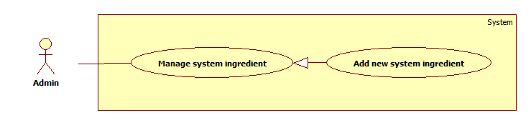

Figure 64: Add New System Ingredient

|  |  |  |  |
| --- | --- | --- | --- |
| **USE CASE SPECIFICATION** | | | |
| **Use Case No.** | AD010 | **Use Case Version** | 2.0 |
| **Use Case Name** | Add New System Ingredient | | |
| **Author** | Nguyễn Thế Vinh | | |
| **Date** | 26/02/2014 | **Priority** | High |
| **Actor:**   * Administrator   **Summary:**   * Administrator can add new system ingredient.   **Goal:**   * Helps administrator add new ingredient into database system.   **Triggers:**   * Administrator wants to add new system ingredient. * In Admin dashboard page, Administrator clicks on “Quản lý kho nguyên liệu”. In “Nguyên liệu” tab, user click button “Thêm” or Administrator can clicks on “Nguyên liệu” after that clicks on “Thêm mới” in navigation bar to go to “Tạo nguyên liệu” page and fill ingredient’s information, after that click button “Tạo mới”.   **Preconditions:**   * User must logged in the system with role “Administrator”.   **Post Conditions:**   * **Success**: New system ingredient be added. * **Fail:** System will transfer to error page or still in current page.   **Main Success Scenario:**   |  |  |  | | --- | --- | --- | | Step | Actor Action | System Response | | 1 | In Admin dashboard page, Administrator clicks on “Quản lý kho nguyên liệu”. In “Nguyên liệu” tab, user click button “Thêm” or Administrator can clicks on “Nguyên liệu” after that clicks on “Thêm mới” in navigation bar | System will show “Tạo nguyên liệu” page includes:   * Tên nguyên liệu [Name: Text box, Require] * Giá(VNĐ/kg) [Price: Text box, Require] * Phân loại [CategoryId: Dropdown List] * IngCopyId [Textbox, Hidden] * Ảnh minh họa [uploadFile, Input File] * Sao chép thành phần dinh dưỡng từ nguyên liệu trong kho hệ thông [Link] * Tạo mới [Submit button] * Nhập lại [Reset button] | | 2 | - Administrator enters the following information (Tên nguyên liệu, Giá, Phân loại).  - Administrator can also copy nutrient composition of available ingredient in system (More info in Copy System Ingredient’s Composition Use Case).  - Click “Tạo mới” button to send request. | * System will insert new system ingredient and nutrient composition copy (if user choose copy system ingredient’s composition) to database. * System redirect to “Thành phần dinh dưỡng” page and show notify “Nguyên liệu \*Name\* đã được thêm mới thành công. Vui lòng nhập thành phần dinh dưỡng” |   **Alternative Scenario:** N/A  **Exceptions:**   |  |  |  | | --- | --- | --- | | Step | Actor Action | System Response | | 1 | Set blank on “Tên nguyên liệu” | System will show the validate message “Vui lòng nhập tên nguyên liệu” and focus on Name textbox | | 2 | Set blank on “Giá(VNĐ/kg)” | System will show the validate message “Vui lòng nhập giá nguyên liệu” and focus on Price textbox | | 3 | Enter non-numeric on “Giá(VNĐ/kg)” | System will show “Giá nguyên liệu phải là số” and focus on Price textbox |   **Relationships:**   * Copy System Ingredient’s Composition   **Business Rules:**   * Price must be numeric | | | |

Table 62: Add New System Ingredient

##### Edit System ingredient’s Info

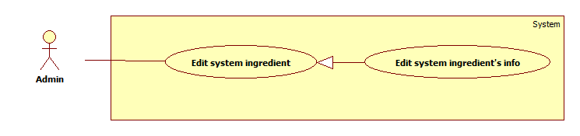

Figure 65: Edit System Ingredient’s Info

|  |  |  |  |
| --- | --- | --- | --- |
| **USE CASE SPECIFICATION** | | | |
| **Use Case No.** | AD011 | **Use Case Version** | 2.0 |
| **Use Case Name** | Edit System Ingredient’s Info | | |
| **Author** | Nguyễn Thế Vinh | | |
| **Date** | 26/02/2014 | **Priority** | Normal |
| **Actor:**   * Administrator   **Summary:**   * Administrator can edit all information of system ingredient.   **Goal:**   * Helps administrator modify name, price and category of system ingredient.   **Triggers:**   * Administrator wants to edit system ingredient. * In Admin dashboard page, Administrator clicks on “Quản lý kho nguyên liệu”. In “Nguyên liệu” tab, administrator search ingredient that they want to edit, clicks on pencil icon button in the right of each ingredient in list and change ingredient’s information, after that click button “Xác nhận”   **Preconditions:**   * User must logged in the system with role “Administrator”.   **Post Conditions:**   * **Success**: System ingredient’s info be changed. * **Fail:** System will transfer to error page or still in current page.   **Main Success Scenario:**   |  |  |  | | --- | --- | --- | | Step | Actor Action | System Response | | 1 | In Admin dashboard page, Administrator clicks on “Quản lý kho nguyên liệu”. In “Nguyên liệu” tab, administrator search ingredient that they want to edit, clicks on pencil icon button in the right of each ingredient in list. | System will show “Sửa nguyên liệu” page includes:   * Tên nguyên liệu [Name: Text box, Require] * Giá(VNĐ/kg) [Price: Text box, Require] * Phân loại [CategoryId: Dropdown List] * Ảnh minh họa [uploadFile, Input File] * Xác nhận [Submit button] * Nhập lại [Reset button] | | 2 | - Administrator changes the following information (Tên nguyên liệu, Giá, Phân loại).  - Click “Xác nhận” button to sendrequest. | System will change the ingredient’s information, update change price in database.  System redirect to “Nguyên liệu của bạn” and show notify “Nguyên liệu \*Name\* đã cập nhật thành công.” |   **Alternative Scenario:** N/A  **Exceptions:**   |  |  |  | | --- | --- | --- | | tep | Actor Action | System Response | | 1 | Set blank on “Tên nguyên liệu” | System will show the validate message “Vui lòng nhập tên nguyên liệu” and focus on Name textbox | | 2 | Set blank on “Giá(VNĐ/kg)” | System will show the validate message “Vui lòng nhập giá nguyên liệu” and focus on Price textbox | | 3 | Enter non-numeric on “Giá(VNĐ/kg)” | System will show “Giá nguyên liệu phải là số” and focus on Price textbox |   **Relationships:**   * N/A   **Business Rules:**   * Price must be numeric | | | |

Table 63: Edit System Ingredient’s Info

##### Edit System Ingredient’s Composition

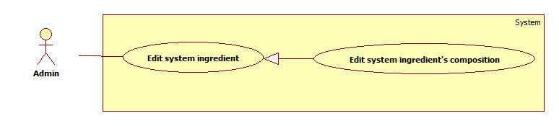

Figure 66: Edit System Ingredient’s Composition

|  |  |  |  |
| --- | --- | --- | --- |
| **USE CASE SPECIFICATION** | | | |
| **Use Case No.** | AD012 | **Use Case Version** | 2.0 |
| **Use Case Name** | Edit System Ingredient’s Composition | | |
| **Author** | Nguyễn Thế Vinh | | |
| **Date** | 26/02/2014 | **Priority** | Normal |
| **Actor:**   * Administrator   **Summary:**   * Administrator can edit system ingredient’s composition.   **Goal:**   * Help administrator modify the nutrient composition value of system ingredient for each type animal   **Triggers:**   * Administrator wants to edit system ingredient’s composition. * Administrator goes to “Quản lý kho nguyên liệu” page. In “Nguyên liệu” tab, administrator search ingredient that they want to edit, clicks on pencil icon button in the right of each ingredient in list and clicks on dropdown button “Chỉnh sửa” in “Sửa nguyên liệu” page and chooses “Thành phần dinh dưỡng”. After that administrator choose animal in tab panel, clicks on value of composition that administrator want to modify, modify value of composition and clicks on ok icon button.   **Preconditions:**   * User must logged in the system with role “Administrator”.   **Post Conditions:**   * **Success**: System ingredient’s composition be changed. * **Fail:** System will transfer to error page or still in current page.   **Main Success Scenario:**   |  |  |  | | --- | --- | --- | | Step | Actor Action | System Response | | 1 | Administrator clicks on dropdown button “Chỉnh sửa” in “Sửa nguyên liệu” page and choose “Thành phần dinh dưỡng”. | System will show “Chỉnh sữa thành phần dinh dưỡng” page. | | 2 | Administrator choose animal in tab panel, clicks on value of composition that administrator want to modify. | Textbox will appear to the administrator to edit the composition value. | | 3 | Administrator modify value and clicks on ok icon button. | System modify the value of this composition in database and notify “Cập nhật thành phần dinh dưỡng thành công” |   **Alternative Scenario:** N/A  **Exceptions:**   |  |  |  | | --- | --- | --- | | Step | Actor Action | System Response | | 1 | Input non-numeric value in composition value textbox | System will notify “Giá trị nhập vào không hợp lệ” and reset the value of this composition. |   **Relationships:**   * N/A   **Business Rules:**   * Composition value must be numeric | | | |

Table 64: Edit System Ingredient’s Composition

##### Hide System Ingredient

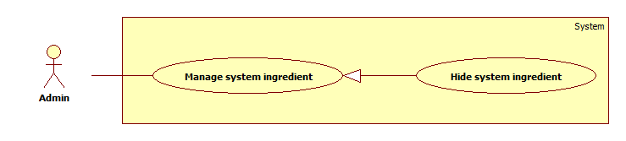

Figure 67: Hide System Ingredient

|  |  |  |  |
| --- | --- | --- | --- |
| **USE CASE SPECIFICATION** | | | |
| **Use Case No.** | AD013 | **Use Case Version** | 2.0 |
| **Use Case Name** | Hide System Ingredient | | |
| **Author** | Nguyễn Thế Vinh | | |
| **Date** | 26/02/2014 | **Priority** | Normal |
| **Actor:**   * Administrator   **Summary:**   * Administrator can hide system ingredient.   **Goal:**   * Help administrator hide system ingredient.   **Triggers:**   * Administrator wants to hide their ingredient. * Administrator goes to “Quản lý kho nguyên liệu” page. In “Nguyên liệu” tab, administrator search ingredient that they want to hide, clicks on trash icon button in the right of each ingredient in list. After that clicks ok in confirm pop up.   **Preconditions:**   * User must logged in the system with role “Administrator”.   **Post Conditions:**   * **Success**: System ingredient’s IsAcive attribute value equals “false” in database. * **Fail:** System will transfer to error page or still in current page.   **Main Success Scenario:**   |  |  |  | | --- | --- | --- | | Step | Actor Action | System Response | | 1 | Administrator goes to “Quản lý kho nguyên liệu” page. In “Nguyên liệu” tab, administrator search ingredient that they want to hide, clicks on trash icon button in the right of each ingredient in list. | System will show a confirm pop up “Bạn muốn ẩn nguyên liệu này?”   * Yes [Button] * No [Button] | | 2 | Administrator selects “Yes”  [Alternative 1] | System will set IsActive attribute of this ingredient value equals “false” in database.  System reload “Quản lý kho nguyên liệu” page and notify “Nguyên liệu \*Name\* đã được ẩn”. |   **Alternative Scenario:**   |  |  |  | | --- | --- | --- | | Step | Actor Action | System Response | | 1 | Administrator selects No. | Administrator stay at current page. |   **Exceptions:**   * N/A   **Relationships:**   * N/A   **Business Rules:**   * N/A | | | |

Table 65: Hide System Ingredient

##### Unhide System Ingredient

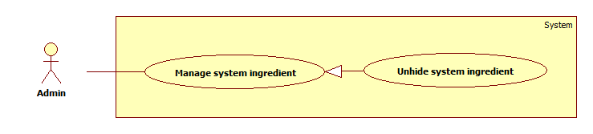

Figure 68: Unhide System Ingredient

|  |  |  |  |
| --- | --- | --- | --- |
| **USE CASE SPECIFICATION** | | | |
| **Use Case No.** | AD014 | **Use Case Version** | 2.0 |
| **Use Case Name** | Unhide System Ingredient | | |
| **Author** | Nguyễn Thế Vinh | | |
| **Date** | 26/02/2014 | **Priority** | Normal |
| **Actor:**   * Administrator   **Summary:**   * Administrator can unhide system hidden ingredient.   **Goal:**   * Help administrator unhide system hidden ingredient.   **Triggers:**   * Administrator wants to unhide system hidden ingredient. * Administrator goes to “Quản lý kho nguyên liệu” page. In “Đã ẩn” tab, administrator search ingredient that they want to unhide, clicks on ok icon button in the right of each ingredient in list. After that, user clicks ok in confirm pop up.   **Preconditions:**   * User must logged in the system with role “Administrator”.   **Post Conditions:**   * **Success**: System ingredient’s IsAcive attribute value equals “true” in database. * **Fail:** System will transfer to error page or still in current page.   **Main Success Scenario:**   |  |  |  | | --- | --- | --- | | Step | Actor Action | System Response | | 1 | Administrator goes to “Quản lý kho nguyên liệu” page. In “Đã ẩn” tab, administrator search ingredient that they want to unhide, clicks on ok icon button in the right of each ingredient in list. | System will show a confirm pop up “Bạn muốn khôi phục nguyên liệu này?”   * Yes [Button] * No [Button] | | 2 | Administrator selects “Yes”  [Alternative 1] | System will set IsActive attribute of this ingredient value equals “true” in database.  System reload “Quản lý kho nguyên liệu” page and notify “Nguyên liệu \*Name\* đã được khôi phục”. |   **Alternative Scenario:**   |  |  |  | | --- | --- | --- | | Step | Actor Action | System Response | | 1 | Administrator selects No. | Administrator stay at current page. |   **Exceptions:**   * N/A   **Relationships:**   * N/A   **Business Rules:**   * N/A | | | |

Table 66: Unhide System Ingredient

#### Producer Manage Store Use Case

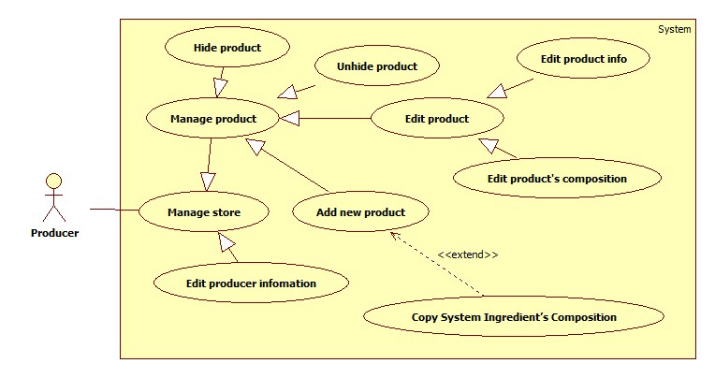

Figure 69: Producer Manage Store Use Case

##### Add New Product



Figure 70: Add New Product

|  |  |  |  |
| --- | --- | --- | --- |
| **USE CASE SPECIFICATION** | | | |
| **Use Case No.** | PD001 | **Use Case Version** | 2.0 |
| **Use Case Name** | Add New Product | | |
| **Author** | Nguyễn Thế Vinh | | |
| **Date** | 26/02/2014 | **Priority** | High |
| **Actor:**   * Producer   **Summary:**   * Producer can add new product.   **Goal:**   * Helps producer add their product into database system.   **Triggers:**   * Producer wants to add new product. * Producer goes to “Quản lý” page. Producer click on “Danh sách sản phẩm” tab, click on “Thêm” button and fill product’s information, after that click button “Tạo mới”   **Preconditions:**   * Producer must logged in the system.   **Post Conditions:**   * **Success**: New product be added. * **Fail:** System will transfer to error page or still in current page.   **Main Success Scenario:**   |  |  |  | | --- | --- | --- | | Step | Actor Action | System Response | | 1 | Producer goes to “Quản lý” page of producer. In “Danh sách sản phẩm” tab, producer click on “Thêm” button. | System will show “Tạo nguyên liệu” for producer page includes:   * Tên nguyên liệu [Name: Text box, Require] * Giá(VNĐ/kg) [Price: Text box, Require] * Phân loại [CategoryId: Dropdown List] * Ảnh minh họa [uploadFile , Input File] * IngCopyId [Textbox, Hidden] * Sao chép thành phần dinh dưỡng từ nguyên liệu trong kho hệ thông [Link] * Tạo mới [Submit button] * Nhập lại [Reset button] | | 2 | - Producer enters the following information (Tên nguyên liệu, Giá, Phân loại, Ảnh minh họa).  - Producer can also copy nutrient composition of available ingredient in system (More info in Copy System Ingredient’s Composition Use Case).  - Click “Tạo mới” button to send request. | * System will insert producer’s new ingredient and nutrient composition copy (if producer choose copy system ingredient’s composition) to database. * System redirect to “Thành phần dinh dưỡng” page and show notify “Nguyên liệu \*Name\* đã được thêm mới thành công. Vui lòng nhập thành phần dinh dưỡng” |   **Alternative Scenario:** N/A  **Exceptions:**   |  |  |  | | --- | --- | --- | | Step | Actor Action | System Response | | 1 | Set blank on “Tên nguyên liệu” | System will show the validate message “Vui lòng nhập tên nguyên liệu” and focus on Name textbox | | 2 | Set blank on “Giá(VNĐ/kg)” | System will show the validate message “Vui lòng nhập giá nguyên liệu” and focus on Price textbox | | 3 | Enter non-numeric on “Giá(VNĐ/kg)” | System will show “Giá nguyên liệu phải là số” and focus on Price textbox |   **Relationships:**   * Copy System Ingredient’s Composition   **Business Rules:**   * Price must be numeric * “Ảnh minh họa” must be .jpg, .png | | | |

Table 67: Add New Product

##### Edit product info



Figure 71: Edit product info

|  |  |  |  |
| --- | --- | --- | --- |
| **USE CASE SPECIFICATION** | | | |
| **Use Case No.** | PD002 | **Use Case Version** | 2.0 |
| **Use Case Name** | Edit Product’s Info | | |
| **Author** | Nguyễn Thế Vinh | | |
| **Date** | 26/02/2014 | **Priority** | Normal |
| **Actor:**   * Producer   **Summary:**   * Producer can edit all information (Name, Price, Category and Image) of their product.   **Goal:**   * Helps producer modify name, price, category and image of their product.   **Triggers:**   * Producer wants to edit their product. * Producer goes to “Quản lý” page of producer. In “Danh sách sản phẩm” tab, Producer search product that they want to edit, clicks on pencil icon button in the right of each product in list and change product’s information, after that clicks button “Xác nhận”   **Preconditions:**   * Producer must logged in the system.   **Post Conditions:**   * **Success**: Product’s info be changed. * **Fail:** System will transfer to error page or still in current page.   **Main Success Scenario:**   |  |  |  | | --- | --- | --- | | Ste | Actor Action | System Response | | 1 | Producer goes to “Quản lý” page of producer. In “Danh sách sản phẩm” tab, Producer search product that they want to edit, clicks on pencil icon button in the right of each product in list. | System will show “Sửa nguyên liệu” for producer page includes:   * Tên nguyên liệu [Name: Text box, Require] * Giá(VNĐ/kg) [Price: Text box, Require] * Phân loại [CategoryId: Dropdown List] * Ảnh minh họa [uploadFile, Input File] * Xác nhận [Submit button] * Nhập lại [Reset button] | | 2 | - Producer changes the following information (Tên nguyên liệu, Giá, Phân loại, Ảnh minh họa).  - Clicks “Xác nhận” button to send request. | * System will change the product’s information, update change price in database. * System redirect to “Quản lý” of producer – “Danh sách sản phẩm” tab and show notify “Nguyên liệu Name\* đã cập nhật thành công.” |   **Alternative Scenario:** N/A  **Exceptions:**   |  |  |  | | --- | --- | --- | | Step | Actor Action | System Response | | 1 | Set blank on “Tên nguyên liệu” | System will show the validate message “Vui lòng nhập tên nguyên liệu” and focus on Name textbox | | 2 | Set blank on “Giá(VNĐ/kg)” | System will show the validate message “Vui lòng nhập giá nguyên liệu” and focus on Price textbox | | 3 | Enter non-numeric on “Giá(VNĐ/kg)” | System will show “Giá nguyên liệu phải là số” and focus on Price textbox |   **Relationships:**   * N/A   **Business Rules:**   * Price must be numeric * “Ảnh minh họa” must be .jpg, .png | | | |

Table 68: Edit Product’s Info

##### Hide product



Figure 72: Hide product

|  |  |  |  |
| --- | --- | --- | --- |
| **USE CASE SPECIFICATION** | | | |
| **Use Case No.** | PD003 | **Use Case Version** | 2.0 |
| **Use Case Name** | Hide Product | | |
| **Author** | Nguyễn Thế Vinh | | |
| **Date** | 26/02/2014 | **Priority** | Normal |
| **Actor:**   * Producer   **Summary:**   * Producer can hide their product.   **Goal:**   * Help Producer hide their product. The hidden product will not show in their store.   **Triggers:**   * Producer wants to hide their product. * Producer goes to “Quản lý” page of producer. In “Danh sách sản phẩm” tab, Producer search product that they want to hide and clicks on trash icon button in the right of each product in list. After that, producer clicks on Yes button on confirm pop up.   **Preconditions:**   * Producer must logged in the system.   **Post Conditions:**   * **Success**: Product’s IsAcive attribute value equals “false” in database. * **Fail:** System will transfer to error page or still in current page.   **Main Success Scenario:**   |  |  |  | | --- | --- | --- | | Step | Actor Action | System Response | | 1 | Producer goes to “Quản lý” page of producer. In “Danh sách sản phẩm” tab, Producer search product that they want to hide and clicks on trash icon button in the right of each product in list. | System will show a confirm pop up “Bạn muốn ẩn sản phẩm này?”   * Yes [Button] * No [Button] | | 2 | Producer selects “Yes”  [Alternative 1] | * System will set IsActive attribute of this product value equals “false” in database. * System redirect to “Quản lý” of producer – “Danh sách sản phẩm” tab and show notify “Nguyên liệu Name\* đã được ẩn.” |   **Alternative Scenario:**   |  |  |  | | --- | --- | --- | | Step | Actor Action | System Response | | 1 | Producer selects No. | Producer stay at current page. |   **Exceptions:**   * N/A   **Relationships:**   * N/A   **Business Rules:**   * N/A | | | |

Table 69: Hide Product

##### Unhide product



Figure 73: Unhide product

|  |  |  |  |
| --- | --- | --- | --- |
| **USE CASE SPECIFICATION** | | | |
| **Use Case No.** | PD004 | **Use Case Version** | 2.0 |
| **Use Case Name** | Unhide Product | | |
| **Author** | Nguyễn Thế Vinh | | |
| **Date** | 26/02/2014 | **Priority** | Normal |
| **Actor:**   * Producer   **Summary:**   * Producer can unhide their hidden product.   **Goal:**   * Help Producer unhide their hidden product   **Triggers:**   * Producer wants to unhide their hidden product. * Producer goes to “Quản lý” page of producer. In “Chỉnh sửa” dropdown tab and clicks on “Sản phẩm ẩn”. Producer search product that they want to unhide and clicks on ok icon button in the right of each product in list. After that, producer clicks on Yes button on confirm pop up.   **Preconditions:**   * Producer must logged in the system.   **Post Conditions:**   * **Success**: Product’s IsAcive attribute value equals “true” in database. * **Fail:** System will transfer to error page or still in current page.   **Main Success Scenario:**   |  |  |  | | --- | --- | --- | | Step | Actor Action | System Response | | 1 | Producer goes to “Quản lý” page of producer. In “Chỉnh sửa” dropdown tab and clicks on “Sản phẩm ẩn”. | System will show the modal includes the list o all hidden product of producer. | | 2 | Producer search product that they want to unhide and clicks on ok icon button in the right ofeach product in list. | System will show a confirm pop up “Bạn muốn khôi phục sản phẩm này?”   * Yes [Button] * No [Button] | | 3 | Producer selects “Yes”  [Alternative 1] | * System will set IsActive attribute of this product value equals “false” in database. * System redirect to “Quản lý” of producer – “Danh sách sản phẩm” tab and show notify “Nguyên liệu Name\* đã được khôi phục.” |   **Alternative Scenario:**   |  |  |  | | --- | --- | --- | | Step | Actor Action | System Response | | 1 | Producer selects No. | Producer stay at current page. |   **Exceptions:**   * N/A   **Relationships:**   * N/A   **Business Rules:**   * N/A | | | |

Table 70: Unhide Product

##### Edit Producer Information



Figure 74: Edit Producer Information

|  |  |  |  |
| --- | --- | --- | --- |
| **USE CASE SPECIFICATION** | | | |
| **Use Case No.** | PD005 | **Use Case Version** | 2.0 |
| **Use Case Name** | Edit Producer Information | | |
| **Author** | Nguyễn Thế Vinh | | |
| **Date** | 26/02/2014 | **Priority** | Normal |
| **Actor:**   * Producer   **Summary:**   * Producer can edit their information (name, address, logo, phone, about)   **Goal:**   * Help producer edits their information (name, address, logo, phone, about)   **Triggers:**   * Producer wants to edit their information. * Producer goes to “Quản lý” page of producer. In “Chỉnh sửa” dropdown tab and clicks on “Thông tin chung”. Producer edits their information (name, address, logo, phone, about). After that, producer clicks on “Lưu lại” button.   **Preconditions**   * Producer must logged in the system.   **Post Conditions:**   * **Success**: Producer’s information will be updated in database. * **Fail:** System will transfer to error page or still in current page.   **Main Success Scenario:**   |  |  |  | | --- | --- | --- | | Step | Actor Action | System Response | | 1 | Producer goes to “Quản lý” page of producer. In “Chỉnh sửa” dropdown tab and clicks on “Thông tin chung”. | System will show the modal includes:   * Tên nhà sản xuất [Name: Text box, Require] * Địa chỉ [Address: Text box, Require] * Tỉnh\thành phố [ProvinceId: Dropdown List] * Số điện thoại [PhoneNumber: Regular Expression "^[0-9]{10,11}$", Require] * Mô tả [Description: Text area] * Logo [uploadFile, Input File] * Lưu lại [Submit button] * Hủy bỏ [Reset button] | | 2 | Producer edits their information (name, address, logo, phone, about). After that, producer clicks on “Lưu lại” button. | * System edits producer’s information in database. * System reloads “Quản lý” for producer page and notify “Thông tin nhà sản xuất đã cập nhật thành công.” |   **Alternative Scenario:**   |  |  |  | | --- | --- | --- | | Step | Actor Actin | System Response | | 1 | Producer click on “Hủy bỏ” button. | Producer stay at current pge. |   **Exceptions:**   |  |  |  | | --- | --- | --- | | Step | Actor Action | System Response | | 1 | Set blank on “Tên nhà sản xuất” | System will show the validate message “Vui lòng nhập tên nhà sản xuất” and focus on Name textbox | | 2 | Set blank on “Địa chỉ” | System will show the validate message “Vui lòng nhập địa chỉ” and focus on Address textbox | | 3 | Set blank on “Số điện thoại” | System will show the validate message “Vui lòng nhập số điện thoại” and focus on PhoneNumber textbox | | 4 | Enter non-numeric on “Số điện thoại” or less than, more than 10 or 11 number | System will show the validate message “Số điện thoại không đúng” and focus on PhoneNumber textbox |   **Relationships:**   * N/A   **Business Rules:**   * “Số điện thoại” must be had 10 or 11 number | | | |

Table 71: Edit Producer Information

## Software System Attribute

### Usability

#### Graphic User Interface

* All the text, label and image in user and producer page should be Vietnamese.
* All the text, label and image in admin page should be Vietnamese.

#### Usability

* Website administrator should need one week of training to be productive with the system.
* The user can use the system easily within an hour of training.
* The producer can use the system easily within an hour of traning.

#### Installation

* The system must be easy to deploy. Customer can deploy successfully and learn to configure, maintain the system within one day of training.
* The attached manual guide must be clear. User can read and do themselves without developer’s help.

### Reliability

* The accuracy of linear programming algorithm is about 99%.
* These results are achieved when user follow the guideline “**User Notice**” in **Software User’s Manual.**

### Availability

* The system shall available 24/7.

### Security

* Privacy: Each role of user has a specific permission to interact with system.
* System always checks authorization and authenticated before doing anything.

### Maintainability

* The system is divided into separate modules.
* The code is easy to maintain and upgrade.

### Portability

* N/A

### Performance

* Calculate Formulation: 2 seconds with 100 ingredient/nutrient constraints.

## Conceptual Diagram

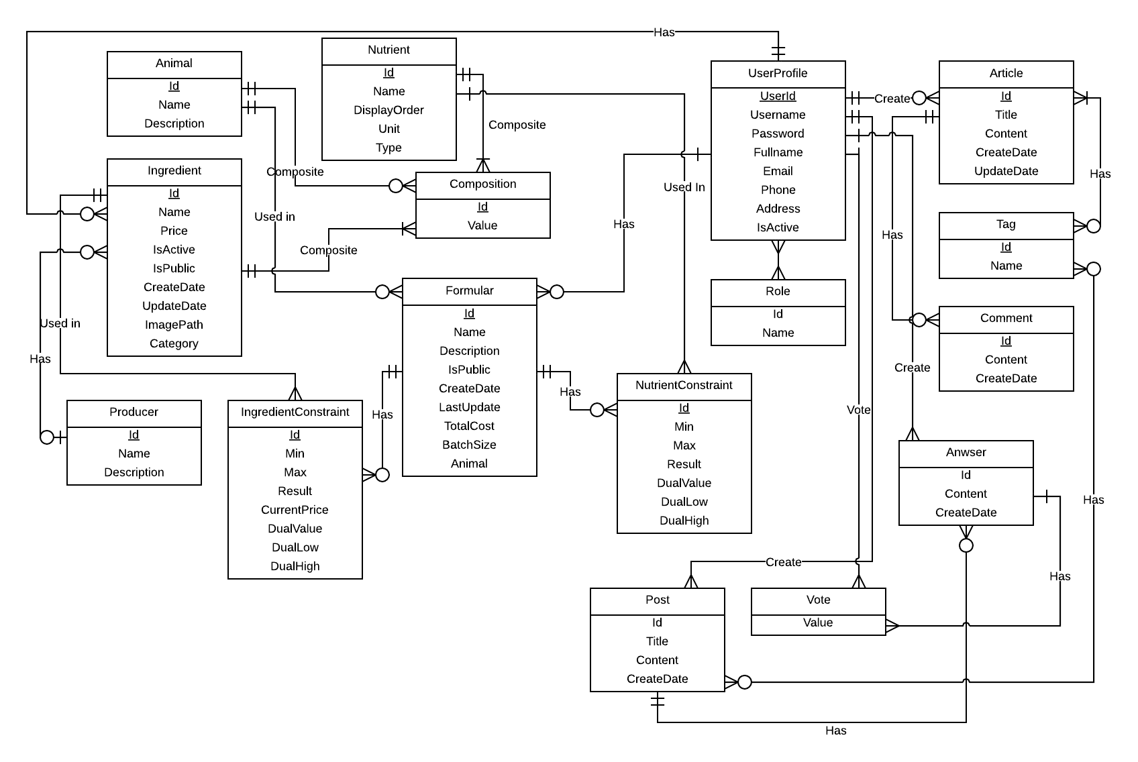

Figure 75: Conceptual Diagram

### Data Dictionary

|  |  |
| --- | --- |
| **Entity Data dictionary: describe content of all entities** | |
| Entity Name | Description |
| Animal | Describe all animal |
| Ingredient | Describe all ingredient in the system |
| Nutrient | Describe all nutrient in the system. |
| Formular | Describe all formula in the system. A formula contains Ingredient Constraints and Nutrient Constraints. |
| IngredientConstraint | Describe all ingredient constraints. |
| NutrientConstraint | Describe all nutrient constraint. |
| Composition | Describe all composition value of combining Animal – Ingredient - Nutrient |
| Article | Describe all article in the system. |
| Tag | Describe all tag in the system |
| ArticleCategory | Describe all article category |
| Post | Describe all the post. |
| Anwser | Describe all answer in the system. |
| Comment | Describe all comments in the system. A comment may applied in article or post. |
| Vote | Describe all vote which users vote for a comment. |
| Producer | Describe all producer in the system. |
| User | Describe account of user of system. User include: normal user, producer, admin … |
| Role | Describe role of user. One user may has many role. |

Table 72: Data Dictionary

# Software Design Description

## Design Overview

* This document describes the technical and user interface design of Feed Formulation System. It includes the architectural design, the detailed design of common functions and business functions and the design of database model.
* The architectural design describes the overall architecture of the system and the architecture of each main component and subsystem.
* The detailed design describes static and dynamic structure for each component and functions. It includes class diagrams, class explanations and sequence diagrams for each Use Cases.
* The database design describes the relationships between entities and details of each entity.
* Document overview:
* Section 2: gives an overall description of the system architecture design.
* Section 3: gives component diagrams that describe the connection and integration of the system.
* Section 4: gives the detail design description include class diagram, class explanation, and sequence diagram to details the application functions.
* Section 5: describe an ERD with logical diagram.

## System Architectural Design

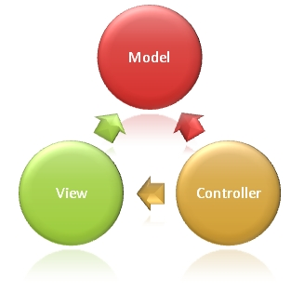

Figure 76: Model – View – Controller Architecture (MVC)

(<http://www.asp.net/mvc/tutorials/older-versions/overview/asp-net-mvc-overview>)

* **Models**. Model objects are the parts of the application that implement the logic for the application s data domain. Often, model objects retrieve and store model state in a database. For example, a Product object might retrieve information from a database, operate on it, and then write updated information back to a Products table in SQL Server.

In small applications, the model is often a conceptual separation instead of a physical one. For example, if the application only reads a data set and sends it to the view, the application does not have a physical model layer and associated classes. In that case, the data set takes on the role of a model object.

* **Views**. Views are the components that display the application s user interface (UI). Typically, this UI is created from the model data. An example would be an edit view of a Products table that displays text boxes, drop-down lists, and check boxes based on the current state of a Products object.
* **Controllers**. Controllers are the components that handle user interaction, work with the model, and ultimately select a view to render that displays UI. In an MVC application, the view only displays information; the controller handles and responds to user input and interaction. For example, the controller handles query-string values, and passes these values to the model, which in turn queries the database by using the values.

## Component Diagram

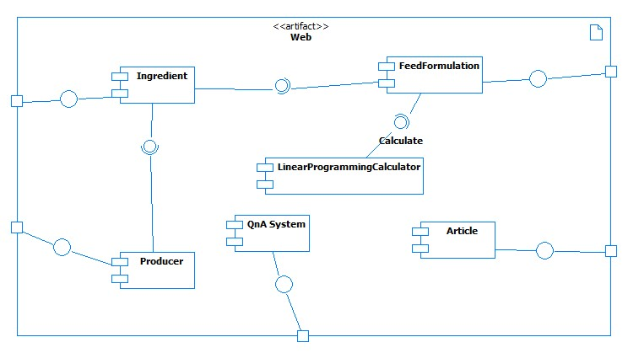

Figure 77: Component Diagram

## Detailed Description of Components

### Class Diagram

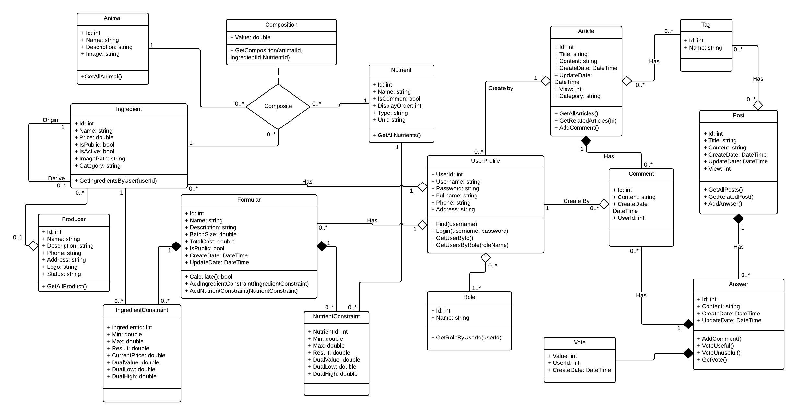

Figure 78: Class Diagram

### Class Diagram Explanation

#### Animal

Attribute

|  |  |  |  |
| --- | --- | --- | --- |
| **Attribute** | **Type** | **Visibility** | **Description** |
| Id | int | public | Id of animal |
| Name | string | public | Name of animal |
| Description | string | public | Description info of animal |
| Image | string | public | Image of animal |

Table 73: Animal attribute

Method

|  |  |  |  |
| --- | --- | --- | --- |
| **Method** | **Return Type** | **Visibility** | **Description** |
| GetAllAnimal() | List | public | Return a list of all animal |

Table 74: Animal method

#### Ingredient

Attribute

|  |  |  |  |
| --- | --- | --- | --- |
| **Attribute** | **Type** | **Visibility** | **Description** |
| Id | int | public | Id of ingredient |
| Name | string | public | Name of ingredient |
| Price | double | public | Price of ingredient |
| IsPublic | bool | public | Ingredient public or not |
| IsActive | bool | public | Ingredient active or not |
| ImagePath | string | public | Image of ingredient |
| Category | string | public | Category of ingredient |

Table 75: Ingredient attribute

Method

|  |  |  |  |
| --- | --- | --- | --- |
| **Method** | **Return Type** | **Visibility** | **Description** |
| GetIngredientsByUser(userId) | List | public | Get list ingredient of user |

Table 76: Ingredient method

#### Nutrient

Attribute

|  |  |  |  |
| --- | --- | --- | --- |
| **Attribute** | **Type** | **Visibility** | **Description** |
| Id | int | public | Id of nutrient |
| Name | string | public | Name of nutrient |
| IsCommon | bool | public | Nutrient common or not |
| DisplayOrder | int | public | Order of appearance |
| Type | string | public | Type of nutrient |
| Unit | string | public | Unit of nutrient |

Table 77: Nutrient attribute

Method

|  |  |  |  |
| --- | --- | --- | --- |
| **Method** | **Return Type** | **Visibility** | **Description** |
| GetAllNutrient() | List | public | Get all nutrient |

Table 78: Nutrient method

#### Composition

Attribute

|  |  |  |  |
| --- | --- | --- | --- |
| **Attribute** | **Type** | **Visibility** | **Description** |
| Value | double | public | value of composition |

Table 79: Composition attribute

Method

|  |  |  |  |
| --- | --- | --- | --- |
| **Method** | **Return Type** | **Visibility** | **Description** |
| GetComposition(animalId, ingredientId, nutrientId) | Composition | public | Get composition by animal, nutrient and ingredient |

Table 80: Composition method

#### IngredientConstraint

Attribute

|  |  |  |  |
| --- | --- | --- | --- |
| **Attribute** | **Type** | **Visibility** | **Description** |
| IngredientId | int | public | The ingredient id of constraint |
| Min | double | public | Min value of constraint |
| Max | double | public | Max value of constraint |
| Result | double | public | Result of constraint after calculation |
| CurrentPrice | double | public | The current price of ingredient in constraint |
| DualValue | double | public | Optimal value of the primal |
| DualLow | double | public | Lower bound of the optimal value |
| DualHigh | double | public | Upper bound of the optimal value |

Table 81: IngredientConstraint

#### NutrientConstraint

Attribute

|  |  |  |  |
| --- | --- | --- | --- |
| **Attribute** | **Type** | **Visibility** | **Description** |
| NutrientId | int | public | The nutrient id of constraint |
| Min | double | public | Min value of constraint |
| Max | double | public | Max value of constraint |
| Result | double | public | Result of constraint after calculation |
| DualValue | double | public | Optimal value of the primal |
| DualLow | double | public | Lower bound of the optimal value |
| DualHigh | double | public | Upper bound of the optimal value |

Table 82: NutrientConstraint

#### Formular

Attribute

|  |  |  |  |
| --- | --- | --- | --- |
| **Attribute** | **Type** | **Visibility** | **Description** |
| Id | int | public | Id of formular |
| Name | string | public | Name of formular |
| Description | string | public | Description of formular |
| BatchSize | double | public | Total weight of formular |
| TotalCost | double | public | Total cost of formular |
| IsPublic | bool | public | Formular is public or not |
| CreateDate | Datetime | public | The date that formular was created |
| UpdateDate | Datetime | public | The date that formular was updated |

Table 83: Formular attribute

Method

|  |  |  |  |
| --- | --- | --- | --- |
| **Method** | **Return Type** | **Visibility** | **Description** |
| Calculate() | bool | public |  |
| AddIngredientConstraint(IngredientConstraint) | bool | public | Add new ingredient constraint to formular |
| AddNutrinetConstraint(NutrientConstraint) | bool | public | Add new nutrient constraint to formular |

Table 84: Formular method

#### Tag

Attribute

|  |  |  |  |
| --- | --- | --- | --- |
| **Attribute** | **Type** | **Visibility** | **Description** |
| Id | int | public | Id of tag |
| Name | string | public | Name of tag |

Table 85: Tag

#### Article

Attribute

|  |  |  |  |
| --- | --- | --- | --- |
| **Attribute** | **Type** | **Visibility** | **Description** |
| Id | int | public | Id of article |
| Title | string | public | Title of article |
| Content | string | public | Content of article |
| CreateDate | Datetime | public | The date that article was created |
| UpdateDate | Datetime | public | The date that article was updated |
| View | int | public | Number of view |
| Category | string | public | The category of article |

Table 86: Article attribute

Method

|  |  |  |  |
| --- | --- | --- | --- |
| **Method** | **Return Type** | **Visibility** | **Description** |
| GetAllArticles() | List | public | Get all article |
| GetRelatedArticle(id) | Article | public | Get related article by id |
| AddComment() | bool | public | Add comment into article |

Table 87: Article method

#### Comment

Attribute

|  |  |  |  |
| --- | --- | --- | --- |
| **Attribute** | **Type** | **Visibility** | **Description** |
| Id | int | public | Id of comment |
| Content | string | public | Comment content |
| CreateDate | Datetime | public | The date that comment was created |
| UserId | int | public | Id of user |

Table 88: Comment

#### Role

Attribute

|  |  |  |  |
| --- | --- | --- | --- |
| **Attribute** | **Type** | **Visibility** | **Description** |
| Id | Int | public | Unique id of each role |
| Name | String | public | Name of role |

Table 89: Role attribute

Method

|  |  |  |  |
| --- | --- | --- | --- |
| **Method** | **Return Type** | **Visibility** | **Description** |
| GetRoleByUser(userId) | Role | public | Get role in system by id. |

Table 90: Role method

#### UserProfile

Attribute

|  |  |  |  |
| --- | --- | --- | --- |
| **Attribute** | **Type** | **Visibility** | **Description** |
| UserId | int | public | Unique id of each user |
| UserName | string | public | Username of user |
| Password | string | public | Password of user |
| Fullname | string | public | Full name of user |
| Phone | string | public | Phone number of user |
| Address | string | public | Address of user |
| IsActive | Boolean | public | Status active of user |

Table 91: UserProfile attribute

Method

|  |  |  |  |
| --- | --- | --- | --- |
| **Method** | **Return Type** | **Visibility** | **Description** |
| Find(username) | UserProfile | pubic | Find user by username |
| Login(username, password) | Bool | public | Login in to system. |
| GetUserByID() | UserProfile | public | Get user in system by id |
| GetUserByRole(roleName) | UserProfile | public | Get all user in role |

Table 92: UserProfile method

#### Producer

Attribute

|  |  |  |  |
| --- | --- | --- | --- |
| **Attribute** | **Type** | **Visibility** | **Description** |
| Id | int | public | Id of producer |
| Name | string | public | Name of producer |
| Description | string | public | Description of producer |
| Phone | string | public | Phone number of producer |
| Address | string | public | Address of producer |
| Logo | string | public | Logo of producer |
| Status | string | public | Status to manage producer |

Table 93: Producer Attribute

Method

|  |  |  |  |
| --- | --- | --- | --- |
| **Method** | **Return Type** | **Visibility** | **Description** |
| GetAllProduct() | List | public | Get all product of producer |

Table 94: Producer method

#### Post

Attribute

|  |  |  |  |
| --- | --- | --- | --- |
| **Attribute** | **Type** | **Visibility** | **Description** |
| Id | int | public | Id of post |
| Title | string | public | Title of post |
| Content | string | public | Post content |
| CreateDate | Datetime | public | The date that post was created |
| UpdateDate | Datetime | public | The date that post was updated |
| View | int | public | Number of view |

Table 95: Post attribute

Method

|  |  |  |  |
| --- | --- | --- | --- |
| **Method** | **Return Type** | **Visibility** | **Description** |
| GetAllPost() | List | public | Get all post in system |
| GetRelatedPost() | Post | public | Get the related post |
| AddAnswer() | bool | public | Add answer to post |

Table 96: Post method

#### Answer

Attribute

|  |  |  |  |
| --- | --- | --- | --- |
| **Attribute** | **Type** | **Visibility** | **Description** |
| Id | int | public | Id of answer |
| Content | string | public | Answer content |
| CrateDate | Datetime | public | The date that answer was created |
| UpdateDate | Datetime | public | The date that answer was updated |

Table 97: Answer attribute

Method

|  |  |  |  |
| --- | --- | --- | --- |
| **Method** | **Return Type** | **Visibility** | **Description** |
| AddCommnent() | bool | public | Add comment to answer |
| VoteUserful() | bool | public | Vote answer as useful |
| VoteUnuserful() | bool | public | Vote answer as unuserful |
| GetVote() | bool | public | Get vote of answer |

Table 98: Answer method

#### Vote

Attribute

|  |  |  |  |
| --- | --- | --- | --- |
| **Attribute** | **Type** | **Visibility** | **Description** |
| Value | int | public | Value of vote |
| UserId | int | public | User vote |
| CreateDate | Datetime | public | The date that user vote |

Table 99: Vote attribute

### Sequence Diagram

#### Create Formula

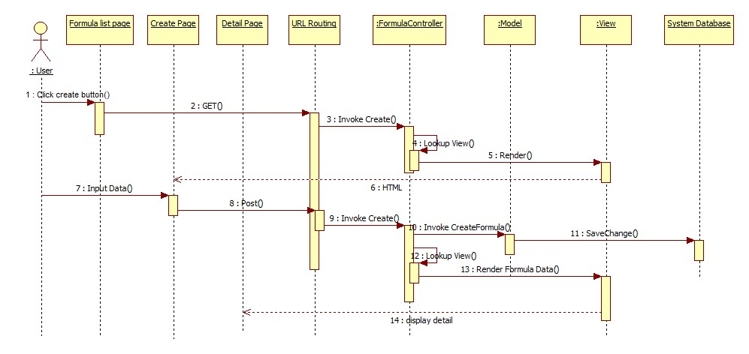

Figure 79: Create Formula Sequence Diagram

#### Add Ingredient Constraint

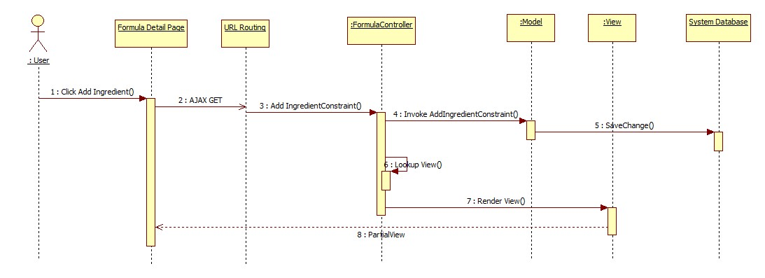

Figure 80: Add Ingredient Constraint

#### Add Nutrient Constraint

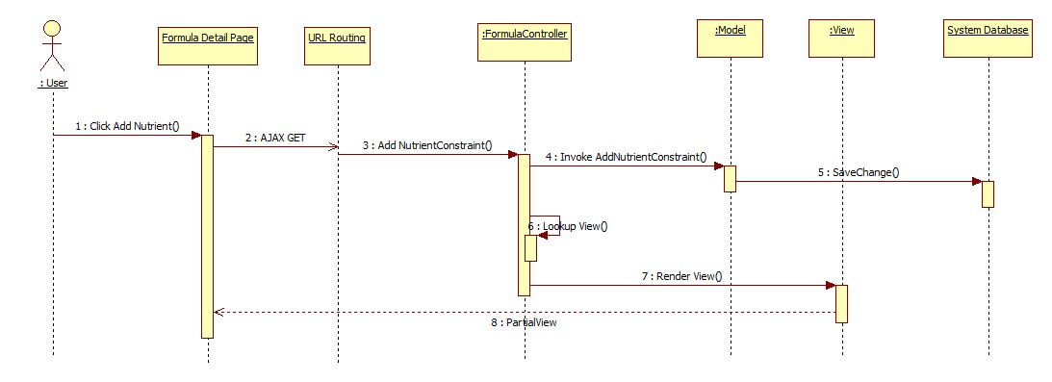

Figure 81: Add Nutrient Constraint

#### Calculate Formula

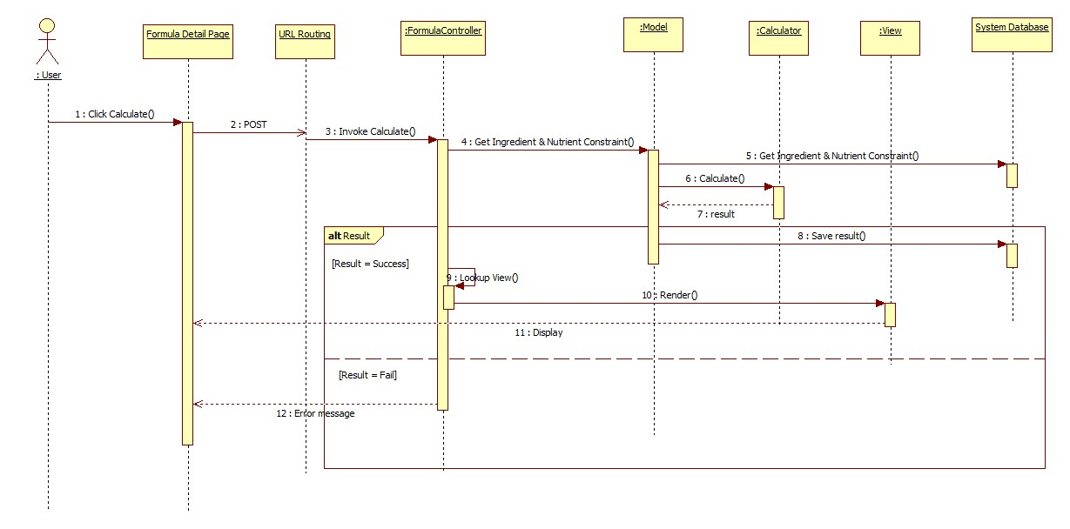

Figure 82: Calculate Formula

#### <User> Export Report

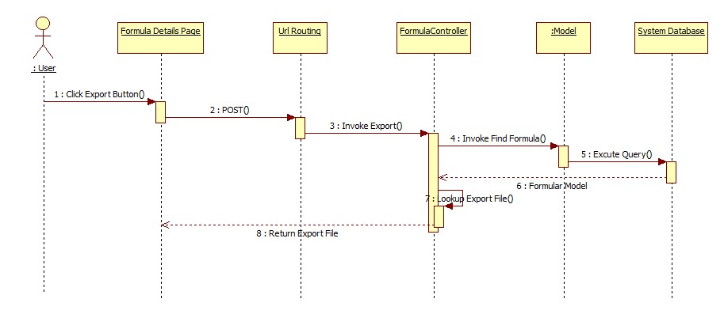

Figure 83: Export Report

#### <User> Create Ingredient

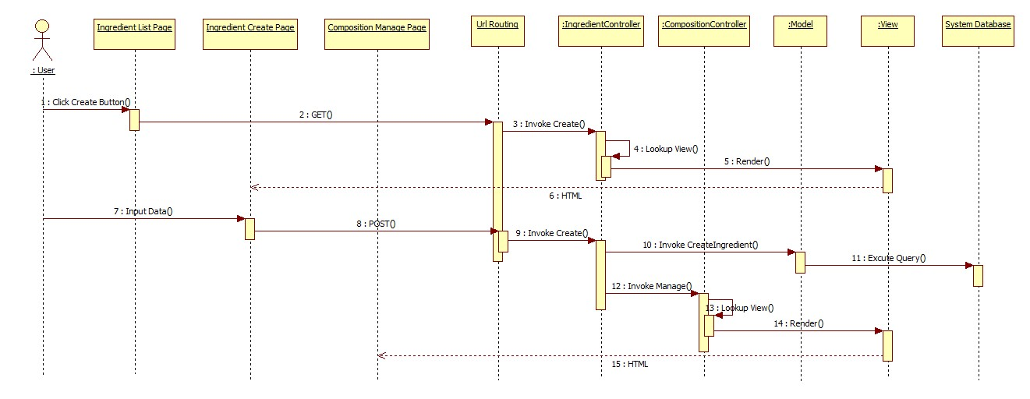

Figure 84: Create Ingredient

#### <User> Edit Ingredient

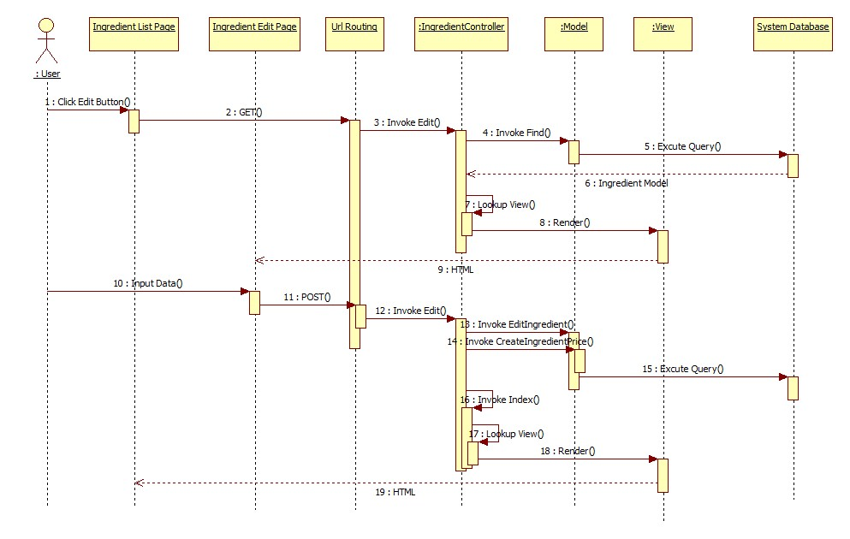

Figure 85: Edit Ingredient

#### Include Ingredient

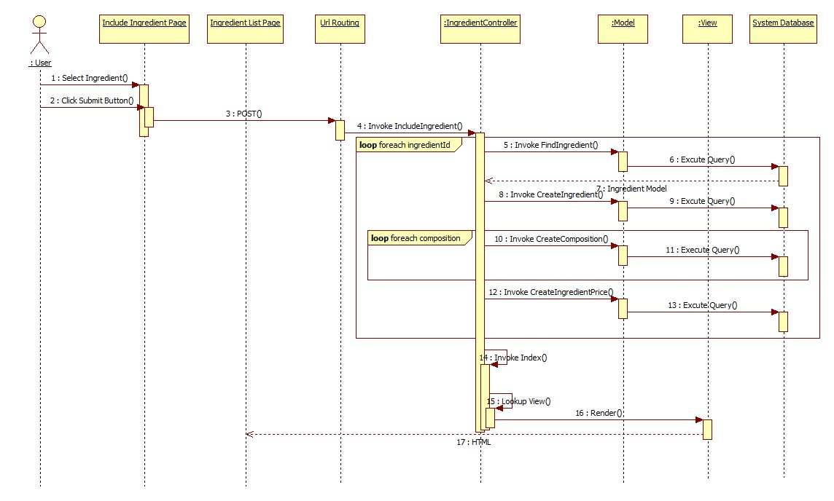

Figure 86: Include Ingredient

#### User Add Ingredient from Producer’s Store

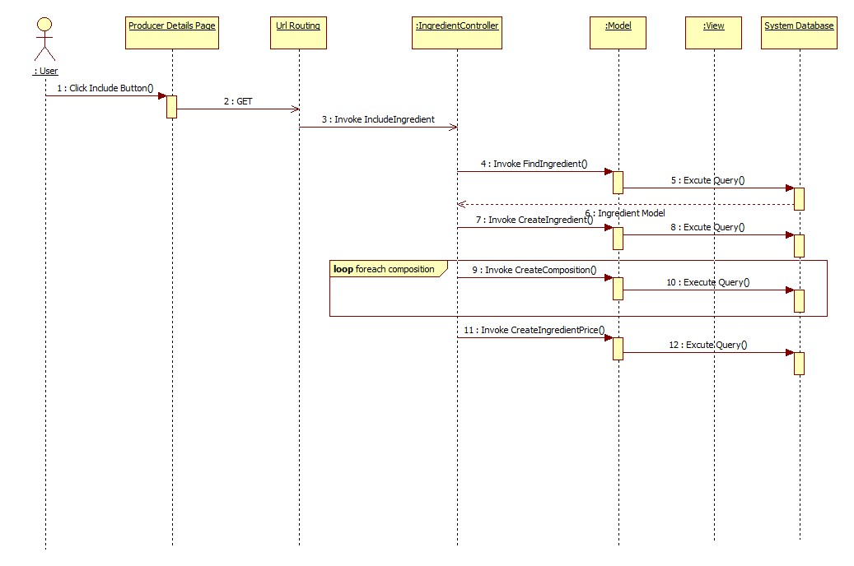

Figure 87: User Add Ingredient from Producer’s Store

#### <Producer> Create Ingredient

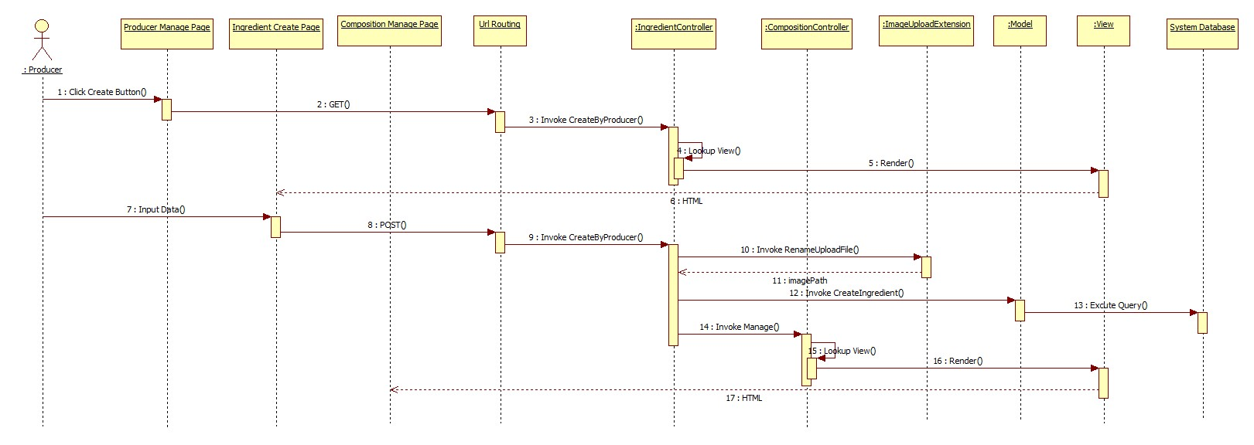

Figure 88: Create Ingredient

#### <Administrator> Create Ingredient

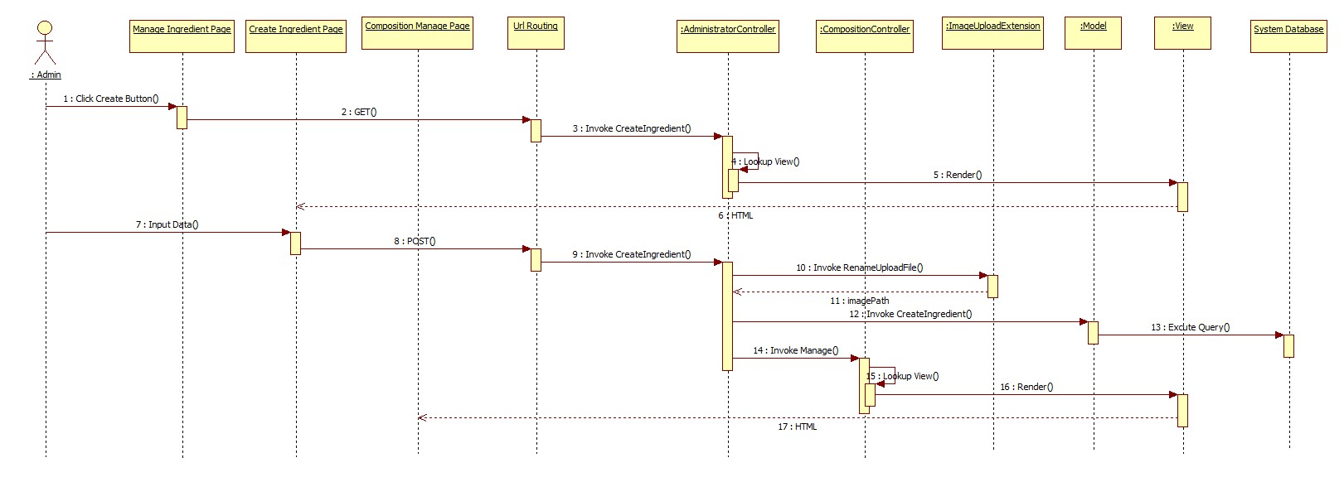

Figure 89: Create Ingredient

#### <Administrator> Edit Ingredient

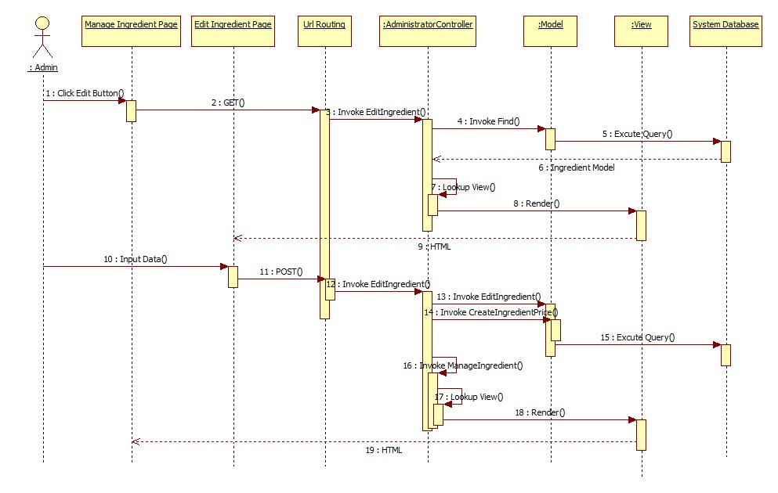

Figure 90: Edit Ingredient

#### <Administrator> Inactive Ingredient

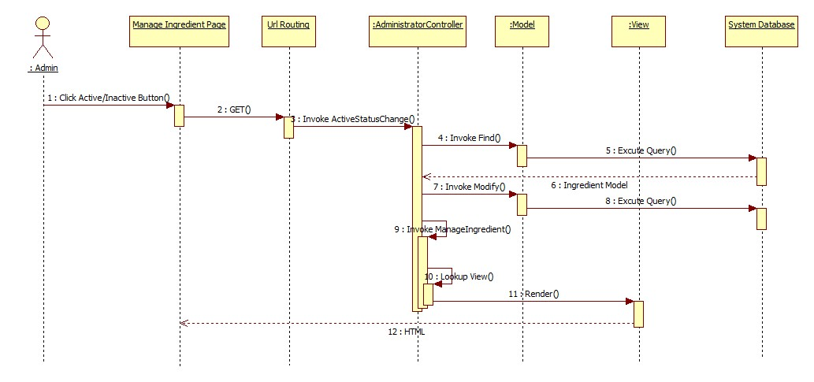

Figure 91: Inactive Ingredient

#### Create Post



Figure 92: Create Post

#### Edit Post



Figure 93: Edit Post

#### Delete Post



Figure 94: Delete Post

#### Create Anwser



Figure 95: Create Anwser

#### Add Comment to answer



Figure 96: Add Comment to answer

#### Like a comment

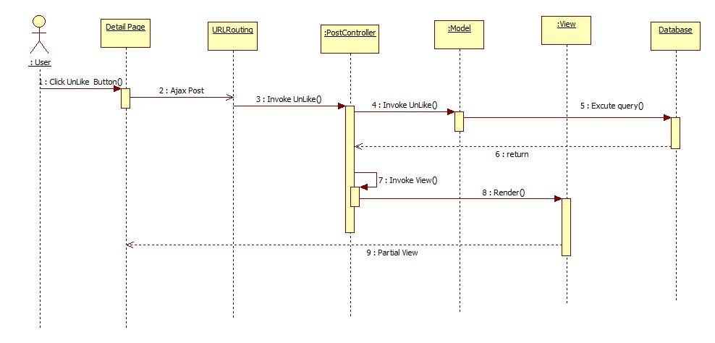

Figure 97: Like a comment

#### Unlike a comment



Figure 98: Unlike a comment

#### Create Article

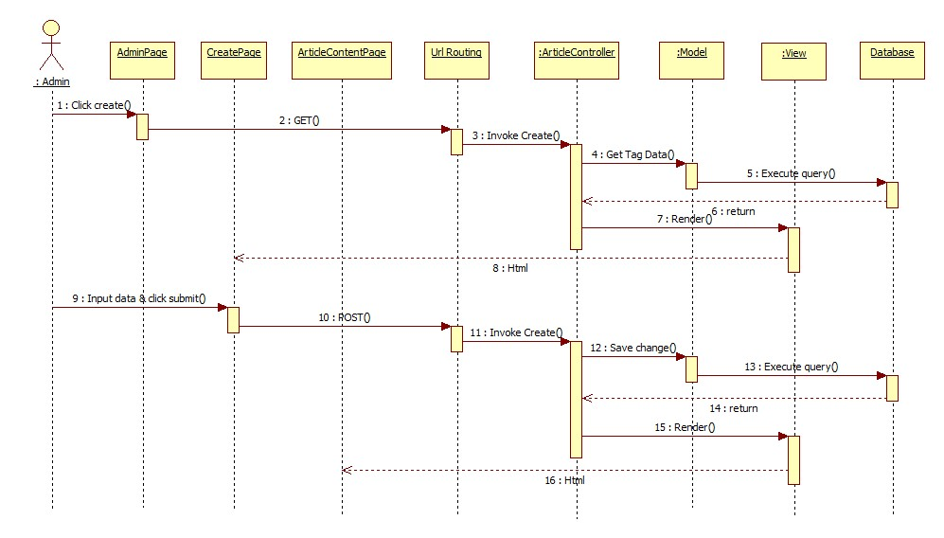

Figure 99: Create Article

#### Edit Article

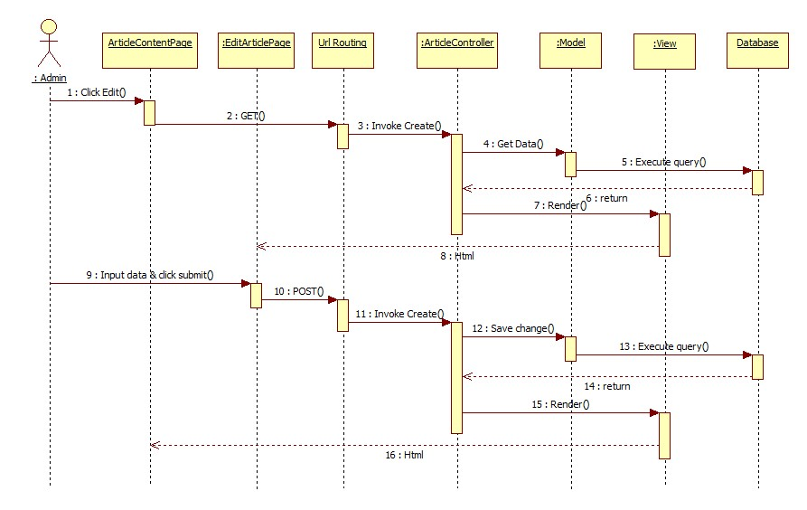

Figure 100: Edit Article

#### View Content

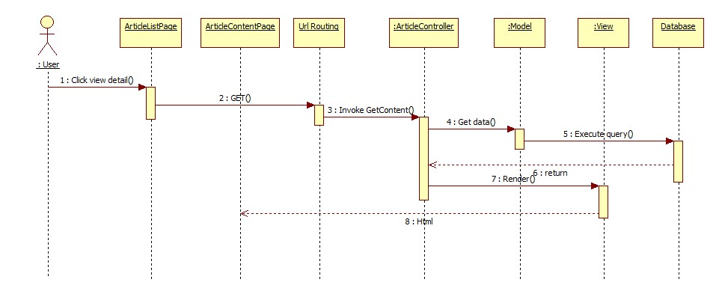

Figure 101: View Content

#### Delete Article

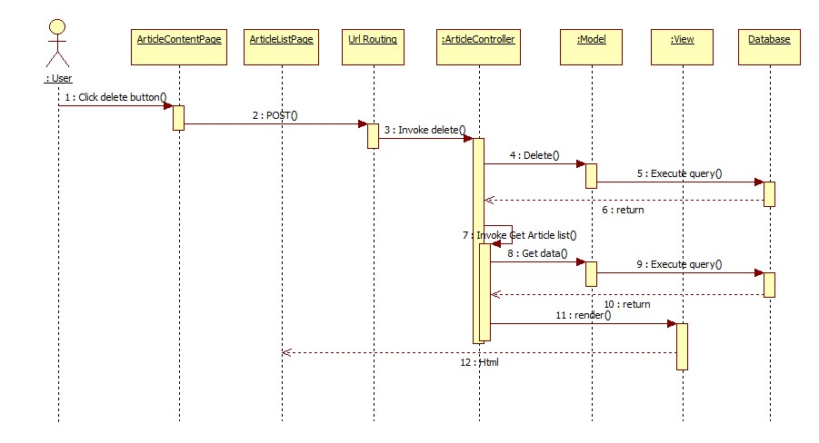

Figure 102: Delete Article

#### Add Comment to Article

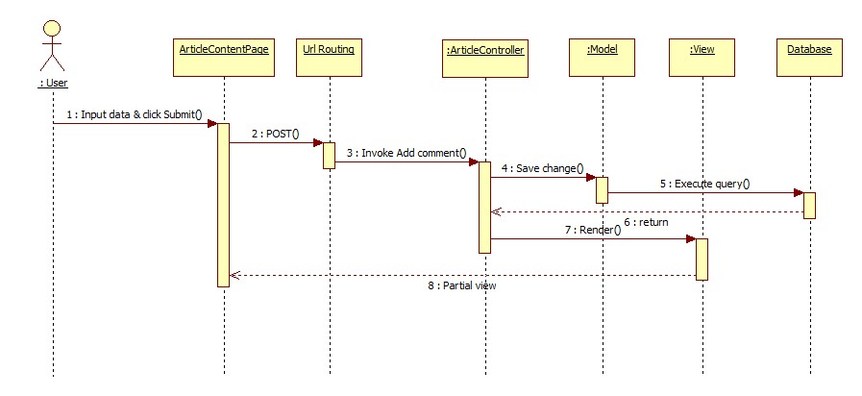

Figure 103: Add Comment to Article

#### Add Nutrient

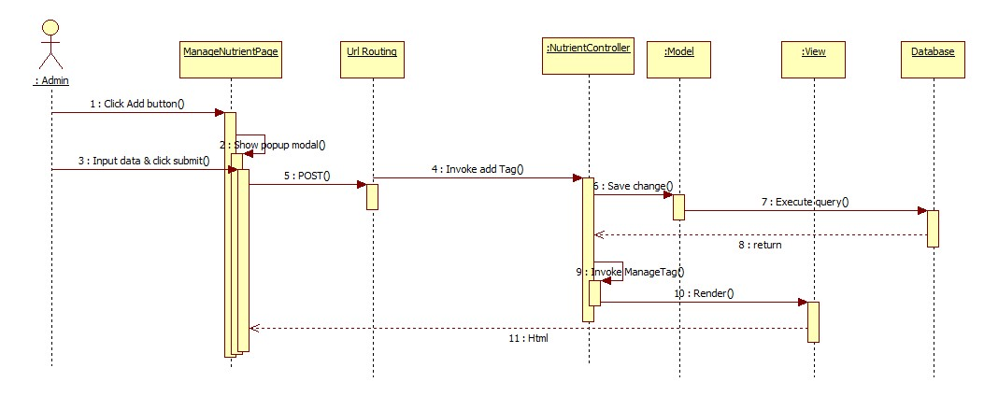

Figure 104: Add Nutrient

#### Edit Nutrient

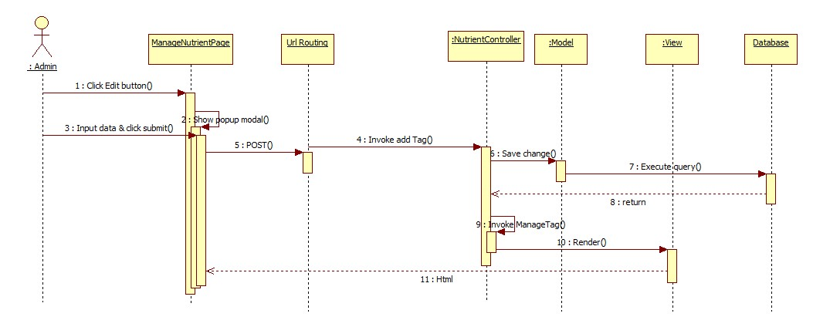

Figure 105: Edit Nutrient

#### Add Tag

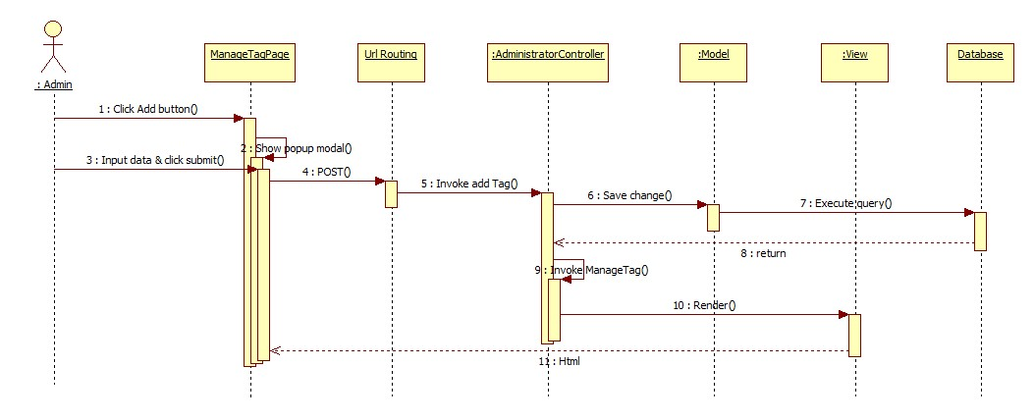

Figure 106: Add Tag

#### Edit Tag

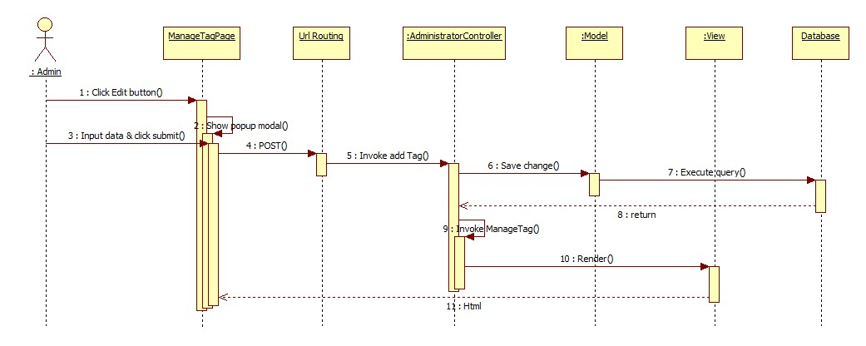

Figure 107: Edit Tag

## User Interface Design

* Reference to CD:
  + <root>/Documents/Final Report Full.docx

## Database Design

**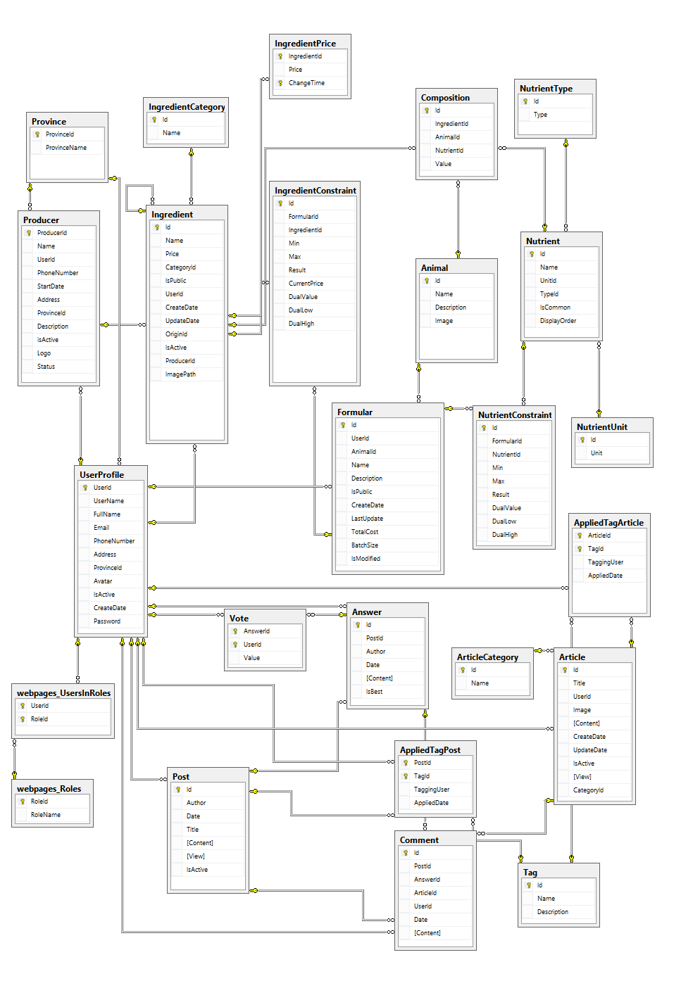**

Figure 108: Database Relationship Diagram

## Algorithms

### Linear Programming

#### Definition

* Linear programming (LP, or linear optimization) is a method to achieve the best outcome (such as maximum profit or lowest cost) in a mathematical model whose requirements are represented by linear relationships. Linear programming is a special case of mathematical programming (mathematical optimization).
* Linear programs are problems that can be expressed in canonical form:
*  \begin{align}
  & \text{maximize}   && \mathbf{c}^\mathrm{T} \mathbf{x}\\
  & \text{subject to} && A \mathbf{x} \leq \mathbf{b} \\
  & \text{and} && \mathbf{x} \ge \mathbf{0}
  \end{align} 

Reference: [http://en.wikipedia.org/wiki/Linear\_programming [4](http://en.wikipedia.org/wiki/Linear_programming%20%5b4)]

#### Methods

There are many algorithms for a linear programming:

* **Simplex algorithm of Dantzig**
* **Criss-cross algorithm**
* **Conic sampling algorithm of Serang**

We choose Simplex algorithm of Dantzig because:

* Fast and accuracy.
* Already implemented in LpSolve

#### Algorithm overview

The simplex algorithm operates on linear programs in *standard form*, that is linear programming problems of the form,

Minimize

\mathbf{c}^T \cdot \mathbf{x}

Subject to

\mathbf{A}\mathbf{x} = \mathbf{b},\, x_i \ge 0

with \scriptstyle x \;=\; (x_1,\, \dots,\, x_n) the variables of the problem, \scriptstyle c \;=\; (c_1,\, \dots,\, c_n) are the coefficients of the objective function, *A* a *p×n* matrix, and \scriptstyle b \;=\; (b_1,\, \dots,\, b_p) constants with \scriptstyle b_j\geq 0. There is a straightforward process to convert any linear program into one in standard form so this results in no loss of generality.

In geometric terms, the feasible region

\mathbf{A}\mathbf{x} = \mathbf{b},\, x_i \ge 0

is a (possibly unbounded) convex polytope. There is a simple characterization of the extreme points or vertices of this polytope, namely \scriptstyle x \;=\; (x_1,\, \dots,\, x_n) is an extreme point if and only if the subset of column vectors \scriptstyle A_i corresponding to the nonzero entries of x (\scriptstyle x_i \,\ne\, 0) are linearly independent. In this context such a point is known as a basic feasible solution (BFS).

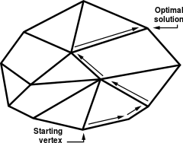

A system of linear inequalities defines a polytope as a feasible region. The simplex algorithm begins at a starting vertex and moves along the edges of the polytope until it reaches the vertex of the optimum solution.

Reference: <http://en.wikipedia.org/wiki/Simplex_algorithm>

# System Implementation & Test

## Introduction

### System Overview

This section provides in detail all necessary information about test plans, test cases, test result, test environments, pass/fail criteria and risks estimations as well as a checklist to cover all possible cases of FeedFormulation.

### Test Approach

- Goal: To test the whole system based on the core workflow.

- Method: System Testing, Black-box Testing.

## Test Plan

The purpose of this section is to verify and ensure that RSM meets its design specification and other requirements from user. The following part will describe which features to be tested and which will not.

### Features to be tested

We will test the entire system based on the following core workflow (Reference: [**Figure 101: Core Workflow**](#_Toc371697397)).

Based on the workflow, all following features will be tested, which can include one or more functions. These features will be focused and tested thoroughly during the test phase.

* User – Manage Ingredient
* User - Formulation
* Producer – Store
* Article Management
* Post Management

### Features not to be tested

* Login, Logout
* Change Password
* Admin - Manage Accounts
* Admin – Manage Tags

### Testing tool and Environment

Environment:

* OS: Windows 7 (32 or 64 bit)
* Memory: 2G RAM or more
* Browser: Firefox v25 or later

## System Testing Test Case

|  |  |  |  |  |  |  |
| --- | --- | --- | --- | --- | --- | --- |
| **ID** | **Test Case Description** | **Test Case Procedure** | **Expected output** | **Result** | **Test Date** | **Note** |
| ST01 | The first time user login to system | 1 – Login into the system  2 – On the home page, click “Bắt đầu”  3 – Click “Công thức” in left sidebar | 2 – System go to Welcome page.  3 – Stay on welcome page with message “Hiện tại chưa có nguyên liệu nào trong kho của bạn. Vui lòng thêm nguyên liệu vào kho từ những nguồn bên dưới“ | Pass | 01/04/2014 |  |
| ST02 | User create first ingredient | 1 – Login into the system  2 – On the home page, click “Bắt đầu”  3 – Click a button “Tạo mới”  4 – Fill in 3 field “Tên nguyên liệu”, “Giá”, “Phân loại”.  5 – Click “Tạo mới” button.  6 – Click “Xong” button. | 2 – System will start Welcome page  3 – Redirect page “Tạo nguyện liệu”  5 – Show table of nutrient and nutrient value.  6 – Go to page “Danh sách nguyên liệu của bạn” | Pass | 01/04/2014 |  |
| ST03 | Copy ingredient from system | 1 – Login into the system  2 – On the home page, click “Bắt đầu”  3 – Click “Kho hệ thống”button.  4 – Select ingredient want to copy, click “Xác nhận” button | 3 – Go to page “Lấy nguyên liệu”  4 – Show message “Bạn vừa lấy thành công 1 nguyên liệu” | Pass | 01/04/2014 |  |
| ST04 | User register to a producer | 1 – Login into the system  2 – On the home page, click “Bắt đầu 3 – Click “Nhà sản xuất” button.  4 – Click “Đăng ký” in tab “Nhà sản xuất” in the left sidebar  5 – Input information to all field:  - "Tên nhà sản xuất"  - "Địa chỉ"  - "Tỉnh\Thành Phố"  - "Điện thoại"  - "Mô tả"  6 – Click “Đăng ký” button | 3 – Go to page “Danh sách các nhà sản xuất”  4 – Go to page “Trở thành nhà sản xuất”  6 – Show message “**Chúc mừng!** Bạn đã đăng ký trở thành nhà sản xuất thành công. Ban quản trị sẽ xét duyệt đơn đăng ký của bạn sớm nhất có thể. Xin cảm ơn.” and basic information had register. | Pass | 01/04/2014 |  |
| ST05 | Producer after admin accepted. | 1 – Login into the system using producer account  2 – On the home page, click “Bắt đầu 3 – Click “Nhà sản xuất” button.  4 – Click “Quản lý” in tab “Nhà sản xuất” in the left sidebar | 4 – Show page “Quản lý thông tin nhà sản xuất của bạn“. | Pass | 01/04/2014 |  |
| ST06 | User create formular | 1 – User click “Công thức” in toggle from user name in header page. | 1 – System go to page “Công thức của bạn“ | Pass | 01/04/2014 |  |
| ST07 | User view article | 1 – User click in hyperlink “Tin tức” in header of home page | 1 – Go to page list of article | Pass | 01/04/2014 |  |
| ST08 | User view question | 1 – User click in hyperlink “Cộng đồng” in header of home page | 1 – Go to page list of question | Pass | 01/04/2014 |  |
| ST09 | User view demo formular | 1 – User click in hyperlink “Công thức mẫu” in header of home page | 1 – Go to page “Công thức mẫu” | Pass | 01/04/2014 |  |
| ST10 | User view list of producer | 1 – User click in hyperlink “Nhà sản xuất” in header of home page | 1 – Go to page list of producer | Pass | 01/04/2014 |  |

Table 100: Core Workflow Test Case

## Module Test Case

### User Manage Ingredient

|  |  |  |  |  |  |  |  |
| --- | --- | --- | --- | --- | --- | --- | --- |
| **ID** | **Test Case Description** | **Test Case Procedure** | **Expected output** | **Inter-test Case Dependence** | **Result** | **Test Date** | **Note** |
| 01 | User goes to add new ingredient page | 1 – Logged in  2 – Click “Thêm” button | 2 – Go to page “Tạo nguyên liệu” |  | Pass | 24/03/2014 |  |
| 02 | Test validate add new ingredient | 1 – Logged in  2 – Click “Thêm” button  3 – Don’t input anything and click “Tạo mới” button | 2 – Go to page “Tạo nguyên liệu”  3 – Show message in 2 field “Tên nguyên liệu” and “Giá” | 01 | Pass | 24/03/2014 |  |
| 03 | Add new ingredient without nutrient | 1 – Logged in  2 – Click “Thêm” button  3 – Input:   * “Tên nguyên liệu”: “Test001” * “Giá”:”1000” * “Phân loại”: “Phụ gia”   4 – Click “Tạo mới”  5 – Click “Xong” button | 2 – Go to page “Tạo nguyên liệu”  4 – Show message “*Nguyên liệu TEST001 đã tạo thành công. Vui lòng nhập thành phần dinh dưỡng.*”   * Redirect to “Thành phần dinh dưỡng” page   5 – Rediect to page “Danh sách nguyên liệu của bạn”. in this page has ingredient “Test001” | 01 | Pass | 24/03/2014 |  |
| 04 | Add new ingredient without copy nutrient and input nutrient value | 1 – Logged in  2 – Click “Thêm” button  3 – Input:   * “Tên nguyên liệu”: “Test002” * “Giá”:”1000” * “Phân loại”: “Phụ gia”   4 – Click “Tạo mới”  5 – Edit value field **Phenylalanine** in column “Giá trị” :12  6 – Click button has icon  7 – Click “Xong” button | 4 – Show message “*Nguyên liệu TEST002 đã tạo thành công. Vui lòng nhập thành phần dinh dưỡng.*”   * Redirect to “Thành phần dinh dưỡng” page   6 – value 0 change to 12   * Show message “*Cập nhật thành phần dinh dưỡng thành công.”*   7 – Rediect to page “Danh sách nguyên liệu của bạn”. In this page has ingredient “Test002” | 01 | Pass | 24/03/2014 |  |
| 05 | Add new ingredient with copy nutrient | 1 – Logged in  2 – Click “Thêm” button  3 – Input:   * “Tên nguyên liệu”: “Test003” * “Giá”:”1000” * “Phân loại”: “Phụ gia”   4 – click hyperlink “***Sao chép thành phần dinh dưỡng từ nguyên liệu trong kho hệ thống***”  5 – In dropdownlist, select “Dầu cá”  6 – Click “Lưu lại” button  7 – Click Ok button  8 - Click “Tạo mới”  9 - Click “Xong” button | 2 – Go to page “Tạo nguyên liệu”  4 – show popup modal “***Chọn nguyên liệu để sao chép***”  6 - Show popup “*Bạn muốn sao chép thành phần từ nguyên liệu này?”*  7 – Appear table “Thành phần dinh dưỡng”  9 - Rediect to page “Danh sách nguyên liệu của bạn”. In this page has ingredient “Test003” | 01 | Pass | 24/03/2014 |  |
| 06 | Include ingredient | 1 – Logged in  2 – Go to “Lấy Nguyên Liệu” page  3 – Check on **Acacia meal (Katin)**  4 **–** Click “Xác nhận” button | 4 – Show message “Bạn vừa lấy thành công 1 nguyên liệu” |  | Pass | 24/03/2014 |  |
| 07 | Get ingredient from producer | 1 – Logged in  2 – Click on “Nhà sản xuất” -> “Danh sách” on left side bar  3 – Click on “Xem chi tiết” button in bottom of the info of producer “Lái Thiêu”  4 – Click on icon  in top of “Bột cá biển”  5 – Click ok button | 2- “Danh sách nhà sản xuất” page will be shown  3 – Show “Chi tiết nhà sản xuất” page  4- Show confirm box “Bạn muốn lấy nguyên liệu này”  5- Show alert “Bạn đã lấy nguyên liệu thành công” |  | Pass | 24/03/2014 |  |
| 08 | View detail of ingredient | 1 – Logged in  2 – Click on icon  in row of **Acacia meal (Katin)** | 2 – Go to page “Chi tiết”   * Show all information of “**Acacia meal (Katin)**” |  | Pass | 24/03/2014 |  |
| 09 | Go to page edit an ingredient | 1 – Logged in  2 – Click on icon  in row of **Acacia meal (Katin)** | 2 – Go to page “Sửa nguyên liệu” |  | Pass | 24/03/2014 |  |
| 10 | Go to page edit an ingredient | 1 – Logged in  2 – Click on icon  in row of **Acacia meal (Katin)**  3 – Edit field “Giá” **25000** to **25001**  4 – Click “Xác nhận” button | 2 – Go to page “Sửa nguyên liệu”  4 – Show message “Nguyên liệu ACACIA MEAL (KATIN) đã cập nhật thành công.”   * Price of **Acacia meal (Katin)** change to 25001 | 09 | Pass | 24/03/2014 |  |
| 11 | Hide ingredient | 1 – Logged in  2 – Click on icon  in row of **Acacia meal (Katin)**  3 – Click Ok button | 2 – Show popup “Bạn muốn ẩn nguyên liệu này?”  3 – Show message “Nguyên liệu ACACIA MEAL (KATIN) đã được ẩn.”   * In tab “Đã ẩn” has ingredient **Acacia meal (Katin)** |  | Pass | 24/03/2014 |  |
| 12 | Unhide ingredient | 1 – Logged in  2 – Click in tab “Đã ẩn”  3 – Click on icon  in row of **Acacia meal (Katin)**  4 – Click Ok button | 3 – Show popup “Bạn muốn khôi phục nguyên liệu này?”  4 – Show message “Nguyên liệu ACACIA MEAL (KATIN) đã được khôi phục.” | 11 | Pass | 24/03/2014 |  |
| 13 | Update price from origin ingredient | 1 – Logged in  2 – Click in “Cập nhật giá” button | 2- Show the message “\*number\* nguyên liệu được cập nhật thành công” |  | Pass | 24/03/2014 |  |

Table 101: User manage ingredient

### Formula

|  |  |  |  |  |  |  |  |
| --- | --- | --- | --- | --- | --- | --- | --- |
| **ID** | **Test Case Description** | **Test Case Procedure** | **Expected output** | **Inter-test Case Dependence** | **Result** | **Test Date** | **Note** |
| 01 | Go to page create new formular | 1 – User logged in  2 – In formular main page, click “Tạo mới” button | 2 – Go to page create formular |  | Pass | 25/03/2014 |  |
| 02 | Test validation | 1 – User logged in  2 – In formular main page, click “Tạo mới” button  3 – Don’t input anything, click “Xác nhận” button | 3 – Show error message in field “Tên công thức” and field “Khối lượng pha trộn” | 01 | Pass | 25/03/2014 |  |
| 03 | Create new formular | 1 – User logged in  2 – In formular main page, click “Tạo mới” button  3 – Input   * “Tên công thức”: “Cong thuc 01” * “Loại vật nuôi”: “Heo” * “Mô tả”: null * “Khối lượng pha trộn”: ”1000”   4 - click “Xác nhận” button | 3 – redirect to page details of this formular | 01 | Pass | 25/03/2014 |  |
| 04 | Test bound of add ingredient when setup formular | 1 – Go to “Cong thuc 01” details page  2 – In tab “Chọn nguyên liệu”, input:   * Dropdownlist select : **Arginine1** * “Tối thiểu”:”50” * “Tối đa”:”40”   3 – Click “Thêm” button | 3 – Show message box “Giá trị tối đa không thể bé hơn tối thiểu” | 03 | Pass | 25/03/2014 |  |
| 05 | Test bound of add ingredient when setup formular | 1 – Go to “Cong thuc 01” details page  2 – In tab “Nguyên liệu”/”Chọn nguyên liệu”, input:   * Dropdownlist select : **Arginine1** * “Tối thiểu”:”40” * “Tối đa”:”50”   3 – Click “Thêm” button | 3 – Add [Arginine1](http://localhost:2456/Ingredients/Details/135) into table behind. | 03 | Pass | 25/03/2014 |  |
| 06 | Test bound of add nutrient when setup formular | 1 – Go to “Cong thuc 01” details page  2 – In tab “Dinh dưỡng”/”Thành phần dinh dưỡng”, input:   * Dropdownlist select : **Phenylalanine** * “Tối thiểu”:”50” * “Tối đa”:”40”   3 – Click “Thêm” button | 3 – Show message box “Giá trị tối đa không thể bé hơn tối thiểu” | 03 | Pass | 25/03/2014 |  |
| 07 | Test bound of add nutrient when setup formular | 1 – Go to “Cong thuc 01” details page  2 – In tab “Dinh dưỡng”/”Thành phần dinh dưỡng”, input:   * Dropdownlist select : **Phenylalanine** * “Tối thiểu”:”40” * “Tối đa”:”50”   3 – Click “Thêm” button | 3 – Add **Phenylalanine** into table behind. | 03 | Pass | 25/03/2014 |  |
| 08 | Edit formular | 1 – Go to “Cong thuc 01” details page  2 – “Sửa” button  3 – Change: “Tên công thức” “**Cong thuc 01**” to “**Cong thuc 02**”  4 – Click “Xác nhận” button | 2 – Go to formular edit page  4 – Redirect to Formular details page   * “**Cong thuc 01**” change to “**Cong thuc 02**” |  | Pass | 25/03/2014 |  |
| 09 | Test bound of add ingredient when setup formular | 1 – Go to “Cong thuc 01” details page  2 – In tab “Nguyên liệu”/”Chọn nguyên liệu”, input:   * Dropdownlist select : **Arginine1** * “Tối thiểu”:”-1” * “Tối đa”:”-1”   3 – Click “Thêm” button | 3 – Can’t not input “-1” in “Tối thiểu”, “Tối đa” | 03 | Pass | 25/03/2014 |  |
| 10 | Test bound of add ingredient when setup formular | 1 – Go to “Cong thuc 01” details page  2 – In tab “Nguyên liệu”/”Chọn nguyên liệu”, input:   * Dropdownlist select : **Arginine1** * “Tối thiểu”:”120” * “Tối đa”:”30”   3 – Click “Thêm” button | 3 – Show message box “Giá trị tối đa không thể bé hơn tối thiểu” | 03 | Pass | 25/03/2014 |  |
| 11 | Test bound of add nutrient when setup formular | 1 – Go to “Cong thuc 01” details page  2 – In tab “Dinh dưỡng”/”Thành phần dinh dưỡng”, input:   * Dropdownlist select : **Phenylalanine** * “Tối thiểu”:”120” * “Tối đa”:”30”   3 – Click “Thêm” button | 3 – Show message box “Giá trị tối đa không thể bé hơn tối thiểu” | 03 | Pass | 25/03/2014 |  |
| 12 | Test bound of add nutrient when setup formular | 1 – Go to “Cong thuc 01” details page  2 – In tab “Dinh dưỡng”/”Thành phần dinh dưỡng”, input:   * Dropdownlist select : **Phenylalanine** * “Tối thiểu”:”-1” * “Tối đa”:”-1”   3 – Click “Thêm” button | 3 – Can’t not input “-1” in “Tối thiểu”, “Tối đa” | 03 | Pass | 25/03/2014 |  |

Table 102: Formula

### Article Management

|  |  |  |  |  |  |  |  |
| --- | --- | --- | --- | --- | --- | --- | --- |
| **ID** | **Test Case Description** | **Test Case Procedure** | **Excpected output** | **Inter-test Case Dependence** | **Result** | **Test Date** | **Note** |
| 01 | Admin go to create article page | 1 - Login into the system using an admin account  2 - Click “Tạo bài viết mới” | 2 - Go to create article page |  | Pass | 25/03/2014 |  |
| 02 | Admin create article page without tag | 1 – Input into “Tiêu đề” field value “Bài viết mẫu”  2 – In editor, input “Tạo bài viết mẫu.”  3 – Click “Đăng bài” button | 3 – Redirect to content page with:  Header:”Bài viết mẫu”.  Content: “Tạo bài viết mẫu.”  Tag: none | 01 | Pass | 25/03/2014 |  |
| 03 | Admin create article page with tag | 1 – Go to create article page  2 - Input into “Tiêu đề” field value “Bài viết mẫu 2”  3 – In editor, input “Tạo bài viết mẫu với tag.”  4 – Select tag “Dinh dưỡng” and “Gia súc”  5 - Click “Đăng bài” button | 5 – Redirect to content page with:  Header:”Bài viết mẫu 2”.  Content: “Tạo bài viết mẫu với tag.”  Tag: “Dinh dưỡng” and “Gia súc” | 01 | Pass | 25/03/2014 |  |
| 04 | Edit an article | 1 – Logged in using admin account  2 – Go to article content “Bài viết mẫu 2”  3 – Click “Sửa” button  4 – Change:  “tiêu đề”: “Chỉnh sửa bài viết mẫu 2”  Editor: “Chỉnh sửa bài viết mẫu với tag.”  Tag: delete tag “Gia súc”  5. Click “Hoàn thành” button | 2 – Show content with “Sửa” button  3 – Show edit article page  “Tiêu đề”: “Bài viết mẫu 2”  Editor: “Tạo bài viết mẫu với tag.”  Tag: “Dinh dưỡng” and “Gia súc”  5: Redirect to content page with:  Header:”Chỉnh sửa bài viết mẫu 2”.  Content: “Chỉnh sửa bài viết mẫu với tag.”  Tag: “Dinh dưỡng” | 03 | Pass | 25/03/2014 |  |
| 05 | Delete an article | 1 – Logged in using admin account  2 – Go to article content “Bài viết mẫu”  3 – Click “Xóa” button | 2 – Show content with “Sửa” button  3 – redirect to list of article   * In this list don’t have article “Bài viết mẫu” | 02 | Pass | 25/03/2014 |  |
| 06 | Add comment | 1 – Logged in  2 – Go to “Chỉnh sửa bài viết mẫu 2”.  3 – Input “First comment” into editor  4 – click “Bình luận” button | 2 – Show content, in the end of article, show editor to comment  4 – Appear comment “First comment” above the editor | 04 | Pass | 25/03/2014 |  |

Table 103: Article management

### Post Management

|  |  |  |  |  |  |  |  |
| --- | --- | --- | --- | --- | --- | --- | --- |
| **ID** | **Test Case Description** | **Test Case Procedure** | **Excpected output** | **Inter-test Case Dependence** | **Result** | **Test Date** | **Note** |
| 01 | User go to create post page | 1 - Login into the system using an user account  2 - Click “Câu Hỏi Mới” | 2 - Go to create post page |  | Pass | 25/03/2014 |  |
| 02 | User create post page without tag | 1 – Input into “Tiêu đề” field value “Chăn nuôi gà”  2 – In editor, input “Tạo giống gà.”  3 – Click “Đăng bài” button | 3 – Redirect to content page with:  Header:” Chăn nuôi gà”.  Content: “Tạo giống gà.”  Tag: none | 01 | Pass | 25/03/2014 |  |
| 03 | User create post page with tag | 1 – Go to create post page  2 - Input into “Tiêu đề” field value “Chăn nuôi gà”  3 – In editor, input “Tạo giống gà.”  4 – Select tag “Dinh dưỡng” and “Gia súc”  5 - Click “Đăng bài” button | 5 – Redirect to content page with:  Header:” Câu hỏi mới 2”.  Content: “Tạo câu hỏi mới với tag.”  Tag: “Dinh dưỡng” and “Gia súc” | 01 | Pass | 25/03/2014 |  |
| 04 | Edit an post | 1 – Logged in using user account  2 – Go to article content “Tạo giống gà.”  3 – Click “Sửa” button  4 – Change:  “tiêu đề”: “Chăn nuôi gà”  Editor: “Tạo giống vịt.”  Tag: delete tag “Gia súc”  5. Click “Hoàn thành” button | 2 – Show content with “Sửa” button  3 – Show edit article page  “Tiêu đề”: “Chăn nuôi gà”  Editor: “Tạo giống gà.”  Tag: “Dinh dưỡng” and “Gia súc”  5: Redirect to content page with:  Header:” Chăn nuôi gà”.  Content: “Tạo giống vịt.”  Tag: “Dinh dưỡng” | 03 | Pass | 25/03/2014 |  |
| 05 | Delete an post | 1 – Logged in using user account  2 – Go to post content “Câu hỏi mới”  3 – Click “Xóa” button | 2 – Show content with “Sửa” button  3 – redirect to list of article   * In this list don’t have post “Câu hỏi mới” | 02 | Pass | 25/03/2014 |  |
| 06 | Add Answer | 1 – Logged in using user account  2 – Go to post content “Tạo giống vịt”  3 – Fill in editor “Trả Lời” value “ vịt con”  4 – click on “Đăng Bài” buton | 2 – Show detail of question “Tạo giống vịt”  4 – Show details of question “Tạo giống vịt” with new answer “vịt con” | 04 | Pass | 25/03/2014 |  |
| 06 | Add comment | 1 – Logged in using user account  2 – Go to “Tạo giống vịt”.  3 – Input “First comment” into editor  4 – Click “Bình luận” button | 2 – Show content, in the end of post, show editor to comment  4 – Appear comment “First comment” above the editor | 04 | Pass | 25/03/2014 |  |
| 07 | Like Answer | 1 – Logged in using user account  2 – Go to “vịt con”.  3 – click “Phù Hợp” button | 3 – Vote mark increase one mark |  | Pass | 25/03/2014 |  |
| 08 | Unlike Answer | 1 – Logged in using user account  2 – Go to “vịt con”.  3 – click “Không Phù Hợp” button | 3 – Vote mark decrease one mark |  | Pass | 25/03/2014 |  |

Table 104: Post management

### Administrator Ingredient management

|  |  |  |  |  |  |  |  |
| --- | --- | --- | --- | --- | --- | --- | --- |
| **ID** | **Test Case Description** | **Test Case Procedure** | **Excpected output** | **Inter-test Case Dependence** | **Result** | **Test Date** | **Note** |
| 01 | Admin goes to add new ingredient page | 1 – Logged in using admin account  2 – Click “Thêm” button | 2 – Go to page “Tạo nguyên liệu” |  | Pass | 27/03/2014 |  |
| 02 | Test validate add new ingredient | 1 – Logged in using admin account  2 – Click “Thêm” button  3 – Don’t input anything and click “Tạo mới” button | 2 – Go to page “Tạo nguyên liệu”  3 – Show message in 2 field “Tên nguyên liệu” and “Giá” | 01 | Pass | 27/03/2014 |  |
| 03 | Add new ingredient without nutrient | 1 – Logged in using admin account  2 – Click “Thêm” button  3 – Input:   * “Tên nguyên liệu”: “Test001” * “Giá”:”1000” * “Phân loại”: “Phụ gia”   4 – Click “Tạo mới”  5 – Click “Xong” button | 2 – Go to page “Tạo nguyên liệu”  4 – Show message “*Nguyên liệu TEST001 đã tạo thành công. Vui lòng nhập thành phần dinh dưỡng.*”   * Redirect to “Thành phần dinh dưỡng” page   5 – Rediect to page “Danh sách nguyên liệu của bạn”. in this page has ingredient “Test001” | 01 | Pass | 27/03/2014 |  |
| 04 | Add new ingredient without copy nutrient and input nutrient value | 1 – Logged in using admin account  2 – Click “Thêm” button  3 – Input:   * “Tên nguyên liệu”: “Test002” * “Giá”:”1000” * “Phân loại”: “Phụ gia”   4 – Click “Tạo mới”  5 – Edit value field **Phenylalanine** in column “Giá trị” :12  6 – Click button has icon  7 – Click “Xong” button | 4 – Show message “*Nguyên liệu TEST002 đã tạo thành công. Vui lòng nhập thành phần dinh dưỡng.*”   * Redirect to “Thành phần dinh dưỡng” page   6 – value 0 change to 12   * Show message “*Cập nhật thành phần dinh dưỡng thành công.”*   7 – Rediect to page “Danh sách nguyên liệu của bạn”. In this page has ingredient “Test002” | 01 | Pass | 27/03/2014 |  |
| 05 | Add new ingredient with copy nutrient | 1 – Logged in using admin account  2 – Click “Thêm” button  3 – Input:   * “Tên nguyên liệu”: “Test003” * “Giá”:”1000” * “Phân loại”: “Phụ gia”   4 – click hyperlink “***Sao chép thành phần dinh dưỡng từ nguyên liệu trong kho hệ thống***”  5 – In dropdownlist, select “Dầu cá”  6 – Click “Lưu lại” button  7 – Click Ok button  8 - Click “Tạo mới”  9 - Click “Xong” button | 2 – Go to page “Tạo nguyên liệu”  4 – show popup modal “***Chọn nguyên liệu để sao chép***”  6 - Show popup “*Bạn muốn sao chép thành phần từ nguyên liệu này?”*  7 – Appear table “Thành phần dinh dưỡng”  9 - Rediect to page “Danh sách nguyên liệu của bạn”. In this page has ingredient “Test003” |  | Pass | 27/03/2014 |  |
| 06 | View detail of ingredient | 1 – Logged in using admin account  2 – Click on icon  in row of **Acacia meal (Katin)** | 2 – Go to page “Chi tiết”   * Show all information of “**Acacia meal (Katin)**” |  | Pass | 27/03/2014 |  |
| 07 | Go to page edit an ingredient | 1 – Logged in using admin account  2 – Click on icon  in row of **Acacia meal (Katin)** | 2 – Go to page “Sửa nguyên liệu” |  | Pass | 27/03/2014 |  |
| 08 | Go to page edit an ingredient | 1 – Logged in using admin account  2 – Click on icon  in row of **Acacia meal (Katin)**  3 – Edit field “Giá” **25000** to **25001**  4 – Click “Xác nhận” button | 2 – Go to page “Sửa nguyên liệu”  4 – Show message “Nguyên liệu ACACIA MEAL (KATIN) đã cập nhật thành công.”   * Price of **Acacia meal (Katin)** change to 25001 | 07 | Pass | 27/03/2014 |  |
| 09 | Hide ingredient | 1 – Logged in using admin account  2 – Click on icon  in row of **Acacia meal (Katin)**  3 – Click Ok button | 2 – Show popup “Bạn muốn ẩn nguyên liệu này?”  3 – Show message “Nguyên liệu ACACIA MEAL (KATIN) đã được ẩn.”   * In tab “Đã ẩn” has ingredient **Acacia meal (Katin)** |  | Pass | 27/03/2014 |  |
| 10 | Unhide ingredient | 1 – Logged in using admin account  2 – Click in tab “Đã ẩn”  3 – Click on icon  in row of **Acacia meal (Katin)**  4 – Click Ok button | 3 – Show popup “Bạn muốn khôi phục nguyên liệu này?”  4 – Show message “Nguyên liệu ACACIA MEAL (KATIN) đã được khôi phục.” | 09 | Pass | 27/03/2014 |  |

Table 105: Administrator Ingredient Management

### Administrator Nutrient Management

|  |  |  |  |  |  |  |  |
| --- | --- | --- | --- | --- | --- | --- | --- |
| **ID** | **Test Case Description** | **Test Case Procedure** | **Excpected output** | **Inter-test Case Dependence** | **Result** | **Test Date** | **Note** |
| 01 | Test add new form | 1 – Logged in using admin account  2 – Click “Thêm” button | 2 - Show popup modal |  | Pass | 27/03/2014 |  |
| 02 | Test validate | 1 – Logged in using admin account  2 – Click “Thêm” button  3 – Don’t input anything, click “Lưu lại” buttom | 2 - Show popup modal  3 – Show message in field “Tên” and field “Thứ tự ưu tiên” | 01 | Pass | 27/03/2014 |  |
| 03 | Add new nutrient | 1 – Logged in using admin account  2 – Click “Thêm” button  3 – Input:   * “Tên”: Test001 * “Đơn vị”: Kcal/kg * “Loại nguyên liệu”: “Năng lượng” * “Thứ tự ưu tiên”: 1   4 – Click “Lưu lại” button | 4 – Show message “*Thành phần Test001 đã thêm thành công*” | 01 | Pass | 27/03/2014 |  |
| 04 | Edit nutrient | 1 – Logged in using admin account  2 – Click “Sửa” button of “Test001”  3 – Change:   * “Tên”: Test002   4 – Click “Lưu lại” button | 4 – Show message “*Thành phần Test002 đã sửa thành công.”* | 03 | Pass | 27/03/2014 |  |
| 05 | Test add new nutrient unit form | 1 – Logged in using admin account  2 – Click “Thêm” button in page “***Quản lý đơn vị dinh dưỡng***” | 2 - Show popup modal |  | Pass | 27/03/2014 |  |
| 06 | Add new nutrient unit | 1 – Logged in using admin account  2 – Click “Thêm” button in page “***Quản lý đơn vị dinh dưỡng***”  3 – in field “Tên đơn vị”, input “‰”  4 – Click “Lưu lại” button | 4 – Show message: “Đơn vị thành phần dinh dưỡng ‰ đã thêm thành công.” |  | Pass | 27/03/2014 |  |
| 07 | Edit nutrient unit | 1 – Logged in using admin account  2 – Click “Thêm” button in page “***Quản lý đơn vị dinh dưỡng***”  3 – in field “Tên đơn vị”, change “ug/kg” to “Ug/kg”  4 – Click “Lưu lại” button | 4 – Show message: “Đơn vị thành phần dinh dưỡng Ug/kg đã sửa thành công.”   * “ug/kg” changed to “Ug/kg |  | Pass | 27/03/2014 |  |
| 08 | Test add new nutrient type form | 1 – Logged in using admin account  2 – Click “Thêm” button in page “***Quản lý loại dinh dưỡng***” | 2 - Show popup modal |  | Pass | 27/03/2014 |  |
| 09 | Add new nutrient type | 1 – Logged in using admin account  2 – Click “Thêm” button in page “***Quản lý loại dinh dưỡng***”  3 – in field “Tên Loại”, input “Vi khoáng”  4 – Click “Lưu lại” button | 4 – Show message: “Loại thành phần dinh dưỡng Vi khoáng đã thêm thành công.” | 08 | Pass | 27/03/2014 |  |
| 10 | Edit nutrient type | 1 – Logged in using admin account  2 – Click “Thêm” button in page “***Quản lý loại dinh dưỡng***”  3 – in field “Tên Loại”, change “Vi khoáng” to “Vi khoáng2”  4 – Click “Lưu lại” button | 4 – Show message: “Loại thành phần dinh dưỡng Vi khoáng2 đã sửa thành công.”   * “Vi khoáng” changed to “Vi khoáng2” | 08 | Pass | 27/03/2014 |  |

Table 106: Administrator Nutrient Management

### Producer

|  |  |  |  |  |  |  |  |
| --- | --- | --- | --- | --- | --- | --- | --- |
| **ID** | **Test Case Description** | **Test Case Procedure** | **Expected output** | **Inter-test Case Dependence** | **Result** | **Test Date** | **Note** |
| 01 | Producer goes to “Quản lý” of producer page | 1 – Logged in with producer account  2 – Click “Nhà phân phối” after that click “Quản lý” in left side bar | 2 – Go to page “Quản lý” of producer page |  | Pass | 28/03/2014 |  |
| 02 | Test validate add new ingredient | 1 – Logged in with producer account  2 – Click “Thêm” button in “Danh sách sản phẩm” tab  3 – Don’t input anything and click “Tạo mới” button | 2 – Go to page “Tạo nguyên liệu”  3 – Show validate message in 2 field “Tên nguyên liệu” and “Giá” |  | Pass | 28/03/2014 |  |
| 03 | Add new ingredient without nutrient | 1 – Logged in with producer account  2 – Click “Thêm” button in “Danh sách sản phẩm” tab  3 – Input:   * “Tên nguyên liệu”: “Test001” * “Giá”:”1000” * “Phân loại”: “Phụ gia” * “Ảnh minh họa” : test.jpg   4 – Click “Tạo mới”  5 – Click “Xong” button | 2 – Go to page “Tạo nguyên liệu”  4 – Show message “*Nguyên liệu TEST001 đã tạo thành công. Vui lòng nhập thành phần dinh dưỡng.*”   * Redirect to “Thành phần dinh dưỡng” page   5 – Rediect to page “Quản lý” -> “Danh sách nguyên liệu” tab. In this page has ingredient “Test001” |  | Pass | 28/03/2014 |  |
| 04 | Add new ingredient without copy nutrient and input nutrient value | 1 – Logged in with producer account  2 – Click “Thêm” button in “Danh sách sản phẩm” tab  3 – Input:   * “Tên nguyên liệu”: “Test002” * “Giá”:”1000” * “Phân loại”: “Phụ gia” * “Ảnh minh họa” : test.jpg   4 – Click “Tạo mới”  5 – Edit value field **Phenylalanine** in column “Giá trị” :12    6 – Click button has icon  7 – Click “Xong” button | 4 – Show message “*Nguyên liệu TEST002 đã tạo thành công. Vui lòng nhập thành phần dinh dưỡng.*”   * Redirect to “Thành phần dinh dưỡng” page   6 – value 0 change to 12   * Show message “*Cập nhật thành phần dinh dưỡng thành công.”*   7 – Rediect to page “Quản lý” of producer -> “Danh sách nguyên liệu” tab. In this page has ingredient “Test002” |  | Pass | 28/03/2014 |  |
| 05 | Add new ingredient with copy nutrient | 1 – Logged in with producer account  2 – Click “Thêm” button in “Danh sách sản phẩm” tab  3 – Input:   * “Tên nguyên liệu”: “Test003” * “Giá”:”1000” * “Phân loại”: “Phụ gia” * Ảnh minh họa: test.jpg   4 – click hyperlink “***Sao chép thành phần dinh dưỡng từ nguyên liệu trong kho hệ thống***”  5 – In dropdownlist, select “Dầu cá”  6 – Click “Lưu lại” button  7 – Click Ok button  8 - Click “Tạo mới”  9 - Click “Xong” button | 2 – Go to page “Tạo nguyên liệu”  4 – show popup modal “***Chọn nguyên liệu để sao chép***”  6 - Show popup “*Bạn muốn sao chép thành phần từ nguyên liệu này?”*  7 – Appear table “Thành phần dinh dưỡng”  9 - Rediect to page “Quản lý” of producer -> “Danh sách nguyên liệu” tab. In this page has ingredient “Test003” |  | Pass | 28/03/2014 |  |
| 08 | View detail of ingredient | 1 – Logged in with producer account  2 – Click on icon  in row of **Test001** | 2 – Go to page “Chi tiết”   * Show all information of “**Test001”** |  | Pass | 28/03/2014 |  |
| 09 | Go to page edit an ingredient | 1 - Logged in with producer account  2 – Click on icon  in row of **Test001** | 2 – Go to page “Sửa nguyên liệu” |  | Pass | 28/03/2014 |  |
| 10 | Go to page edit an ingredient | 1 – Logged in with producer account  2 – Click on icon  in row of **Test001**  3 – Edit field “Giá” **1000** to **1001**  4 – Click “Xác nhận” button | 2 – Go to page “Sửa nguyên liệu”  4 – Show message “Nguyên liệu ACACIA MEAL (KATIN) đã cập nhật thành công.”   * Price of **Acacia meal (Katin)** change to 1001 | 09 | Pass | 28/03/2014 |  |
| 11 | Hide ingredient | 1 – Logged in with producer account  2 – Click on icon  in row of **Test001**  3 – Click Ok button | 2 – Show popup “Bạn muốn ẩn nguyên liệu này?”  3 – Show message “Nguyên liệu TEST001 đã được ẩn.”   * In modal “Sản phẩm ẩn” has ingredient **Test001** |  | Pass | 28/03/2014 |  |
| 12 | Unhide ingredient | 1 - Logged in with producer account  2 – Click in dropdown tab “Chỉnh sửa” and choose “Sản phẩm ẩn”  3 – Click on icon  in row of **Test001**  4 – Click Ok button | 2 – Show the “Sản phẩm ẩn” modal includes list of inactive ingredient.  3 – Show popup “Bạn muốn khôi phục nguyên liệu này?”  4 – Show message “Nguyên liệu TEST001 đã được khôi phục.” | 11 | Pass | 28/03/2014 |  |
| 13 | Edit producer info | 1 - Logged in with producer account  2 – Click in dropdown tab “Chỉnh sửa” and choose “Thông tin chung”  3 – Change “Số điện thoại” to “0123456789”  4 – Click “Lưu lại” button | 2 – Show the “Chỉnh sửa thông tin chung” modal.  4- Reload “Quản lý” page. The producer’s phone number has changed |  | Pass | 28/03/2014 |  |

Table 107: Producer

# Software User’s Manual

## Installation Guide

### Setting up environment at server site

The following software must be installed into the server machine:

#### Hardware requirements

Personal computers for developing with the minimum configuration:

* CPU Core i5 2.4GHz.
* 4GB of RAM.
* 300GB of hard disk.
* Internet (> 10Mbps).

#### Software requirements

* Web Server: Internet Information System – IIS 8.0
* Microsoft Windows 7: operating system and platform for development
* SQL Server 2012: used to create and manage the database for web application

### Deployment at server side

#### Prepare deployment package

* Extract the deployment package to a folder on the server.
* For example: D:\Capstone Project

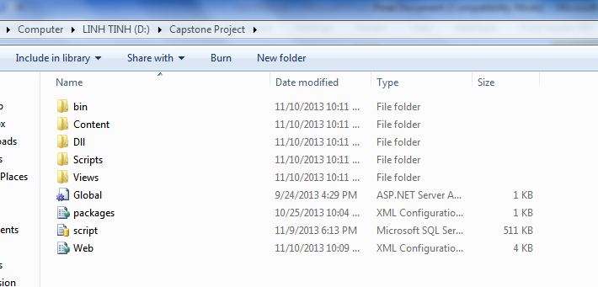

Figure 109: Prepare deployment package

#### Deploy database

* Open Microsoft SQL Server Management Studio

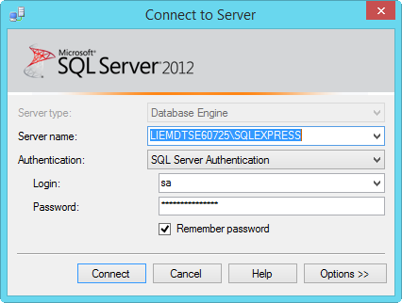

Figure 110: Deploy database – 1

* Open the database.sql file

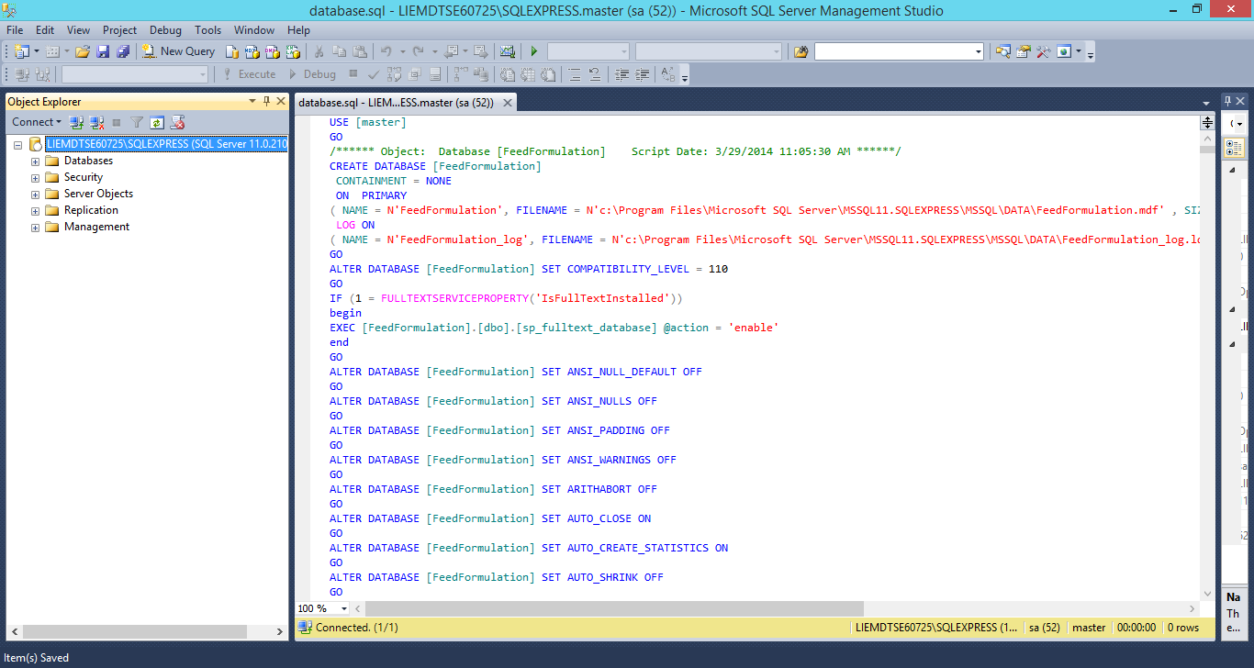

Figure 111: Deploy database - 2

* Execute the script to finish the process

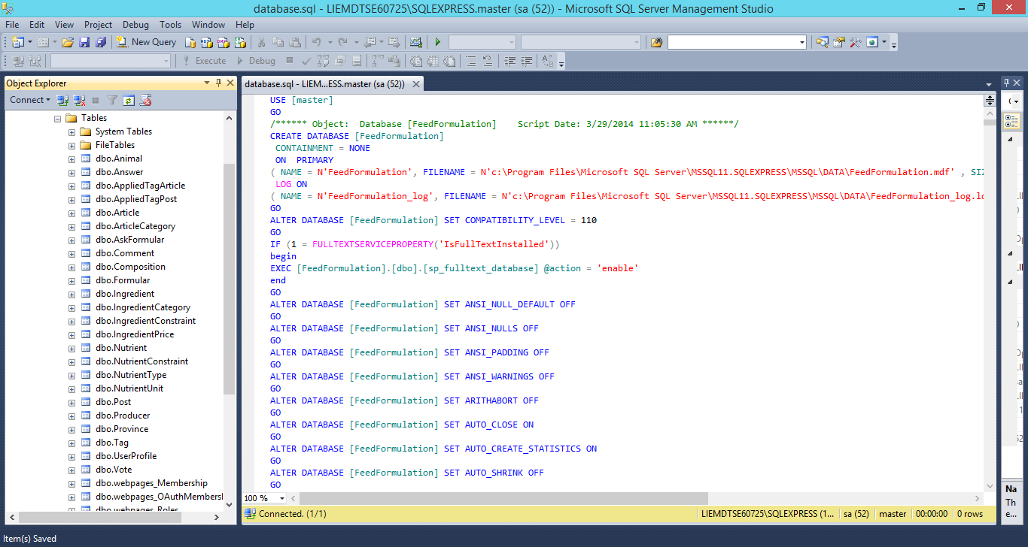

Figure 112: Deploy database - 3

#### Deploy web application on server

* Change the connection string in Web.config
* Replace the “integrated security” with your own username and password

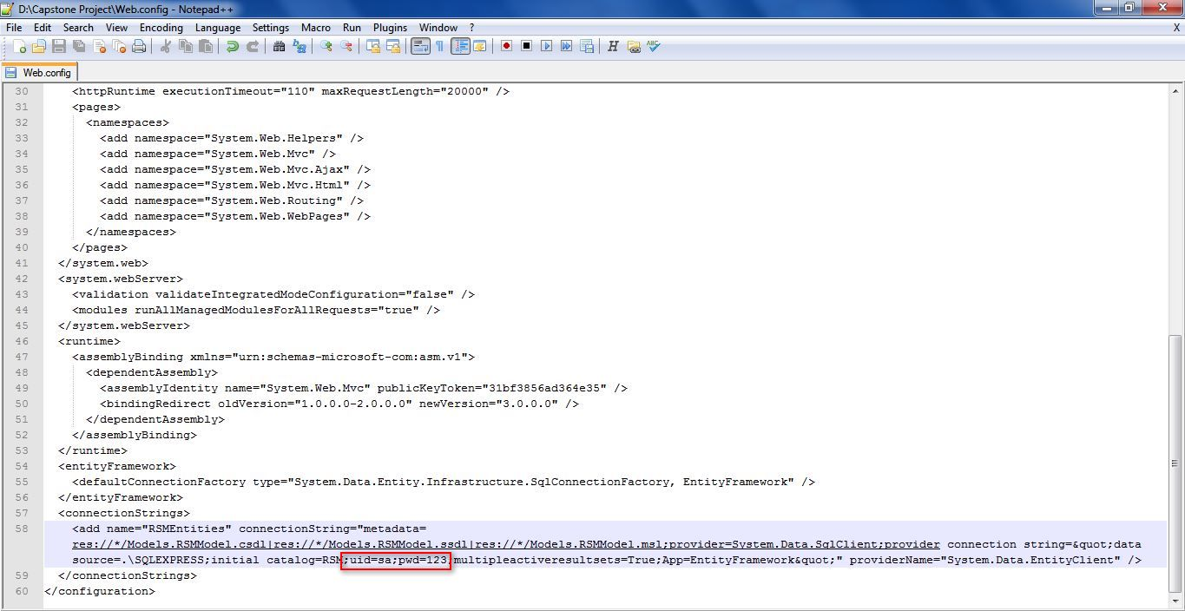

Figure 113: Deploy web application on server – 1

* Right click as Sites. Choose “Add Web Site”.

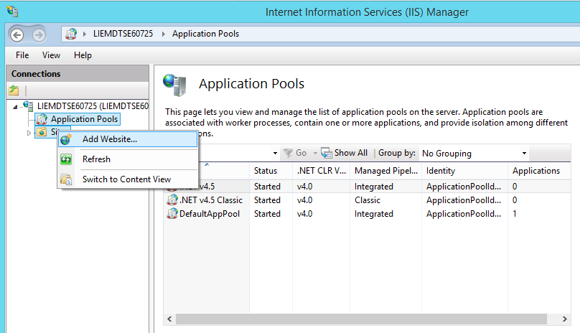

Figure 114: Deploy web application on server – 2

* Enter site name. Choose Application Pool as ASP.NET 4.5
* Select the path as the folder in step 1. Enter port other than 80.

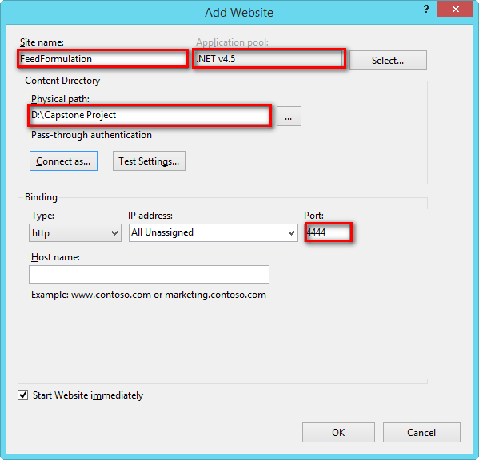

Figure 115: Deploy web application on server – 3

* Press ok to finish the process

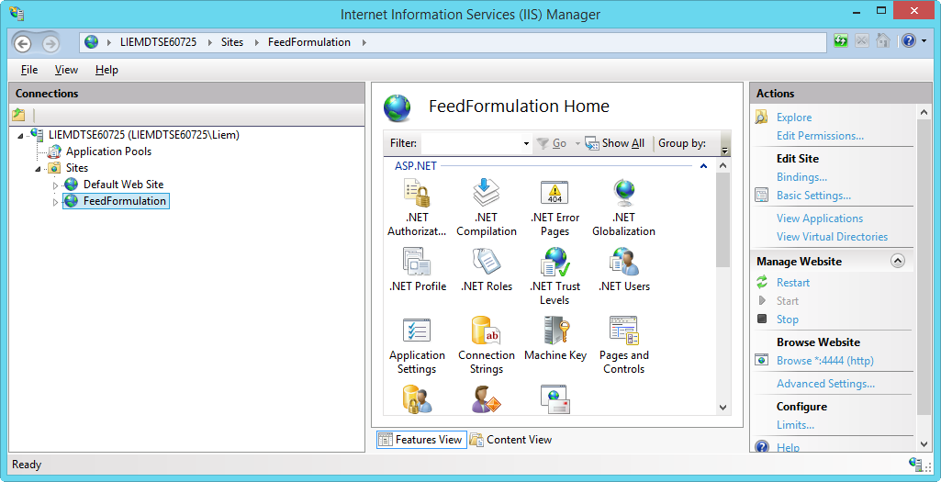

Figure 116: Deploy web application on server – 4

### Setting up the environment at client side

#### Setting up for computer

* The client devices need to have one of the following browsers to access the website:
* Google Chrome.
* Firefox.

## User Guide

* Reference to CD:
  + <root>/Documents/Final Report Full.docx

# Appendix

1. Linear Programming Wikipeadia: [http://en.wikipedia.org/wiki/Linear\_programming#Simplex\_algorithm\_of\_Dantzig](http://en.wikipedia.org/wiki/Linear_programming%23Simplex_algorithm_of_Dantzig)
2. Simplex algorithm of Dantzig:

<http://en.wikipedia.org/wiki/Simplex_algorithm>